SalesOutlook Web®

User Guide

Revised: January 29, 2013

**SalesOutlook, Inc.**

**(770) 642-4923**

Welcome to SalesOutlook Web® 3

Getting Started 4

Working With Account Profiles 6

Create a new Account 7

Searching for Accounts. 9

Edit Account Information 10

Viewing and Creating Account Notes 11

Creating an Account Opportunity 13

Working with Account Contacts 15

# 

# Welcome to SalesOutlook Web®

SalesOutlook is the first application to fully leverage MS Outlook and Exchange Server to provide full functional customer relationship management (CRM). This Guide is intended for all levels of SalesOutlook users from the novice to the experienced user who wants to optimize customer relationships. You’ll find this guide to be a comprehensive overview of SalesOutlook Web.

SalesOutlook is a complete Customer Relationship Management (CRM) solution. It begins by enabling you to track all of the details related to an account. For sales representatives, we recommend you begin by taking the top 25 accounts in your territory and entering the basic information. Once entered, you’re able to manage these accounts by integrating all aspects such as contacts, opportunities, notes, and customer related inquires for these accounts.

SalesOutlook Web is designed to enhance the SalesOutlook Outlook CRM client and can be used as a subset to gather and input data via handheld devices such as tales and smartphones as well as any computer with a browser.

# 

# Getting Started

You can get started right away using SalesOutlook Web by requesting a userid and password to be setup by your SalesOutlook Account Representative. As of this writing the URL is <http://m.salesoutlook.com> . Sign in and click on **User Setup** to enter the information for your Exchange server.

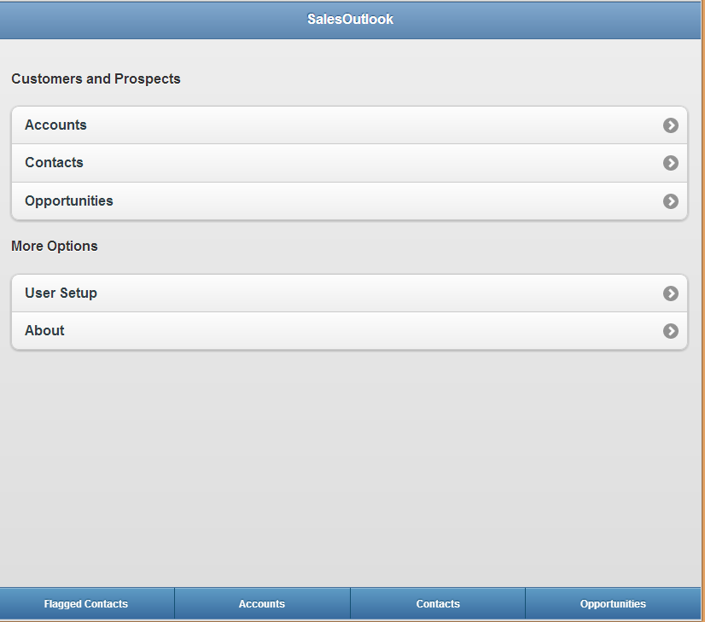



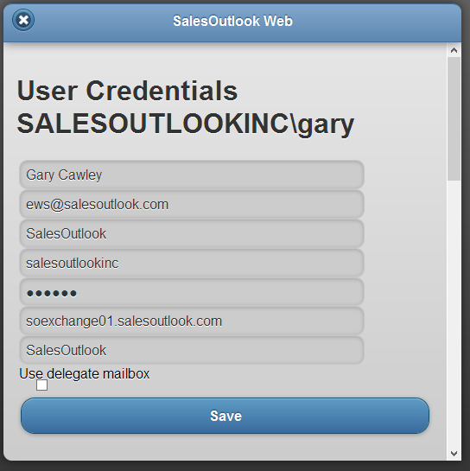

3

1

8

7

4

6

5

2

1. Enter your name
2. Enter your email address or Exchange login name. Note: If you are using a delegate mailbox then enter the email address of the delegate mailbox.
3. Enter your email address
4. Enter in a domain name if you do not use an email address to login. Leave this blank if you use an email address to log in. If you login with domain\username then the first part needs to go into the domain field.
5. Enter the password associated with the step 2.
6. Enter the server URL that you use to login to OWA. If you login to <https://server.outlook.com/owa> then enter server.outlook.com. If you use Office 365 you will need to login to your Inbox to find the URL.
7. Enter the path to the SalesOutlook folder. This will normally be “SalesOutlook” but it you have a top level folder (ie CRM) then enter “CRM\SalesOutlook”
8. Check use Delegate if this is a delegate mailbox.

Working With Account Profiles

Account Profiles enables you to track and maintain all details related to an account (customer). SalesOutlook is an account centric program and therefore, all items are entered through Account Profiles. Once in Account Profiles, access to other folders such as opportunities, contacts, and tasks are accessible.

Click on the Accounts section.



You have three options for Accounts. New Account, Search or list my Accounts. Click on the New Account to create a new account

## Create a new Account

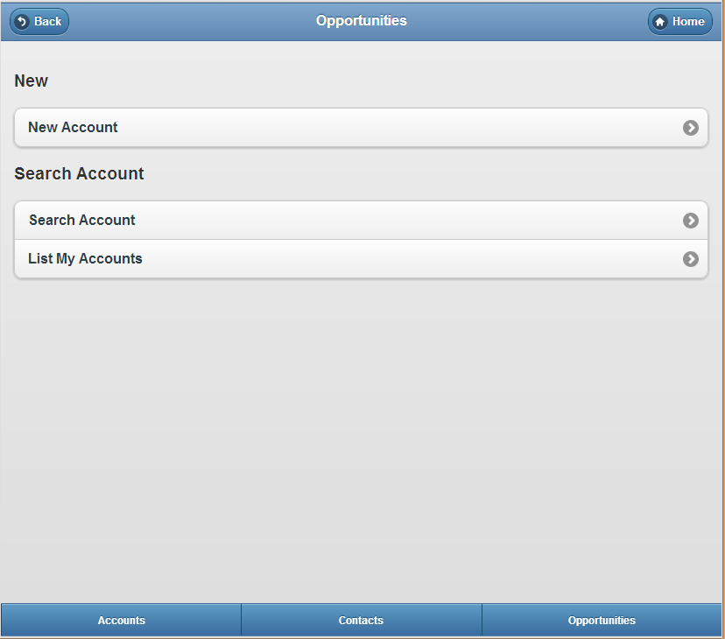

Enter the account information and click on Save.

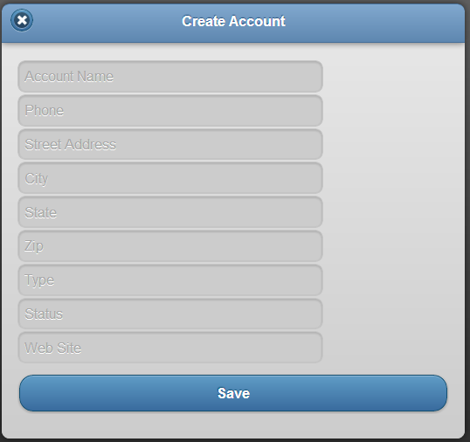



Searching for Accounts.   
If you click on Search account then enter the search information and click on the Search button.

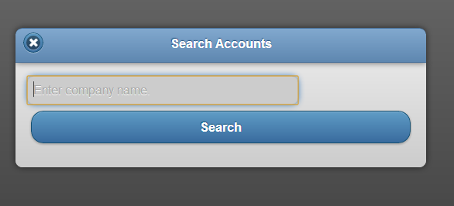

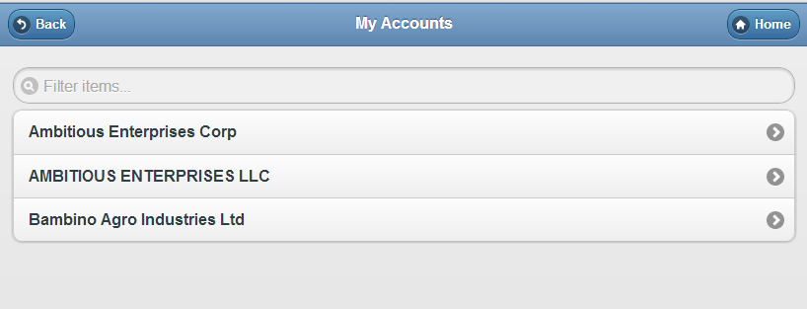

If you search for an account or list your accounts (Accounts where you are the account manager) then you will get a list of accounts.

Click on an account to open the account record.

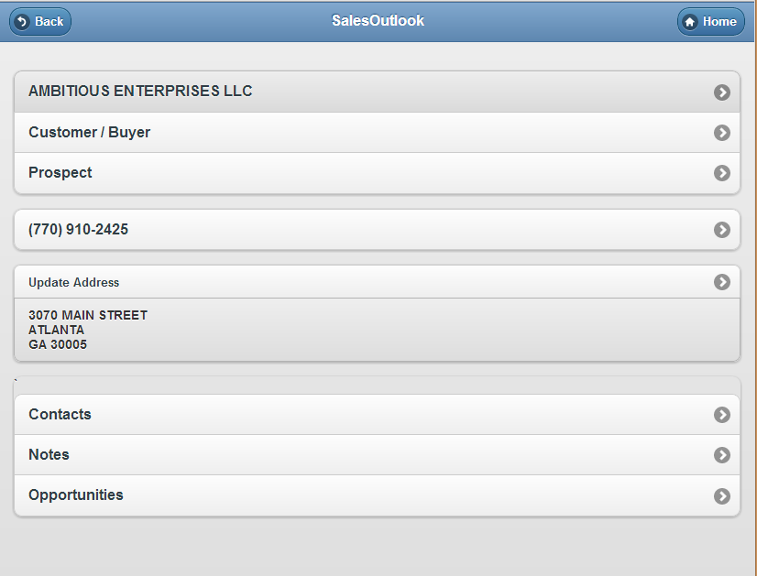Edit Account Information  
Enter the new information and click on the Save button.

*Click on Update Address to update the account Address*

*Click the company name to edit the Account type, status and phone number*

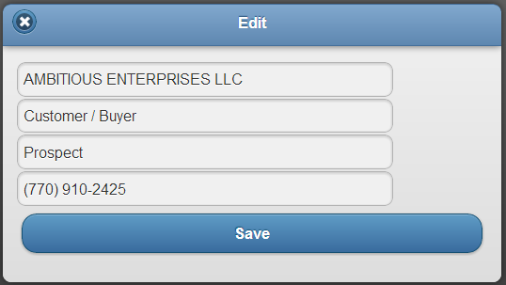



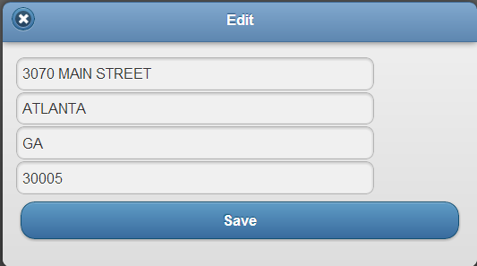

Viewing and Creating Account Notes   
Click on notes to see the notes for the account.

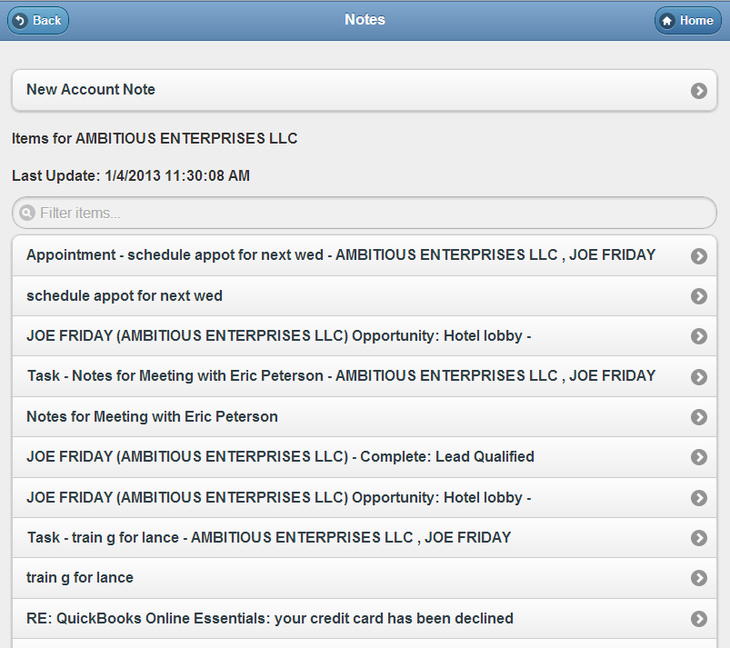Click on New Account Note to create a new note.

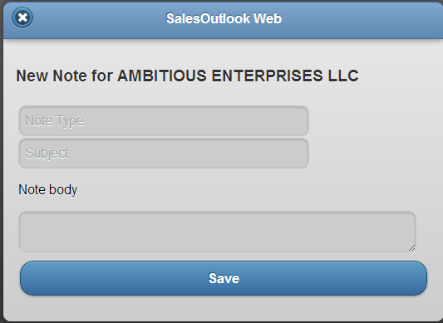

Creating an Account Opportunity

Click on opportunities then click on create a new opportunity.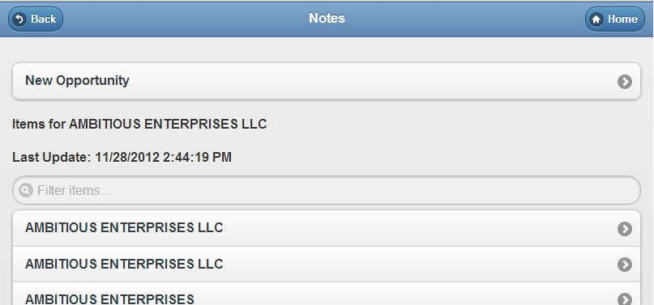

Enter the information and click on Save.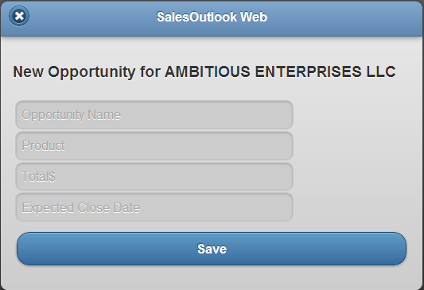

Working with Account Contacts