How to enter the SalesOutlook License Key.

1. Navigate to the SalesOutlook Folder in Outlook. (Press Ctrl-6)

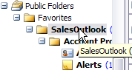
2. Open the SalesOutlook Setup form (Choose Grouped by type view)

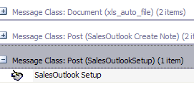

3. Click on the license key tab (Note: Outlook 2007 and Outlook 2010 have a ribbon so click on the ribbon item)
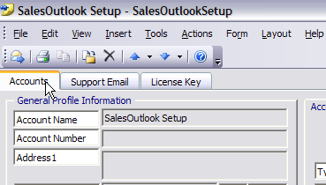

Outlook 2007 or greater will have it in the ribbon under show. It is the third icon or it will say license key.
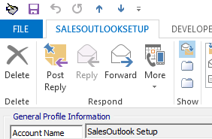
4. Change the SalesOutlook key and close and save the form. You can highlight existing users and delete them (make sure the semi colon is deleted with the user) and add additional users.

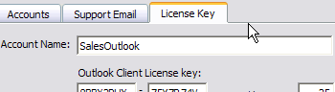

Editing users
Highlight an existing user (include leading semicolon) and press delete. Click on users to add a new user.

