SalesOutlook SharePoint Add-in

SalesOutlook SharePoint User’s Guide

The SalesOutlook SharePoint addin is designed to archive notes history to a SharePoint List server. This allow for the removal of older notes from the Exchange server and stored in a central location.
SalesOutlook users will not see any difference when looking for notes in an Exchange server or a SharePoint server. The SalesOutlook built in Web browser will display the SharePoint list in the Outlook form.
Normal SalesOutlook screen showing a notes list looking at notes in an Exchange folder.
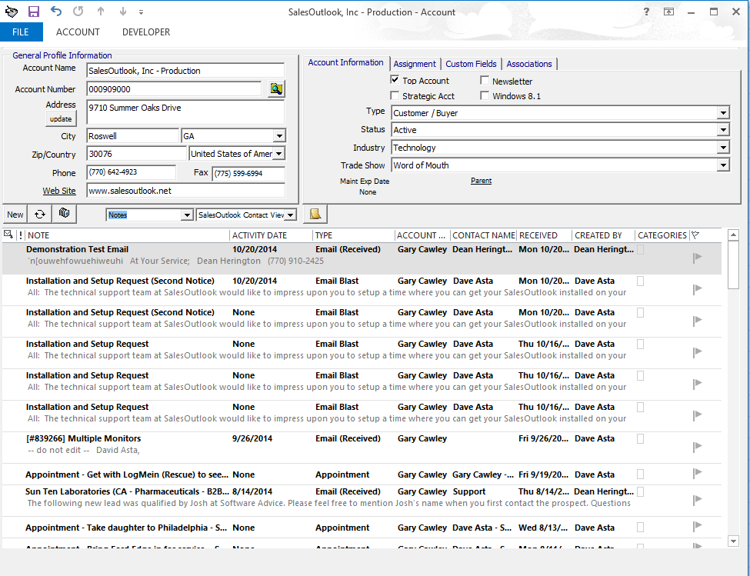

Normal SalesOutlook screen showing a notes list looking at notes in a SharePoint List.
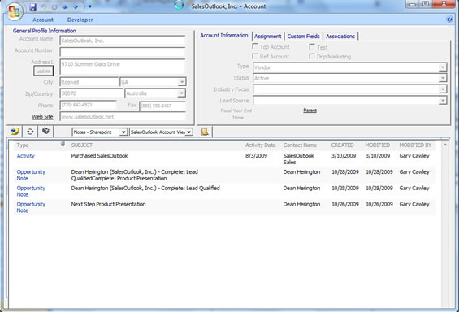

Viewing the note is SharePoint will look different for the end user.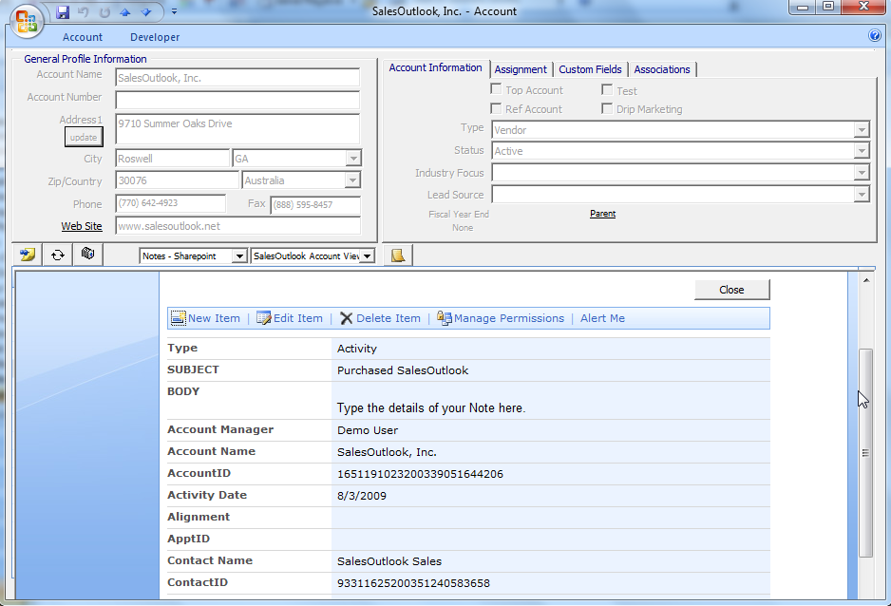

Archiving Notes

Click on the SharePoint button on the SalesOutlook toolbar.
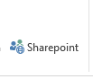
Navigate to the folder you want to archive. Enter your SharePoint server name and click go. You may be prompted for a login to SharePoint. Select the SharePoint List you want to archive the items to. You can then either choose a date range to archive or select the items to archive. Click on the required action button.
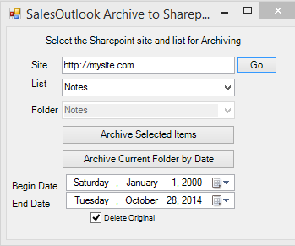

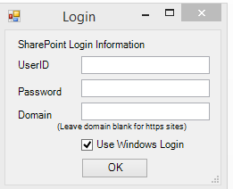

Creating the SharePoint List for SalesOutlook

How to create a list from a SalesOutlook folder.
1. Open SalesOutlookReports.mdb.
2. Create a query with the folder and fields in a way you want to see the list in SharePoint.
3. Save the query. Note: The first field will have the edit link on it.
3. Export the query to a SharePoint site. We recommend creating a separate site (tab) in SharePoint first.

Create SharePoint list to view.
1. Create List view in SharePoint (Make the edit or link the first field)
2. Choose site actions | Edit page.
3. Click edit web part | Modify shared Web part.
4. Change toolbar type to no toolbar. Save and exit out.
5. Open SharePoint designer and navigate to the list folder.
6. Create a new aspx page.
7. Open the list view in step 1.
8. Copy the webpart to the new aspx page and save it.
9. Open the new page in Internet explorer.
10. Create a system folder drop down and add the URl to the 'default view' field.

Creating a Folder drop down to view a SharePoint list.

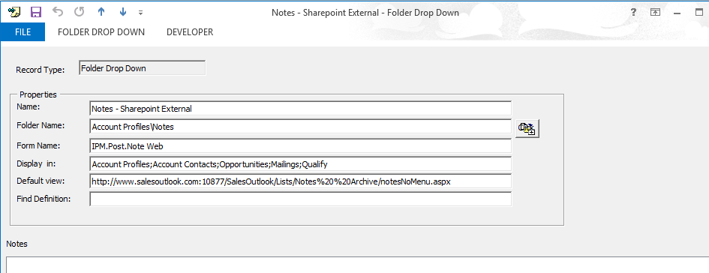

Create a new folder drop down and enter the SharePoint Url in the Default View field.

