SalesOutlook Private Folder Option for Contacts Setup Instructions

SalesOutlook Private Folder setup

The SalesOutlook Private Folder checkbox on a contact form is designed to automatically file email to a private folder. This allows for the filing of emails from a contact to a secure location.

Setup of Private folders

Note: Private folders can be setup anywhere within an Exchange database.
Example: Create a new folder in the Exchange database called Private under the Notes folder.

- Download a template pst from the website
- Unzip the SalesOutlook.pst and open it in Outlook (File | Open | Outlook data File | SalesOutlook.pst from step 1)
- Navigate to the SalesOutlook\account Profiles\notes folder of the pst.
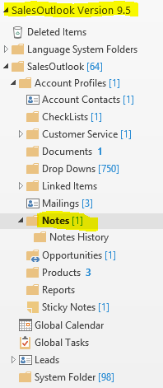
- Right Click on the Notes folder and choose rename. You can call it Private or anything you want to call it.
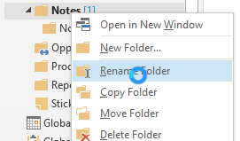
- Delete the Notes History folder under Private
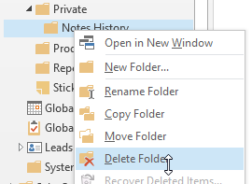
- Right Click on Private and choose Copy Folder and copy the Private folder under Notes in your All Public Folders SalesOutlook Database.
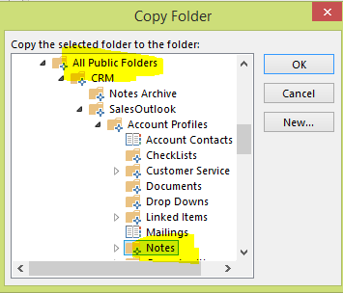
- Navigate to the All Public folders version of the Private folder. Right Click on Private and choose Properties then the Permissions Tab. Set the Default user to have no permissions. Uncheck Folder Visible.
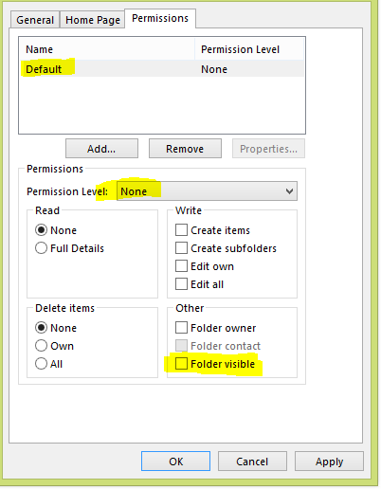
- Click on add the users or add the users Group that will be allowed to save emails to this folder.
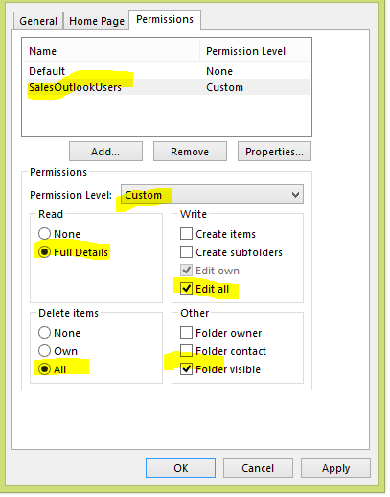
- Install the latest Account Contact form.
  - Download the new Account Form to your hard drive and unzip it.
  - Open Outlook and choose File | Options | Advanced |Scroll to Custom Forms | manage Button.
  - Click on the set button and navigate to the All Public Folders Account Contacts.
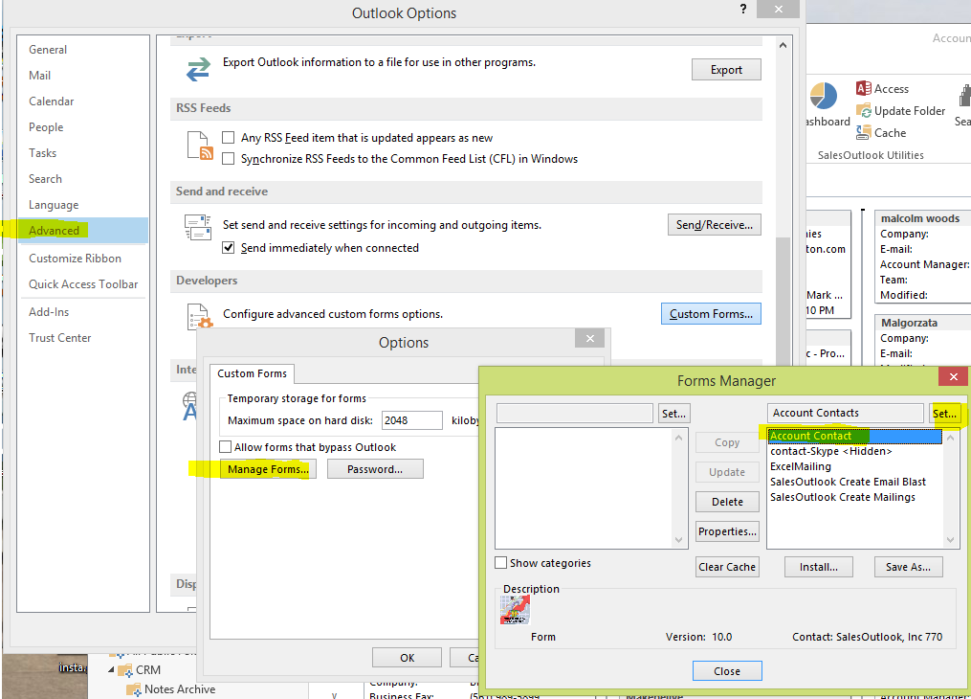
  - Click on Install and navigate to the AccountContact.fdm from step 1. Make sure you choose fdm file extension.
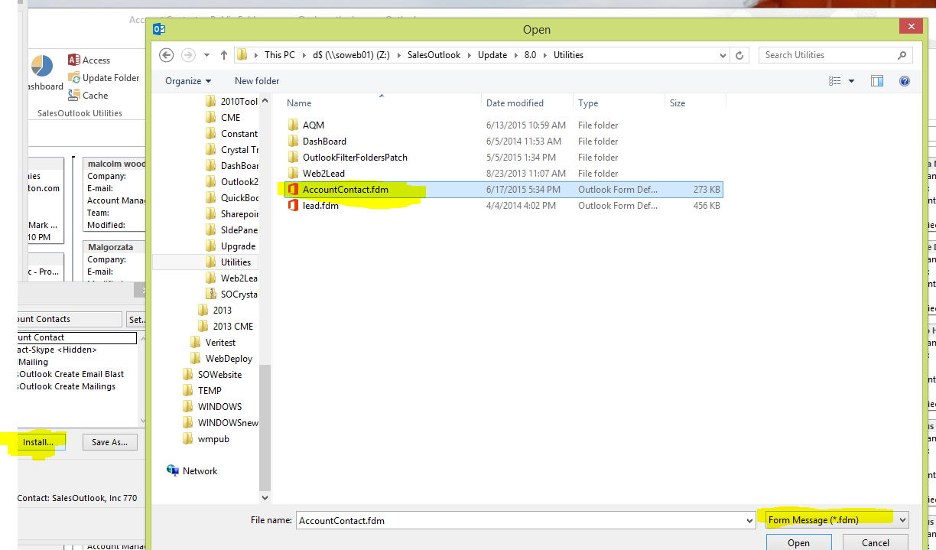
  - Select Yes to replace the existing form.
  - Navigate to the ”Account Contacts” folder and create the fields. Right click on a field heading in a table view and choose field chooser.
  - Click New and enter “Private Folder” and make the Type Yes/No
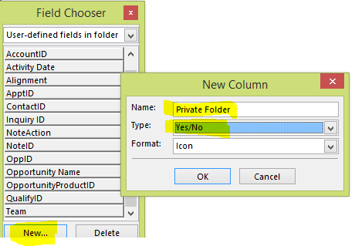
  - Click New and enter “PrivateEntryID” and the Type is text.
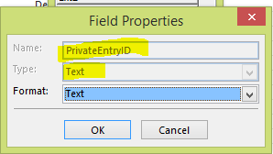
  - Click New and enter “PrivateStoreID” and the type is text.
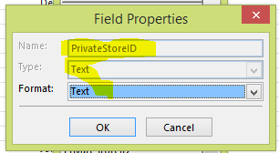
  - Click New and enter “Do Not AutoFile” and the type is Yes/No.
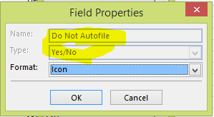
- Add a private folder for a contact. Open the Contact and click on the Private Folder Checkbox. A folder list popup will load and choose the private folder.
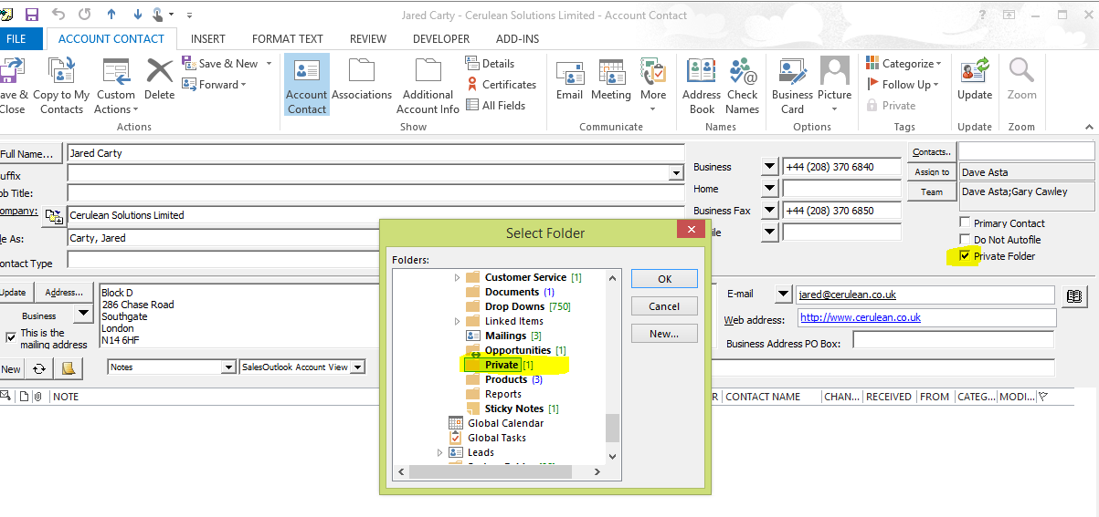
- Download and Run the latest update for all users that need to use the private folder. Close Outlook before running the update or you will have to reboot.
- Setup a folder drop down for the user to view the private emails (Note: only valid users will see the emails). Navigate to the System Folder and copy the Notes Folder Drop Down.
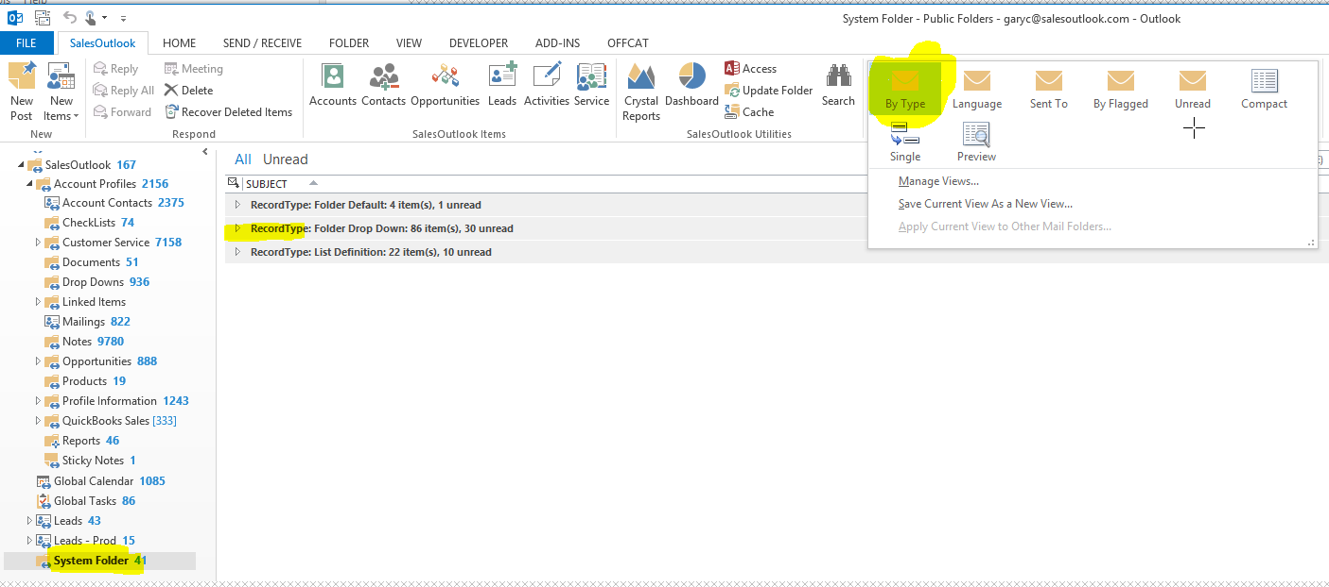
- Copy the Note Folder Drop Down (Ctrl-C then Ctrl-V)
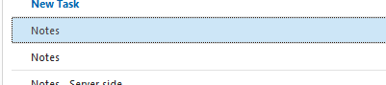
- Open one of the notes folder drop downs by double clicking it and change it to Private Folder.
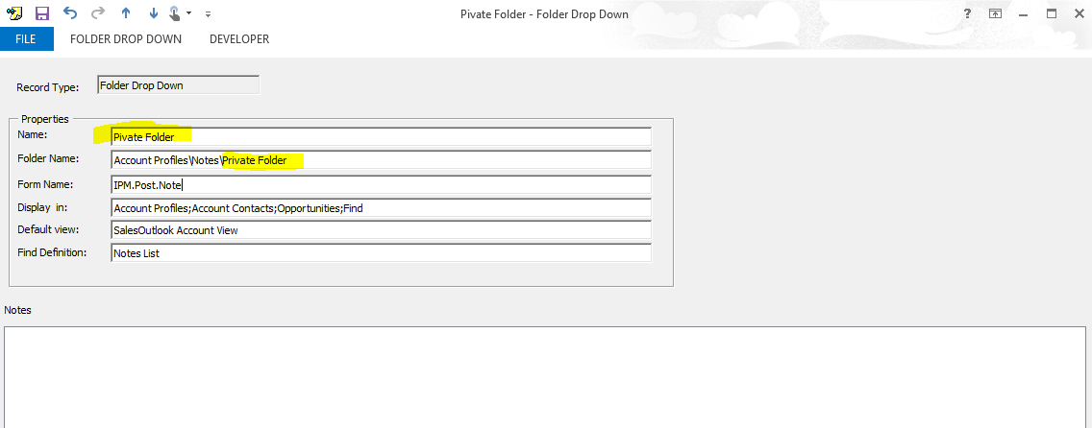
- Optional: You can create a separate system folder with the above option if you do not want non private users to see the folder drop down.

