SalesOutlook®
Forms Guide

SalesOutlook, Inc.
(770) 642-4923

Fields on the forms

Account Profile Form
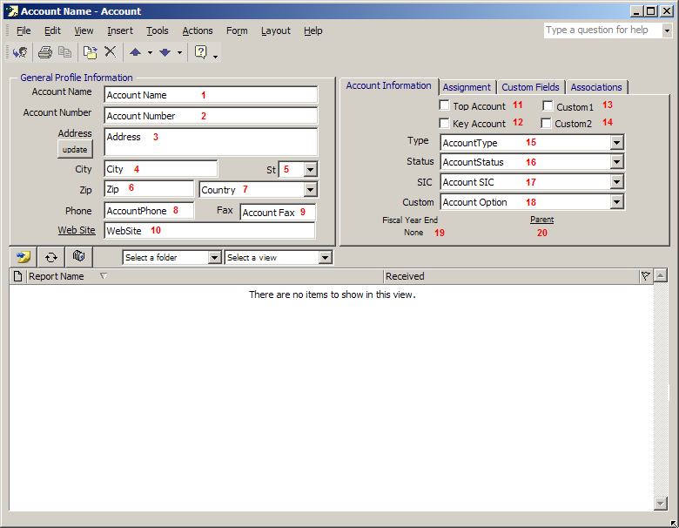

 |  | Fieldname | Form Name
1 | Account Name |  | Account Name
2 | AccountNumbertxt |  | Account Number
3 | AccountAddress1 |  | Address
4 | AccountCity |  | City
5 | AccountState |  | State
6 | Accountzip |  | Zip Code
7 | AccountCountry |  | Country
8 | AccountPhone |  | Phone
9 | Account Fax |  | Fax
10 | Account Web |  | Web Site
11 | Top25 |  | Top Account
12 | Key Account |  | Key Account
13 | AccountCheckbox1 |  | Custom1
14 | AccountCheckbox2 |  | Custom2
15 | AccountType |  | Type
16 | Account Status |  | Status
17 | Account SIC |  | SIC
18 | Account Option |  | Custom
19 | Fiscal Year End |  | Fiscal Year End
20 | Account Parent |  | Parent

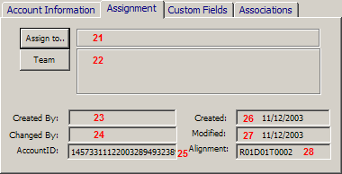

 |  | Fieldname | Form Name
 | 21 | Account Manager | Assign to
 | 22 | Team | Team
 | 23 | From | Created By
 | 24 | Changed By | Changed By
 | 25 | AccountID | AccountID* Primary Key
 | 26 | Received | Created
 | 27 | Modified | Modified
 | 28 | Alignment | Alignment

Custom Drop Down

Type | Status

SIC | Custom

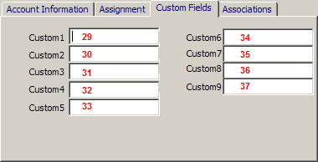

 | Fieldname | Form Name
29 | Custom1 | Custom1
30 | Custom2 | Custom2
31 | Custom3 | Custom3
32 | Custom4 | Custom4
33 | Custom5 | Custom5
34 | Custom6 | Custom6
35 | Custom7 | Custom7
36 | Custom8 | Custom8
37 | Custom9 | Custom9

The following are on the Account Profile form but are not shown.

 | Fieldname | Form Name
38 | FROM | Creator of the item
39 | SUBJECT | Account Name
40 | BODY | Associations Tab
41 | Web Page | Web Page
42 | MESSAGE CLASS | IPM.Post.SalesOutlook_2000
43 | CREATED | Date item created per store
44 | MODIFIED | Date item modified
45 | Account LocationID | Parent Account ID
46 | AccountNotes | AccountNotes
47 | FormType | FormType
48 | In Folder | Current Folder
49 | Message | Body of Account
50 | Selected Item | Current Radio Button
51 | Selectedview | Current view

  - Primary Key = Link to child objects

Account Contact Form

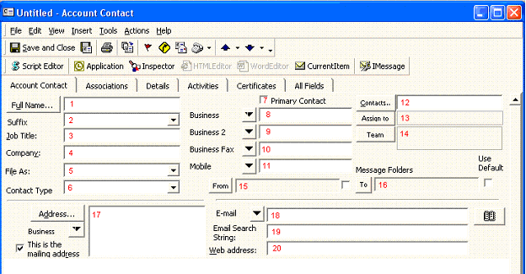

 |  | Fieldname | Form Name
 | 1 | FULL NAME | Full Name
 | 2 | Suffix | Suffix
 | 3 | JOB TITLE | Job Title
 | 4 | COMPANY | Company
 | 5 | FILE AS | File As
 | 6 | Contact Type | Contact Type
 | 7 | Primary Contact | Primary Contact
 | 8 | BUSINESS_TELEPHONE_NUMBER | Business
 | 9 | BUSINESS2_TELEPHONE_NUMBER | Business 2
 | 10 | BUSINESS_FAX_NUMBER | Business Fax
 | 11 | MOBILE_TELEPHONE_NUMBER | Mobile
 | 12 | Contacts | Contacts
 | 13 | Account Manager | Assign To
 | 14 | Team | Team
 | 15 | Message From Folder | From
 | 16 | Message To Folder | To
 | 17 | Address Selected | Address
 | 18 | EMAIL1 | Email
 | 19 | EmailSearchString | Email Search String
 | 20 | WEB PAGE | Web Address

The following are on the Account Contacts form and may or may not be shown due to selection:

 | Fieldname | Form Name
25 | DEPARTMENT_NAME | Department
26 | OFFICE_LOCATION | Office
27 | PROFESSION | Profession
28 | ASSISTANT | Assistant’s Name
29 | NICKNAME | Nickname
30 | SPOUSE_NAME | Spouse’s name
31 | BIRTHDAY | Birthday
32 | WEDDING_ANNIVERSARY | Anniversary
33 | BODY | Associations Tab
34 | Categories | Categories
35 | SURNAME | Last
36 | MIDDLE_NAME | Middle
37 | GIVEN_NAME | First
38 | STREET_ADDRESS | Street
39 | POSTAL_ADDRESS | Zip/Postal Code
40 | LOCALITY | City
41 | STATE_OR_PROVINCE | State/Province
42 | POSTAL_CODE | Zip
43 | HOMEADDRESS | Based on address pull down with selection as Home
44 | HOME_ADDRESS_STREET | Street (Home)
45 | HOME_ADDRESS_POST_OFFICE_BOX | PO Box (Home)
46 | HOME_ADDRESS_CITY | City (Home)
47 | HOME_ADDRESS_STATE_OR_PROVINCE | State/Province (Home)
48 | HOME_ADDRESS_POSTAL_CODE | Zip/Postal Code (Home)
49 | HOME_ADDRESS_COUNTRY | Country (Home)
50 | OTHERADDRESS | Based on address pull down with selection as Other
51 | OTHER_ADDRESS_STREET | Street (Other)
52 | OTHER_ADDRESS_POST_OFFICE_BOX | PO Box (Other)
53 | OTHER_ADDRESS_CITY | City (Other)
54 | OTHER_ADDRESS_STATE_OR_PROVINCE | State/Province (Other)
55 | OTHER_ADDRESS_POSTAL_CODE | Zip/Postal Code (Other)
56 | OTHER_ADDRESS_COUNTRY | Country (Other)
57 | BUSINESSADDRESSSTREET | Street (Business)
58 | BUSINESSADDRESSPOSTOFFICEBOX | PO Box (Business)
59 | BUSINESSADDRESSCITY | City (Business)
60 | BUSINESSADDRESSSTATE | State/Province (Business)
61 | BUSINESSADDRESSPOSTALCODE | Zip/Postal Code (Business)
62 | BUSINESS_ADDRESS_COUNTRY | Country (Business)
63 | ASSISTANT_TELEPHONE_NUMBER | Assistant (Based on telephone dropdown selection)
64 | COMPANY_MAIN_PHONE_NUMBER | Company (Based on telephone dropdown selection)
65 | HOME_TELEPHONE_NUMBER | Home (Based on telephone dropdown selection)
66 | HOME2_TELEPHONE_NUMBER | Home 2 (Based on telephone dropdown selection)
67 | HOME_FAX_NUMBER | Home Fax (Based on telephone dropdown selection)
68 | OTHER_TELEPHONE_NUMBER | Other (Based on telephone dropdown selection)
60 | PRIMARY_FAX_NUMBER | Primary Fax
70 | PAGER_TELEPHONE_NUMBER | Pager
71 | PRIMARY_TELEPHONE_NUMBER | Primary
72 | FROM | Creator of the item
73 | TITLE | Title
74 | INITIALS
75 | GENERATION | Suffix
76 | SUBJECT | Account Name
77 | BUSINESS_HOME_PAGE | Email
78 | EMAIL2 | Email 2 (Based on email dropdown selection)
79 | EMAIL3 | Email 3 (Based on email dropdown selection)
80 | Account Name | Account Name
81 | AccountType | Account Type
82 | Account Status | Account Status
83 | Account SIC | Account SIC
84 | Account Option | Account Option
85 | Top25 | Top25
86 | Key Account | Key Account
87 | AccountCheckbox1 | Custom1 (Checkbox)
88 | AccountCheckbox2 | Custom2 (Checkbox)
89 | Custom1 | Custom1
90 | Custom2 | Custom2
91 | Custom3 | Custom3
92 | Custom4 | Custom4
93 | Custom5 | Custom5
94 | Custom6 | Custom6
95 | Custom7 | Custom7
96 | Custom8 | Custom8
97 | Custom9 | Custom9
98 | Alignment | Alignment
99 | Selected Item | Select A Folder
100 | Selected View | Selected A View

Note: The fields located on the Account Info tab of the Account Contact form are named the same and have the same labels as the 4 checkboxes, 4 drop downs and 9 custom text fields on the Account Profile form and are available on the Account Contact form in SalesOutlook 4.3 and later.

Custom Drop Down

Contact Type | Suffix

Opportunity Form

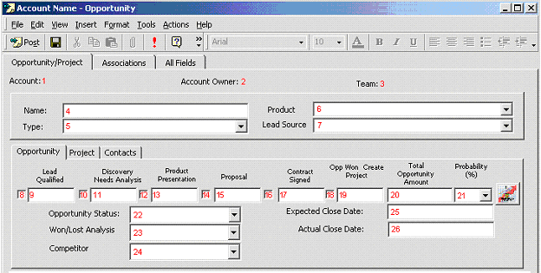

 | FieldName | Form Name
1 | Account Name | Account
2 | Account Owner | Account Manager
3 | Team | Team
4 | Name | Name
5 | Opportunity Type | Type
6 | Product | Product
7 | Lead Source | Lead Source
8 | Stage1 | Lead Qualified (Check box)
9 | Stage1Date | Lead Qualified (text)
10 | Stage2 | Discovery Needs Analysis (check box)
11 | Stage2Date | Discovery Needs Analysis (text)
12 | Stage3 | Product Presentation (check box)
13 | Stage3Date | Product Presentation (text)
14 | Stage4 | Proposal (check box)
15 | Stage4Date | Proposal (text)
16 | Stage5 | Contract Signed (check box)
17 | Stage5Date | Contract Signed (text)
18 | Stage6 | Opp Won Create Project (check box)
19 | Stage6Date | Opp Won Create Project (text)
20 | TotalPurchase | Total Opportunity Amount
21 | Probability | Probability
22 | Opportunity Status | Opportunity Status
23 | Won/Lost | Won/Lost Analysis
24 | Competitor | Competitor
25 | Expected Close Date | Expected Close Date
26 | Actual Close Date | Actual Close Date

 | Fieldname | Form Name
27 | ProjectStage1 |  | Kick Off (check box)
28 | ProjectStage1Date |  | Kick Off (text)
29 | ProjectStage2 |  | Analyze Requirements (check box)
30 | ProjectStage2Date |  | Analyze Requirements (text)
31 | ProjectStage3 |  | Assign Project Tasks (check box)
32 | ProjectStage3Date |  | Assign Project Tasks (text)
33 | ProjectStage4 |  | Customer Signoff (check box)
34 | ProjectStage4Date |  | Customer Signoff (text)
35 | ProjectStage5 |  | Install/Training Dates Set (check box)
36 | ProjectStage5Date |  | Install/Training Dates Set (text)
37 | ProjectStage6 |  | Product Install Complete (check box)
38 | ProjectStage6Date |  | Product Install Complete (text)
39 | ProjectCost |  | Project Cost
40 | Project Status |  | Project Status
41 | Reason for Delay |  | Reasons for delay
42 | Expected Project Close Date |  | Expected Project Done
43 | Actual Project Close Date |  | Actual Close Date

Custom Drop Down

Type | Product

Lead Source | Status

 | Fieldname | Form Name
44 | Contact1 |  | Primary Contact
45 | Contact2 |  | Secondary Contact
46 | Contact3 |  | Manager Contact
47 | Contact4 |  | Technical Contact
48 | Contacts |  | Contacts

The following are on the Opportunity form but are not shown:

 | Fieldname | Form Name
49 | Account Manager |  | Account Manager
50 | Alignment |  | Alignment
51 | Division Manager |  | Division Manager
52 | Account Name |  | Account Name
53 | Accountzip |  | Accountzip
54 | AccountID |  | Account ID
55 | ContactID |  | Contact ID
56 | OppID |  | Opportunity ID* Primary Key
57 | Team |  | Team
58 | RegionNumberTxt |  | Region
59 | DivisionNumberTxt |  | Division
60 | TerritoryNumberTxt |  | Territory
61 | BODY |  | Associations Tab
62 | CREATED |  | Date item created per store
63 | FROM |  | Creator of the item
64 | MESSAGE CLASS |  | IPM.Post.Opportunity
65 | MODIFIED |  | Date item modified
66 | Product Group |  | Product Group (related to Product)
67 | Received |  | Date item received
68 | Selected Item |  | Current Radio Button

Note Form

 | Fieldname | Form Name
1 | Type | Note Type
2 | Subject | Note
3 | Contact Name | Contact Name
4 | Account Name | Account Name
5 | Account Manager | Account Manager
6 | Team | Team
7 | BODY | (Body of Note)
8 | Categories | Categories

The following are on the Note form but are not shown:

 | Fieldname | Form Name
8 | Alignment |  | Alignment
9 | Alignment1 |  | Alighnment1
10 | Alignment2 |  | Alignment2
11 | Alignment3 |  | Alignment3
12 | Alignment4 |  | Alignment4
13 | Alignment5 |  | Alignment5
14 | NoteCategory |  | NoteCategory
15 | AccountID |  | Account ID
16 | ContactID |  | Contact ID
17 | OppID |  | Opportunity ID
18 | Note Type |  | Note Type
19 | CREATED |  | Date item created per store
20 | FROM |  | Creator of the item
21 | Message |  | Body of Note
22 | MESSAGE CLASS |  | IPM.Post.Note
23 | MODIFIED |  | Date item modified

Custom Drop Down

Note Type

Customer Service Form

 | Fieldname | Form Name
1 | Account Name | Account
2 | Inquiry Type | Inquiry Type
3 | Assign To | Assign To
4 | Contact Name | Contact
5 | BusinessPhone | Phone
6 | BusinessFax | Fax
7 | InquiryPriority | Priority
8 | InquiryStatus | Status
9 | Knowledge Base Article | Knowledge Base Article
10 | Inquiry ID | (blank)
11 | Date Resolved | Resolve Date
12 | Created | Create Date
13 | Account Manager | Account Manager
14 | Team | Team
15 | Total Time | Total Time
16 | Subject | Problem Description
17 | BODY | Problem Resolution

The following are on the Note form but are not shown:

 | Fieldname | Form Name
18 | In Folder | Current Folder
19 | AccountID | Account ID
20 | Alignment | Alignment
21 | ContactID | Contact ID
22 | Account Manager | Account Manager
23 | Account | Account
24 | Categories | Categories
25 | Selected Item | Current Radio Button
26 | MODIFIED | Date item modified
27 | MESSAGE CLASS | IPM.Post.CustomerService
28 | FROM | Creator of the item
29 | CREATED | Date item created per store
30 | Message | Body of Note

Actions Form

 | Fieldname | Form Name
1 | Type | Action Type
2 | Subject | Action
3 | Account Name | Account Name
4 | Contact Name | Contact Name
5 | BusinessPhone | (Body of Action)
6 | Categories | Categories

The following are on the Actions form but are not shown:

 | Fieldname | Form Name
7 | AccountID | Account ID
8 | Alignment | Alignment
9 | ContactID | Contact ID
10 | CREATED | Date item created per store
11 | FROM | Creator of the item
12 | MESSAGE CLASS | IPM.Post.Action
13 | MODIFIED | Date item modified
14 | Note Type | Note Type
15 | OppID | Opportunity ID

Products Form

 | Fieldname | Form Name
1 | Subject | Product Name
2 | Product Group | Product Group
3 | In Stock | In Stock
4 | Price | Price
5 | Discount 1-10 | Discount 1-10
6 | Discount 10-25 | Discount 10-25
7 | Discount 25-100 | Discount 25-100
8 | BODY | Product Literature

The following are on the Products form but are not shown:

 | Fieldname | Form Name
9 | CREATED | Date item created per store
10 | FROM | Creator of the item
11 | MESSAGE CLASS | IPM.Post.Product
12 | MODIFIED | Date item modified

