SalesOutlook®
User Guide

Revised: April 27, 2009

SalesOutlook, Inc.
9710 Summer Oaks Drive
Roswell, GA 30076
(770) 642-4923

Copyright Notice

© 2009 SalesOutlook, Inc. All rights reserved.

This document contains highly confidential information considered by SalesOutlook, Inc. to be a proprietary trade secret and is intellectual property that is owned solely by SalesOutlook, Inc.

This document and the information it contains is protected by international copyright laws and treaties and additional intellectual property laws and treaties as they apply to confidential information and trade secrets. Unauthorized distribution, transmission, disclosure or other use is expressly prohibited.

Individuals, and the individuals and/or organizations they represent whether through a formal or informal relationship, may face criminal and/or civil litigation that may result in severe fines, monetary damages and/or even imprisonment for disclosing the information contained in this document to any unauthorized person or entity.

No portion of the information contained in this document may be disclosed or distributed to any person or entity that is not a lawfully licensed user of the software product described by the technical characteristics and specifications contained in this document without first obtaining the express written permission of SalesOutlook, Inc. A SalesOutlook, Inc. representative may be contacted by visiting www.salesoutlook.net in your web browser.

Trademark Notice

SALESOUTLOOK®, SalesOutlook CRM, SalesOutlook SBE, SalesOutlook Web Access, SalesOutlook Active Security, Pocket SalesOutlook, SalesOutlook Reports, Common Sense CRM and other SalesOutlook, Inc. brand names, product names and marketing slogans are either trademarks, service marks or registered trademarks of SalesOutlook, Inc. in the United States and/or other countries.

All other company, product and brand names are owned by other companies and/or individuals.

Legal Disclaimer

Information in the document is subject to change without notice and is offered “As Is” and without any warranty whatsoever, including warranties relating to merchantability or fitness for a particular purpose or use.

The software described in this document is furnished under a license agreement. The software may be used only in accordance with the terms of the license agreement. It is against the law to copy the software on any medium except as specifically allowed in the license agreement.

No part of this document may be reproduced or transmitted in any form or by any means – electronic or mechanical – including photocopying, recording, or information recording and retrieval systems, for any purpose without the express written permission of SalesOutlook, Inc.

Those who violate the intellectual property rights of SalesOutlook, Inc. will be prosecuted to the fullest extent allowed by applicable law.

Table of Contents

Welcome to SalesOutlook® 7
SalesOutlook Toolbar Quick Reference 8
Account Profile Quick Reference 9
Getting Started 10
SalesOutlook Conventions 10
Working With Account Profiles 11
Scenarios 12
Scenario 1 - Creating a new Account 12
Scenario 2 - Opening an existing Account 12
Scenario 3 - Selecting the active View for the Account Profiles folder 14
Scenario 4 - Finding an Account 17
Scenario 5 - Changing the Account Name 19
Scenario 6 - Activating the Power User Interface 19
Tab & Field Descriptions 21
General Profile Information 21
Account Information Tab 22
Assignment Tab 22
Custom Fields Tab 23
Associations Tab 24
Working With Account Locations 25
Scenarios 25
Scenario 1 - Creating addititonal Locations for an Account 25
Scenario 2 - Linking an existing Account as an Account Location 26
Working With Account Contacts 30
Scenarios 30
Scenario 1 - Adding a new Account Contact to an Account 30
Scenario 2 - Creating an Account Contact using the Right Click menu 31
Scenario 3 - Converting an existing Contact into an Account Contact 34
Scenario 4 - Adding an Account Contact using the toolbar 37
Scenario 5 - Finding an Account Contact 41
Tab & Field Descriptions 43
Account Contact Tab 43
Associations Tab 44
Details Tab 45
Activities Tab 45
Certificates Tab 46
Mailbox / Email Integration 46
Working With Notes 47
Scenarios 47
Scenario 1 - Adding a Note 47
Scenario 2 - Using Notes for Account History 48
Scenario 3 - Adding a Note to an Account Contact using the toolbar drop down meenu 49
Scenario 4 - Adding a Note for an Opportunity using the Right Click menu 53
Scenario 5 - Adding an automated note. 54
Scenario 6 – Creating an email, task or appointment from a note. 55
Working With Documents and Spreadsheets 56
Scenarios 56
Scenario 1 – Linking or attaching a document 56
Scenario 2 – using a pre-defined Word template 58
Working With Tasks 63
Scenarios 63
Scenario 1 - Creating Tasks 63
Scenario 2 - Assigning / Reassigning a Task 65
Working With Appointments 69
Scenarios 69
Scenario 1 - Adding a new Appointment 69
Creating Checklists (Optional with Small Business Edition) 72
Working With Checklists (Optional with Small Business Edition) 72
Working With Leads (Optional with Small Business Edition) 74
Managing Your Daily Activities 76
Scenarios 76
Scenario 1 - Viewing your Activities (Tasks & Appointments) 76
Working with Linked Items (Optional with Small Business Edition) 78
Associating Free-Form Information 81
Inserting / Attaching a File 82
Associating an Outlook Item with a SalesOutlook Item 82
Converting Email into Notes 84
Using the SalesOutlook Quick View 87
Scenario 1: Display Sender information using the Quick View 87
Scenario 2: Create an Opportunity Note or a Customer Service Action 88
Scenario 3: Create / Open SalesOutlook items related to the Sender of an Email Message 89
Working With Automatically Filed Email Notes 91
How to setup Auto Filed Email messages. 91
How to tell which emails were automatically filed. 91
Working With Contact Synchronization 91
How to setup Contact Synchronization. 91
Working With Mailings (Optional with Small Business Edition) 93
Scenarios 93
Scenario 1 - Adding an Account Contact to a Mailing list 93
Create a bulk Mailing 95
Create an Email Blast 95
Creating the Email Blast for the Account Contacts folder. 96
Creating the Email Blast for the Mailings folder. (optional for SBE) 96
Working With Customer Service Inquiries (Optional with Small Business Edition) 97
Scenarios 97
Scenario 1 - Adding a Customer Service Inquiry from an Account form 97
Scenario 2 - Adding a Customer Service Inquiry using the Toolbar Drop Down menu 99
Customer Service Inquiry Field Descriptions 102
Inquiry Type 102
Assign To 102
Add Action 102
Create Task 103
Knowledge Base Article 103
Start Timer 103
Email (button) 104
Working With Opportunities 105
Scenarios 105
Scenario 1 - Adding an Opportunity and/or Project to an Account 105
Scenario 2 - Adding an Opportunity using the Actions menu option 107
Tab & Field Descriptions 109
Opportunity Tab 109
Project Tab 110
Contacts Tab 110
Working with the Global Calendar (Optional with Small Business Edition) 111
Adding an Appointment from the toolbar 111
Selecting an Existing Contact or Account to an Appointment form 111
Adding an Appointment from an Account or Contact form 112
Adding a New Appointment to an Existing Account 112
Deleting an Appointment 112
Viewing Global Calendar information 113
Global Calendar Item. 113
Normal Appointment form. 114
Modifying Global Calendar information 115
Setting Global Calendar Registry information 116
Setup up multiple Global Calendars 116
Disable the Global Calendar 116
Remove the Text on SalesOutlook Toolbar buttons 117
Printing Outlook Views 119
Print your Account list 119
Print your Contacts phone list 120
Print your Calendar 120
Print your Forecast for this Month 121
Print your Weekly Activity Log 122
Crystal Reports for SalesOutlook 123
Sample Forecast for this Month Report 125
Sample Monthly Call Log Report 126
Sample Open Customer Service Inquires Report 127
Reporting via an Access (ODBC) Database 127
Working With Views (Saved Queries) in SalesOutlook 129
An Introduction to Microsoft Outlook Views 129
What are Views? 129
What parameters define a View? 129
Who can define Views for everyone to use? 130
Customizing Outlook Views 130
Scenario 1 - Displaying additional fields in a View 130
Scenario 2 - Reordering the Columns in a View 134
Scenario 3 - Removing fields from a View 135
Scenario 4 - Grouping Items in a View 136
Creating a New View 139
Where do the fields exist? 139
Scenario 1 - Creating an Account Profile view for your companies 141
Scenario 2 - Creating a View for Account Contacts 144
Scenario 3 - Choosing non-standard fields 148
Final Thoughts About Views 150
Creating MailMerge Documents in Outlook 151
Mail Merge Overview 151
What are MailMerge documents? 151
Scenarios 153
Scenario 1 - Creating Address Labels 153
Scenario 2 - Creating a Form Letter 160
Scenario 3 - Reusing Mail Merge Documents 166

Welcome to SalesOutlook®

SalesOutlook is the first application to fully leverage MS Outlook and Exchange Server to provide full functional customer relationship management (CRM). This Guide is intended for all levels of SalesOutlook users from the novice to the experienced user who wants to optimize customer relationships. You’ll find this guide to be a comprehensive overview of SalesOutlook. However, those of you wanting to take advantage of the additional capabilities of MS Outlook, should explore additional resources.

SalesOutlook is a complete Customer Relationship Management (CRM) solution. It begins by enabling you to track all of the details related to an account. For sales representatives, we recommend you begin by taking the top 25 accounts in your territory and entering the basic information. Once entered, you’re able to manage these accounts by integrating all aspects such as contacts, opportunities, notes, and customer related inquires for these accounts.

Customer Service faces ongoing challenges to maintain a customer for life. SalesOutlook gives customer service representatives the means to create actions, tasks, and a knowledge base. With the use of these tools, service reps can provide superior products and services. With the integration of these components within SalesOutlook, you can convert more prospects into customers, and maintain quality customer service.

While this document may not be tailored to the way you do business, SalesOutlook is designed to be customizable to the way your organization operates.

SalesOutlook Toolbar Quick Reference
Click here to get a list of predefined Crystal reports.
Click here to update the SalesOutlook cache. This is only necessary if default values have changed or if you experience problems.
Click here to find an existing SalesOutlook item.

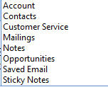
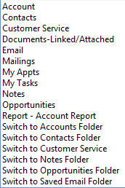
Click here to email the support department if you experience a problem.
Click here to add a new item
Click here to switch to a folder.

Account Profile Quick Reference

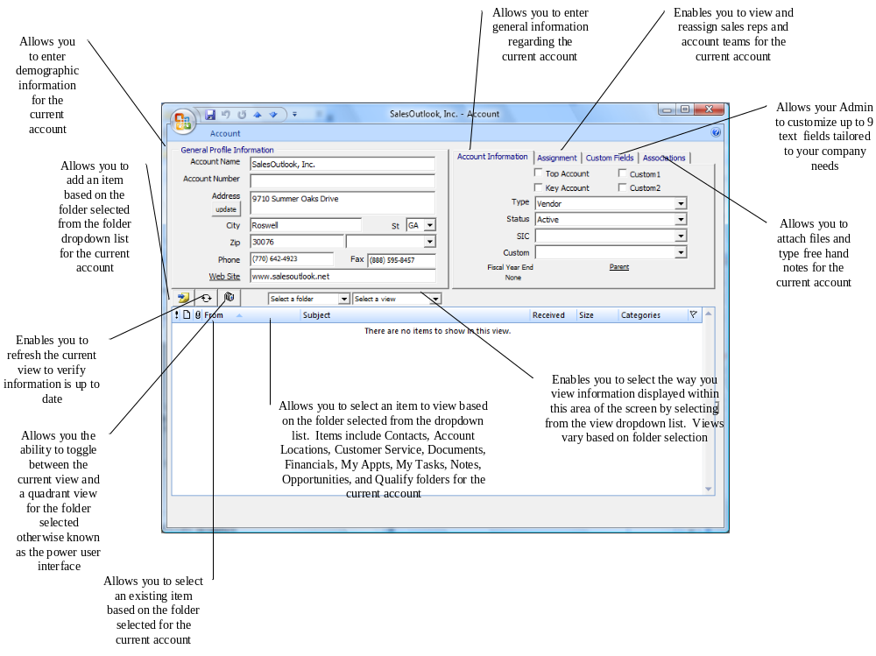

Getting Started
You can get started right away using SaleOutlook by using the SalesOutlook toolbar. Click on the ▼ (see quick reference on previous page) and select an item from the list to create that item. IE select Accounts to create a new Account record.

Other items can be created quickly with the SalesOutlook toolbar but you will have to use the select button to assign a contact or account to the item. So if you create a note and you want that note linked to an account or contact then use the select button to select the account or contact to link the note to.

Use the SalesOutlook Quick Links to open the related items. Click on any underlined label and it will open the linked item. IE Click on the word Company in a contact form to open the account record.

Finding contacts and accounts is easy with the Find Contact and Find Account buttons. Just click these buttons and enter all or partial information to search. You can even enter a company name in the Find Contact and all the contacts for that company will show up.

SalesOutlook Conventions

SalesOutlook Select -- Click on this button on any form to select either a contact or account to assign the item to.
SalesOutlook Quick Links -- Click on any underlined item on a form to launch that item.
SalesOutlook Folder drop down -- Click on the ▼ on any form to select what folder you want to see related items for. Note: not all forms have this drop down.
SalesOutlook New Item -- Click on the new item button on any form to create a new item that is listed in the folder drop down. Note: not all forms have this button.

SalesOutlook Folder view drop down -- Click on the ▼ on any form to select what folder view you want displayed. Note: not all forms have this drop down.

Working With Account Profiles

Account Profiles enables you to track and maintain all details related to an account (customer). SalesOutlook is an account centric program and therefore, all items are entered through Account Profiles. Once in Account Profiles, access to other folders such as opportunities, contacts, and tasks are accessible.

In addition, Account Profiles allows you to create notes, appointments, multiple account locations, and other items related to an account. Additional information regarding these items are discussed in detail later in this manual.

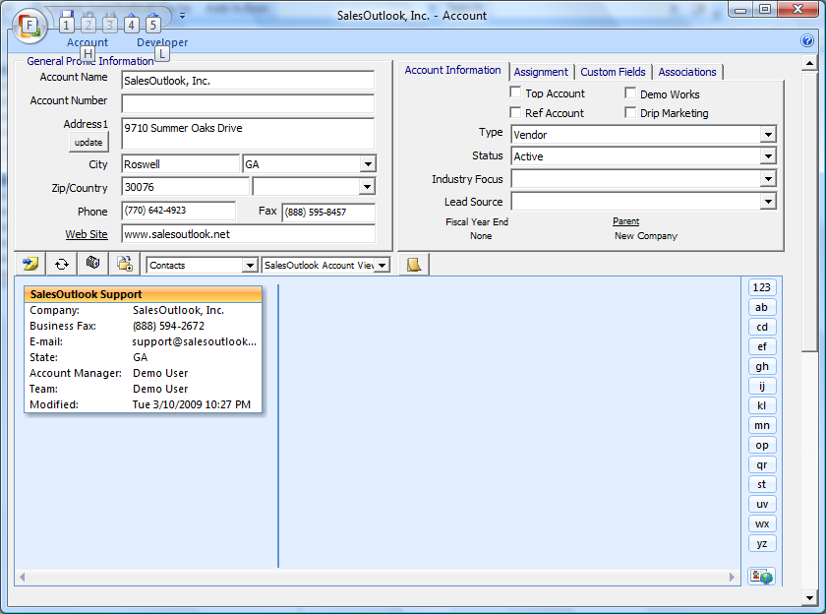

Helpful Hints
- Selection of a Folder within the dropdown list displays that item’s information about the account in the lower half of the screen. Once a folder is selected, a view can also be selected to display that information in a variety of different ways.
- The “New Item” dropdown found on the SalesOutlook Toolbar enables you to create many SalesOutlook items in just 2 clicks. After the form for your new item displays, use the “Select Contact” button to link it to the Account AND to the Account Contact of your choice (all at once), or you can just click the Select Account button to link the item to the Account Profile of your choice (link to Account only – no link to an Account Contact).

Scenarios

Scenario 1 - Creating a new Account

- Start from the main SalesOutlook Add/Action toolbar item.
- To add a new Account to your system, click on the Account option.

Scenario 2 - Opening an existing Account
- To select an existing Account, first select a view of your accounts (see scenario 3 - “Selecting Views for an Account” below).
- Highlight the Account you wish to view, double-click on the Account to open. 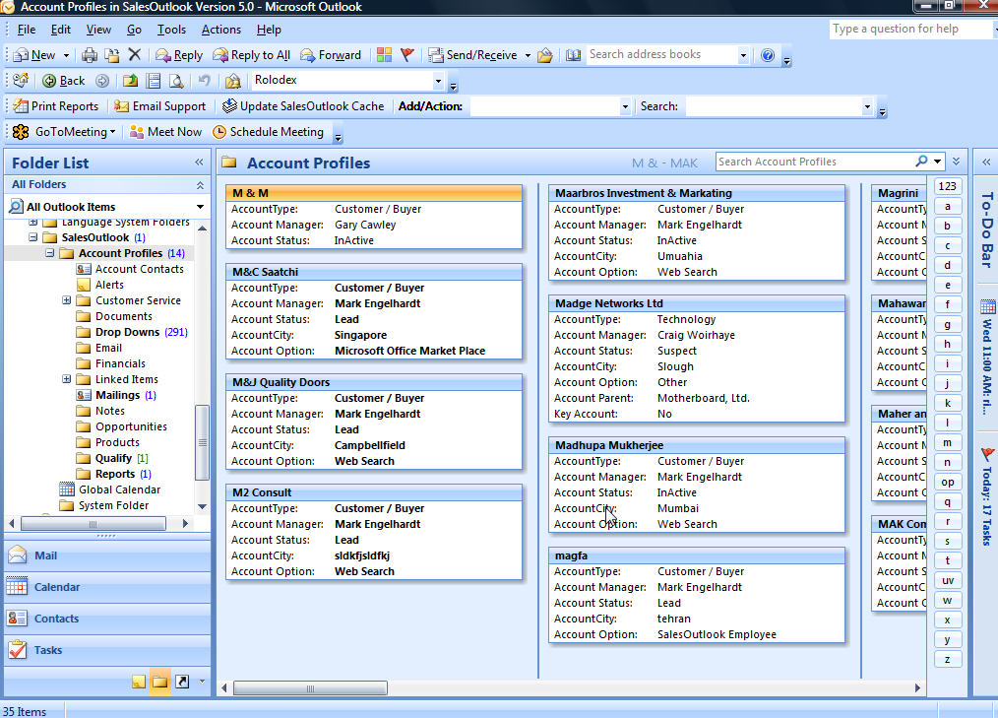

Scenario 3 - Selecting the active View for the Account Profiles folder

Outlook Tip: If you do not see a dropdown on your Outlook Advanced Toolbar as circled in the illustration below, you can turn on the Advanced Toolbar to display it. To turn on the Advanced Toolbar, on Outlook’s main menu click View | Toolbars | Advanced and ensure that a checkmark appears next to the Advanced Toolbar option. If a checkmark does not appear, click the toolbar name to check the toolbar to instruct Outlook to display it.

- The current view box displays the selected view. In the above example we can determine we’re using the Rolodex view since the Current View box displays “Rolodex.”
- To change this view, simply select the down arrow on the Current View box located on the Advanced Toolbar and select another view from the list.

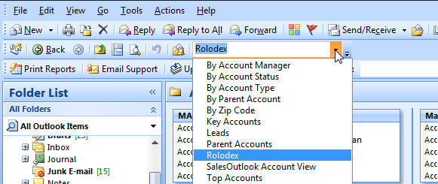
Your SALESOUTLOOK Administrator has created several default views for you to select using the drop down on the Advanced Toolbar.

- Views can also be changed by selecting View from the main menu. After selecting View, select Current View, and pick a view from the displayed list. In the example screen below, we can determine that the “SalesOutlook Account View” is actively displayed since a checkmark is located next to its name in the list of views available in the folder.

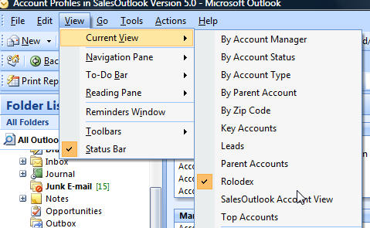

IMPORTANT CONCEPT: Each folder may contain a variety of views of the same underlying data. Also, many views are available only within specific folders. For example, only the Account Profiles folder contains the Parent Accounts view. To determine the folder you’re currently working with, check the folder name appearing just under your main Outlook toolbars. The following image illustrates the that the Account Profiles folder is currently the “active” folder.

TIP: You can also check the location of the folder by navigating through your folder list. For more information concerning views, review the “Creating Views in MS Outlook” topic discussed later in this manual.

Scenario 4 - Finding an Account

- To find an Account quickly, click on the Search | Account drop down on the SalesOutlook Toolbar.
Search Account Drop Down

- Within the List of Outlook Accounts screen, type in the name of the Account you are trying to locate within the search field and press Search. Click on the Account. Once selected, click on the Select button to view the account within the Account Profiles form.
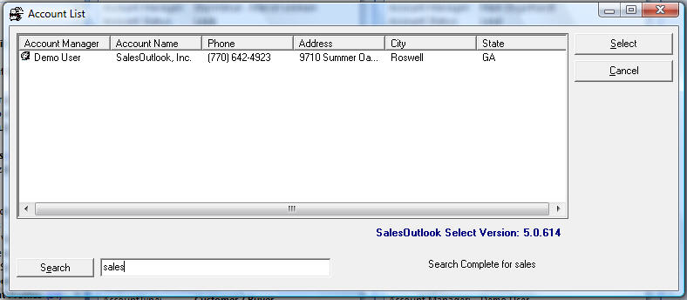
Type Account Name here

Scenario 5 - Changing the Account Name

- While working within the Account Profiles form, SalesOutlook will recognize when a change is made to the Account Name. Upon saving the account, SalesOutlook will update all the sub forms with the new account name.

Scenario 6 - Activating the Power User Interface

- The Power User Interface Icon allows you to toggle between the normal single-list interface and a new, multi-quadrant view of multiple lists of related items. This feature is currently available only within the Account Profiles form. Simply click the Power User Interface icon to display the 4-quadrant view. Click the icon again to revert back to the standard view.

- When working within the Power User Interface (shown below), you have the ability to not only view multiple items for an account, but also the ability to add and open items within the views selected.

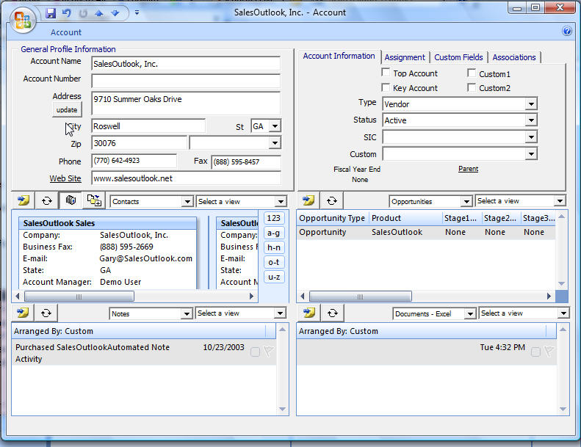
Add button
Add button
Add button
Add button

Helpful Hints
You can click the Refresh button on the toolbar to ensure that information shown within the view is up to date.

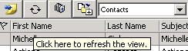

Tab & Field Descriptions

General Profile Information

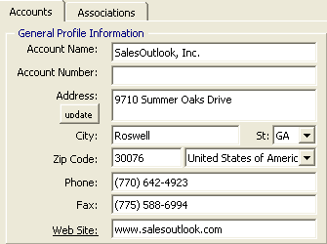

- This tab contains the Account demographic information.
- Only the Account Name is required when entering demographic information.
- Enter Account Name, Account Number (if any), address, city, state, zip code, phone, & fax numbers. and web site address for this account.
- Enter a web site address. You can click the web site label which is underlined to take you to the URL for that web site.
- Click on the SAVE button on the Tool Bar to save the Account record before proceeding. The update button allows you to update contacts with the Account address. If at any time you make a change to the account address, simply click the “Update” button to update the contact’s address associated with the Account. You can either update all contacts associated with that account with the same address, or you can update the contacts one at a time to decipher which contacts to update to the new address.

Account Information Tab

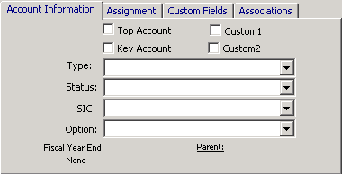

- The Account Information tab allows you to define specific information relating to an account. This information helps when displaying views and generating reports.
- If you consider this account to be one of your top 25 accounts, click the checkbox next to Top Account. Define your key Accounts in the same manner.
- Select Type and Status dropdowns for this account
- SIC and Custom fields are additional fields that can be designed specifically for your business needs.
- Enter a Fiscal Year End by highlighting None and typing in a calendar date. You can also type in phrases and SalesOutlook will automatically display the date for you. For example, type ‘end of year’ and a date of December 31 now appears.
- The name of the parent account will automatically display if account locations are added to this account. When you are within a child account, you may select the Parent label to open the parent account record.
- Your administrator can change the name of these checkboxes and pull downs.

Assignment Tab

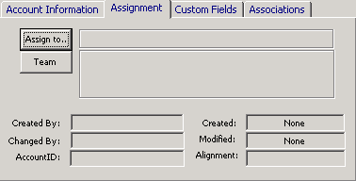

- The default assignment displays the creator of the Account record. To change the assignment, click on the ASSIGN TO button. The Global Address Book is displayed. Select the person you wish to assign to this Account.
- The creator is also listed on the team. Additional team members may be added. To select additional team members, click the TEAM button. Selecting a Team makes this record available to all Team members. Team members also have the ability to change core account information.
- The CREATED BY field defaults to the user whom created the account.
- CREATED displays the date the Account Profile item was created in that folder.
- RECEIVED displays the date your server originally received the item. Therefore, it is safe to use the RECEIVED date as the actual “created” date for the record. This is especially true in environments where the Exchange Administrator may have reasons to move items out of the folder and copy them back in. In that case, the CREATED date will no longer reflect the original date the item was created but rather the system timestamp of when the item was copied / moved back into the folder.
- The CHANGED BY field will populate if at any time the account information is changed.
- MODIFIED date displays the last time the account information changed (saved).
- When you save a new Account, a new AccountID is automatically assigned. If an Alignment value is used by your organization, then that information is automatically generated as well.

Custom Fields Tab

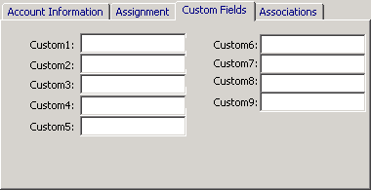

- The custom fields tabs allows up to 9 custom fields to be associated with your account.
- Your administrator can change the names of these custom fields to values that will help organize your accounts. Please see the administrator manual for customization options.

Associations Tab

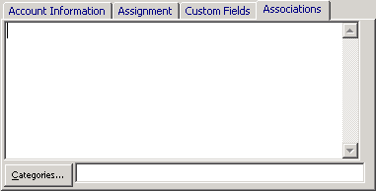

- The Associations tab allows you to attach items such as word documents, spreadsheets, and presentations.
- Select the Associations tab and attach any shortcuts.
- Assign any categories relating to those items by clicking on the categories button.

ACCOUNT RELATED FORMS

Working With Account Locations

Account Locations allows you to enter multiple locations for a single, “parent” account. Account Locations may define the subsidiaries, divisions and branch offices of a large conglomerate, or they may simply represent shipping locations, a FedEx address, billing locations, cost centers or other related information.

To view the locations defined for an account, simply click on the “Select a Folder” dropdown and select Account Locations from the list. If any locations are present, they will appear in the viewing area under the toolbar.

Scenarios

Scenario 1 - Creating addititonal Locations for an Account

- Within Account Profiles, click on the “Select a Folder” dropdown and select Account Locations from the list. Next, click the “Add a New Item” icon to display a blank Account Profile form. It will enable you to define a new Account Location for this Account.

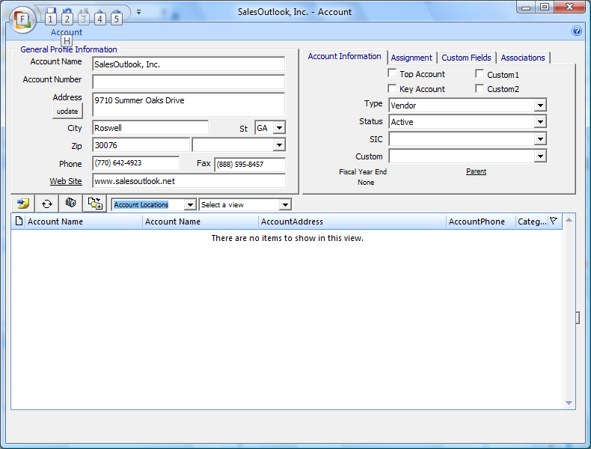
Click to create a new Account Location

- Enter any information pertaining to the account on this form. When saved, the new Account Location will be linked with the “Parent” location. This new Account has all the functionality as does any other Account. You can maintain contacts, notes, opportunities etc.

Scenario 2 - Linking an existing Account as an Account Location

- Within Account Profiles, open the Parent Account and click on the “Select a Folder” dropdown. Then select Account Locations from the list.
- Next, click the “Select” icon.

Click to select from existing Accounts

- A “List of Outlook Accounts” screen displays. Type in the desired Account name in which you want to link to the Parent Account within the search feature. Click to select the single account, or you can select multiple accounts one at a time by holding down the Ctrl key. To add multiple accounts in order, hold the shift key. Once selected, click on the select button to add as an account location for the account.

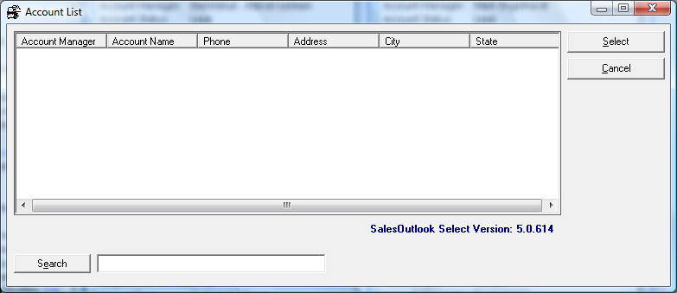

- Once selected, the relationship to the new “Parent” is displayed on the Account Profile form for the child account.

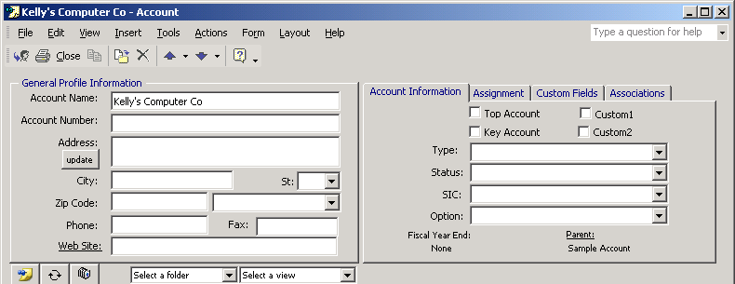

NOTE: When sorting Accounts, each “Parent” and “Child” Account will be listed as an individual Account, and can be maintained independently. This means that the full functionality of an Account Profile is available to each Account Location of amy Parent Account Proile.

For example, Account Location type Account Profile records maintain their own set of Account Contacts, Opportunities, Notes, Customer Service Inquiries and etc. However, a link to the Parent Account is maintained by the system until you use the “Disassociate from Parent Account” feature to remove the link that binds the two Account Profile records.

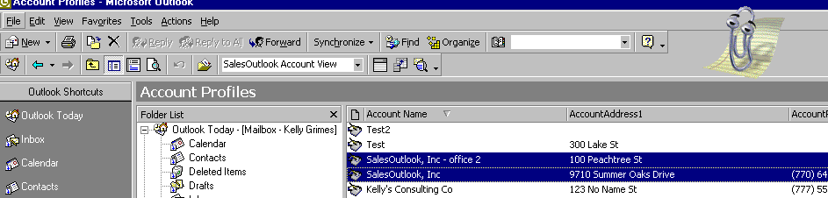
Both Accounts listed individually

Working With Account Contacts

Account Contacts are normally created and associated with an account by creating a new Account Contact via the Account Profiles form. Defining the Account Contacts for an Account enables you to assign inquiries to a contact, add notes and opportunities specifically associated with that Contact, and to perform several other contact-related tasks. Once you have saved an account, you are ready to add and associate Account Contacts with that account.

Scenarios

Scenario 1 - Adding a new Account Contact to an Account

- Within Account Profiles, click on the “Select a Folder” dropdown and select Contacts from the list. Next, click the “Add a New Item” icon to display a blank Account Contact form.

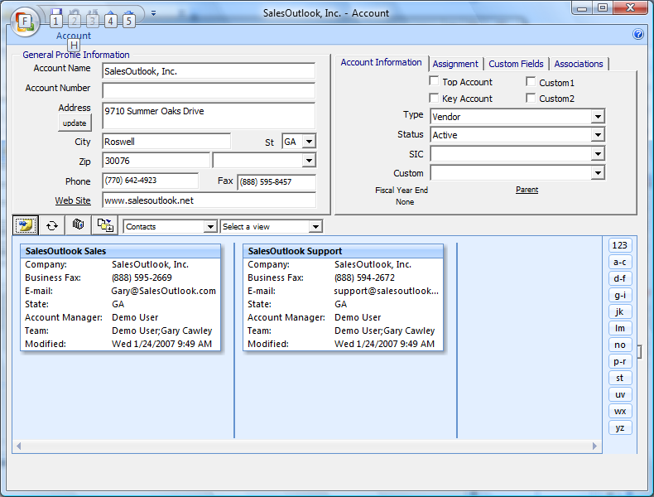
Click here to Add a new Contact

- A new Account Contact form appears with the basic demographic information displayed for that account.

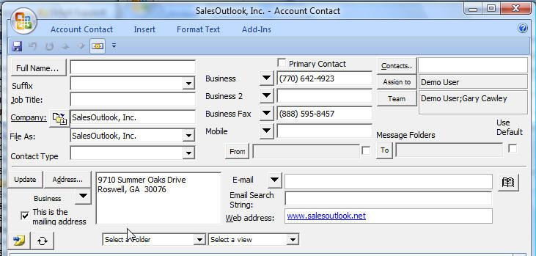

Scenario 2 - Creating an Account Contact using the Right Click menu

SalesOutlook gives you the ability to quickly add an Account Contact without having to open an Account Profile form.

- Select the Account Profiles icon form the Outlook toolbar. If you do not have an Account Profiles icon, navigate to the Account Profiles folder from within the Folder List.

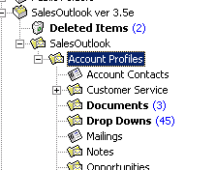

- A view of your accounts will appear on the right hand side of the screen.
- Select the Account that you quickly want to add an Account Contact to and RIGHT CLICK. A context menu similar to the one below will appear.

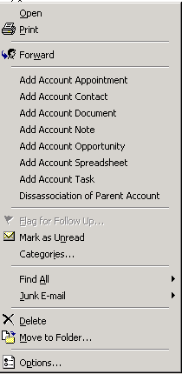

- Select “Add Account Contact” to quickly add a contact to this Account.

- The Account Contact form displays.

- Enter the Contact information and save and close the form. Once saved, you’ll be back at the Account Profiles folder. You can view the contact by opening the Account Profile or by selecting the Account Contacts folder from within the Folder List.

NOTE: Not only are you able to add Contacts quickly to an Account, but SalesOutlook also gives you the ability to quickly add Appointments, Documents, Notes, Opportunities, Spreadsheets, and Tasks to Account. If you want to quickly add these items to an Account Contact, simply right click on an Account Contact in the Account Contacts folder from within the Folder List.

Scenario 3 - Converting an existing Contact into an Account Contact

- Within Account Profiles, simply click on the “Select a Folder” dropdown and select Contacts from the list. Next, click the “Select” icon.

Click here to select from existing Contacts

- The Select Folder window is displayed. Navigate to the contacts folder and click on the OK button.

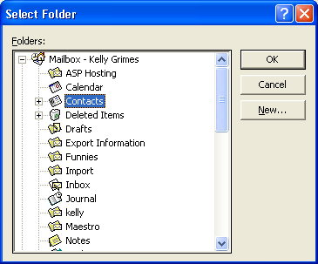

- A “List of Outlook Contacts” screen displays.
- Type in the desired Contact name in which you want to link to this Account within the search feature.
- Click to select a single contact, or you can select multiple contacts one at a time by holding down the Ctrl key. To add multiple contacts in order, hold the shift key.

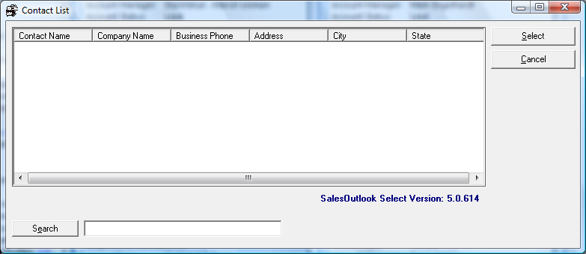

- Once you have made your selection(s), click on the Select button to add the selected contact(s) to the Account record.
- Once selected, the relationship is displayed on the Account Profile form for the selected contact.

Scenario 4 - Adding an Account Contact using the toolbar

- Click on the Add/Actions toolbar drop down and select Contacts.

- A blank Account Contact screen displays. Type in a contact name and any other information related to this contact.

NOTE: The contact address will automatically default to the company address once we associate an account with this contact.

- Next, select an existing company for this contact by clicking the Select button.

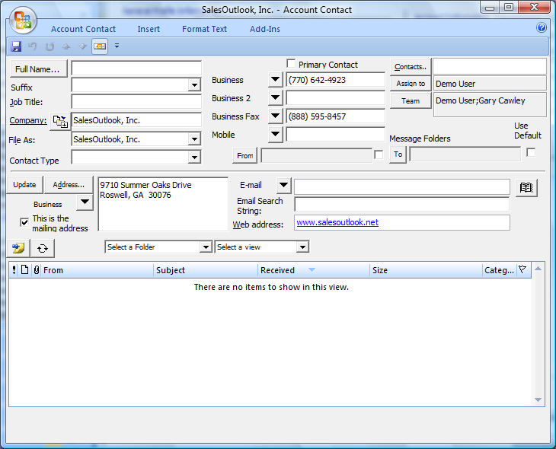
Click here to select from existing Accounts

- A “List of Outlook Accounts” screen displays. Type in the desired Account name in which you want to link to this Account Contact within the search feature. Click to highlight the Account and click the Select button to associate the account with this contact.

- A message occurs prompting you to update all sub items.

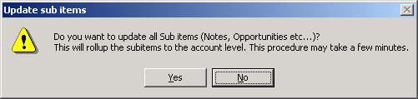

- Save and close the Account Contact form. The contact is now added within the Account Contacts folder and is linked to the Account.

Scenario 5 - Finding an Account Contact

- To find an Account Contact quickly, click on the Search | Contact Contact drop down on the Tool Bar.

Search Contact Drop Dwon

- Within the List of Outlook Contacts screen, type in the name of the Account Contact you are trying to locate within the search field and press Search.
- Click on the Account Contact.
- Once selected, click on the Select button to view the contact within the Account Contacts form.

Type Account Contact Name here

Tab & Field Descriptions

Account Contact Tab

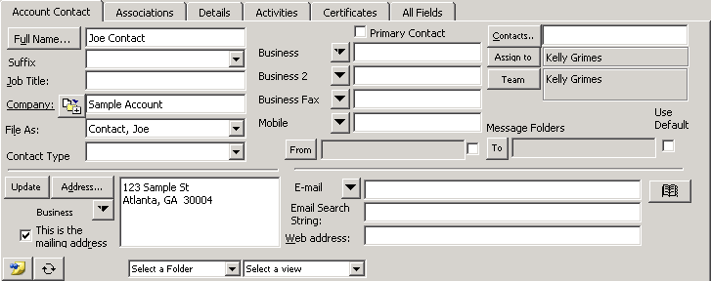

- The Account Contact tab allows you to enter information directly associated to the contact such as contact name, title, and contact type.
- You can quickly review the Account information by clicking on the Company label. Clicking the Company label will launch the account form within the contact form.
- You can click the select button to associate an existing company with a contact.
- SalesOutlook allows you to enter many different types of phone numbers. You can select from an existing list of 19 different items. To access this list, click on the down arrow next to any of the displayed phone numbers.
- The “Assign to’’ field automatically displays the owner associated with this account.
- The “Team’ field automatically displays any team members associated with this account.
- The "From" field works directly with the Messages From radio button. You can display different email messages from this contact by selecting different folders. To select a folder, click the From field and choose which folder to search. After selecting the folder, click the Messages From radio button to display any emails from this contact for the folder selected.
- The “To” field works directly with the Messages To radio button. You can display different email messages to this contact by selecting different folders. To select a folder, click the To field and choose which folder to search. After selecting the folder, click the Messages To radio button to display any emails from this contact for the folder selected.
- Email allows you to enter up to 3 different email addresses. Select the down arrow next to the email address to access this feature. You can select from your personal address book by clicking on the book icon.
- Enter an email address within the Email Search String if you’d like to search a different email address for the Messages From and Messages To fields. Often the email name may not match up to the name stamped with a contact’s email. This way, you can search messages by entering another email address.
- You can add items with the Add button and refresh the view at any time with the Refresh button.

Associations Tab

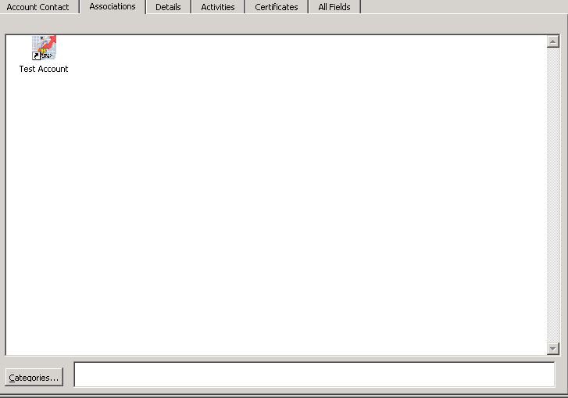

- As with Account Profiles, the Associations tab allows you to attach items such as word documents, spreadsheets, and presentations.
- Select the Associations tab, and attach any shortcuts.
- Assign any categories relating to those items by clicking on the categories button.

Details Tab

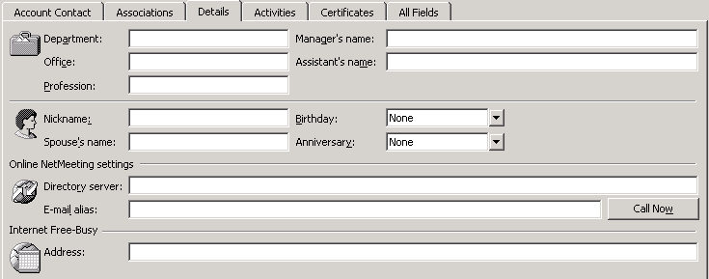

- The Details tab allows you to enter personal information concerning this contact such as birthday, nickname, and spouse’s name. You can also enter net meeting information within this screen.

Activities Tab

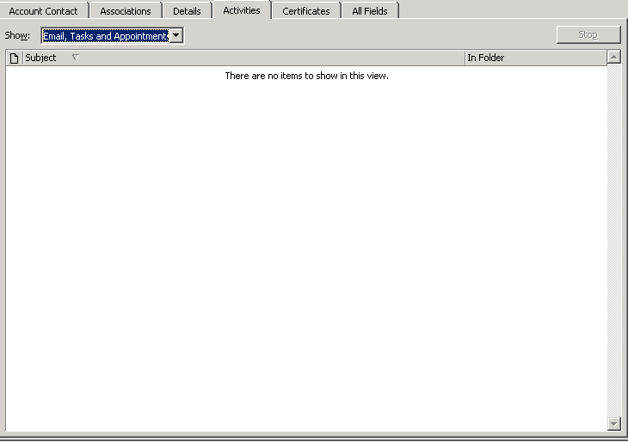

- The Activities tab will search emails, tasks, and appointments associated with the contact.

Certificates Tab

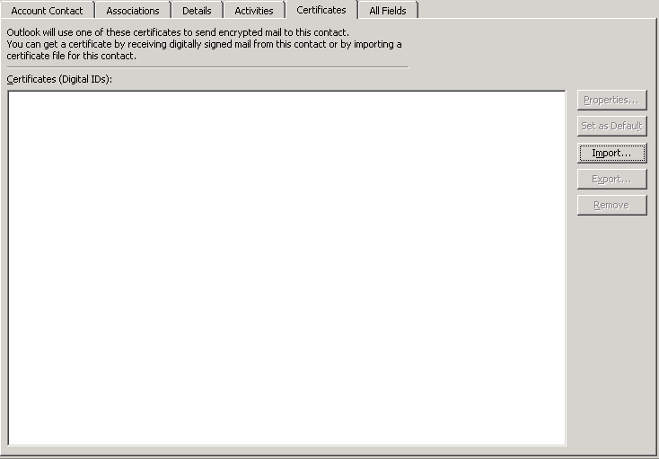

- The certificates tab allows you to send encrypted email messages to this contact. For more information concerning this feature, consult your Microsoft Outlook resources.

Mailbox / Email Integration
Messages From
Once selected, the Messages From folder dropdown will show the emails you received from this contact.

Messages To
Once selected, the Messages To folder dropdown will show emails you sent to this contact.

My Appointments
Once selected, the My Appointments folder dropdown lists your appointments and events. All Calendar items are listed to help simplify the scheduling process.

My Tasks
Once selected, the My Tasks folder dropdown lists the tasks in your private Tasks folder that relate to this Account Contact.

Working With Notes

Notes can be added at the Contact, Account, and Opportunity level. The Notes Field (textbox) will allow you to add free form notes to the Account, Contact, or Opportunity record.

Scenarios

Scenario 1 - Adding a Note

- On the lower half of the Accounts form, or on any form that offers “Notes” in the folder dropdown, click on Notes in the folder dropdown list. The resulting view is a listing of all notes linked to this account, including all notes, for all contacts, for all opportunities, for all projects, for all mailings, created by all users. The view represents the key interactions and noteworthy communications and activities for the entire relationship.

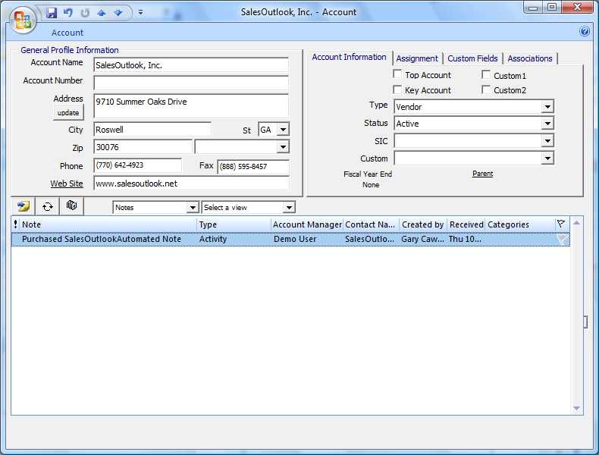

- Clicking the Add (icon) button will display the Notes form. Select the Note Type from the Drop Down. Type your Note subject in the space provided. For more extensive details, use the large text field below.
- Click the Email, Appointment or task button(s) if you wish to send the note details in an email to all members defined on the Team.
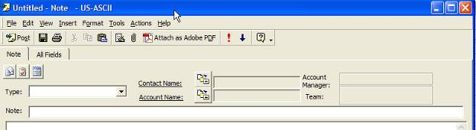
- Notes can be added directly into the Notes area as shown below. Click in the lower section to save.

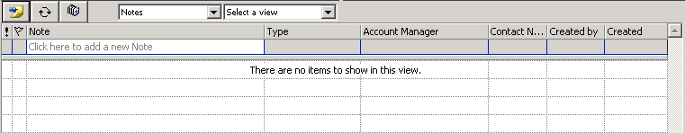
Click in this box to type your note
Click anywhere in this section to save your note.

Scenario 2 - Using Notes for Account History

The Note area will keep track of all of the interactions that you, your team, and management may have with this Account or its Contacts. Call activity defined by the Note Type keeps the entire Account Team informed on actions and progress. The Note Type is also helpful for filtering and grouping records in custom folder views or on reports.

- Notes can be kept on the opportunities or projects in the same manner as discussed previously. Click on the Notes radio button to display all Notes associated with this opportunity or project. Click Add to display the Notes form and add detailed notes.

Remember you can add notes directly into this field.
Click anywhere in this section to save your note.

- Additionally, Tasks and/or Appointments can be viewed and/or entered here. See the sections on Tasks and Appointments for further information.

Scenario 3 - Adding a Note to an Account Contact using the toolbar drop down meenu

- Click on the Add/Actions menu drop down and select Notes.

- The Note form displays.

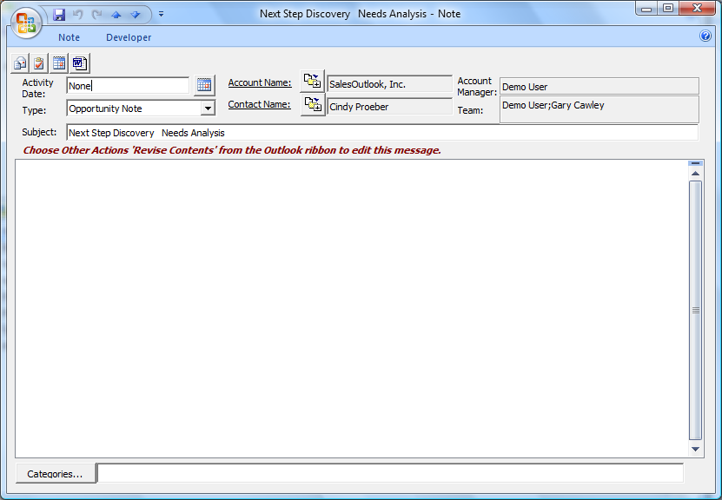

- Click the Select button next to Contact Name. A “List of Outlook Contacts” screen displays. Type in the first part of the desired Contact’s name that you want to link. Click on the contact in the result list, and then click Select.

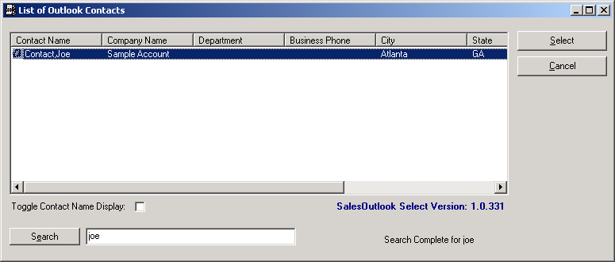

- The Note form displays with the account and contact information already populated. Add any desired note information within this Note form.

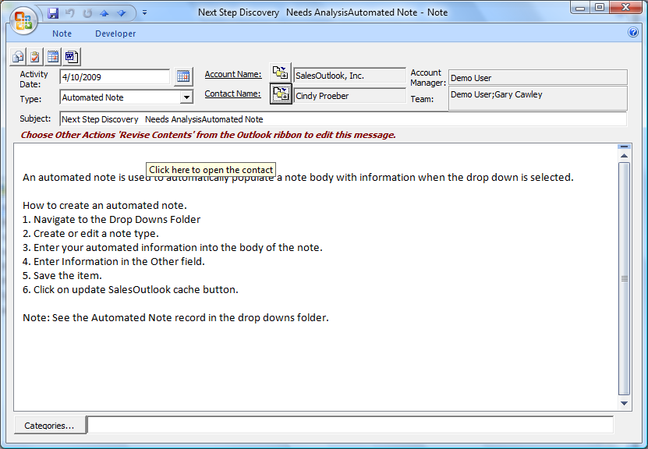

- Save and close the Note form. The note is now added within the Notes folder and is linked to the account and to the account contact.

Scenario 4 - Adding a Note for an Opportunity using the Right Click menu
- Use the Add /Action drop down to switch to the Opportunities folder.

- From within the desired Opportunity view, right click on the opportunity for which you want to add the note and select “Add Opportunity Note”.

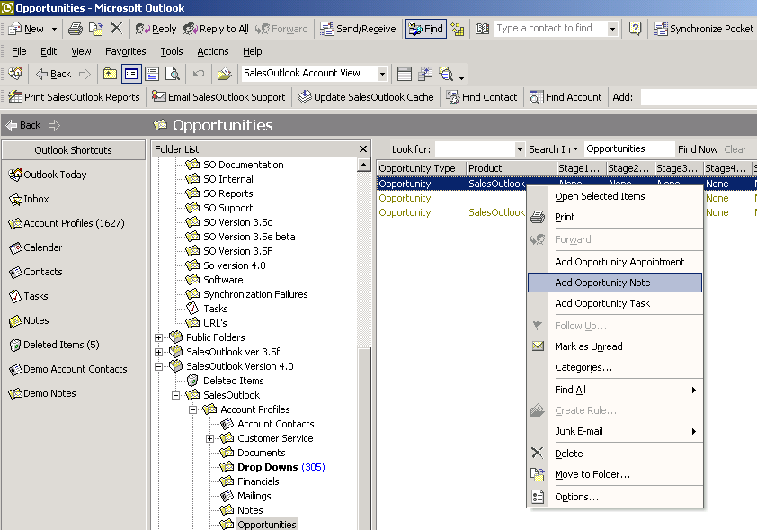

- The Note form displays with the account, contact, and note type as Opp Note. Simply add your note details and save the form. The note is associated with the opportunity.

Scenario 5 - Adding an automated note.
- Create a new note.
- Choose a drop down that is setup as an automated note.

Note: Please see the SaleOutlook Administrative guide for detailed instructions on how to create an automated note.

Scenario 6 – Creating an email, task or appointment from a note.

- Click on the button that cooresponds to the item you would like to create.
- A new item will be created with the data from the note copied to the created item.

Working With Documents and Spreadsheets

SalesOutlook allows you to create and manage you company’s documents and spreadsheets. You system administrator can place shared documents within the SalesOutlook folder that become available through the Documents and Spreadsheets folders. For more information concerning sharing documents, seek the SalesOutlook 3.5 Administrator Guide. Once you’re Administrator has shared documents and spreadsheets, you can associate these documents or spreadsheets to an Account or Contact. You also have the ability to link to documents that are not shared. However, these documents create a shortcut that is only available for that user who created the document unless other users are connected directly to the network.

Scenarios

Scenario 1 – Linking or attaching a document

- Within the Account Profiles form, click on the “Select a Folder” dropdown and select Documents from the list. Next, click the “Add a New Item” icon to display a blank Document form.

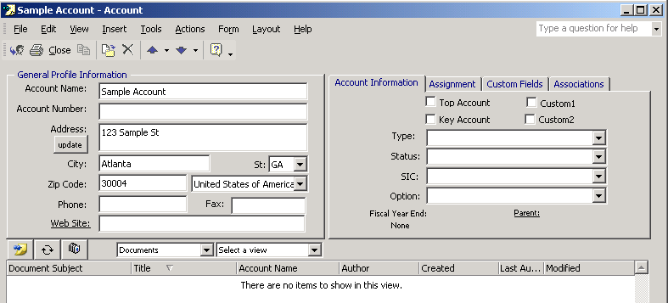
Click to add a document

- The document form displays.

- Select a Document type from the dropdown list. You may also type a subject pertaining to this document/spreadsheet into the Subject field.
- If you prefer to link an existing document or file, click the Link Document button. Browse your files to the section to create a shortcut for this item. Once the item is linked, you can click the Open Document button to open that item for review.
- Attachments are created by clicking in the large white space and then selecting Insert / File from the toolbar. Navigate to the document or spreadsheet to attach to this Account.

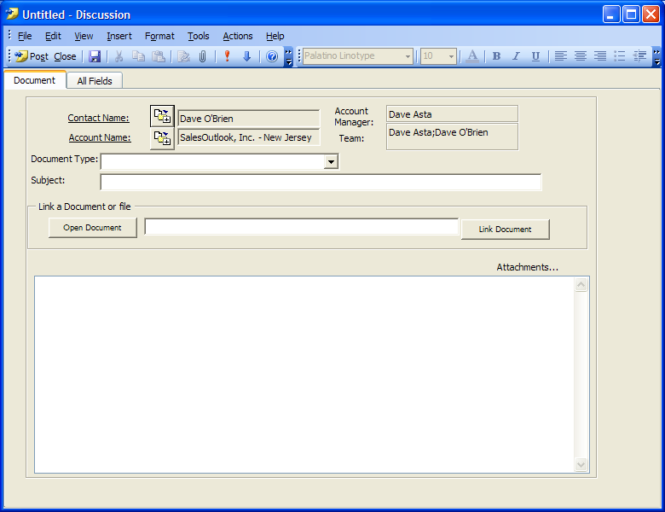

Scenario 2 – using a pre-defined Word template

- To associate a Word Document , choose the Documents – Word drop down. 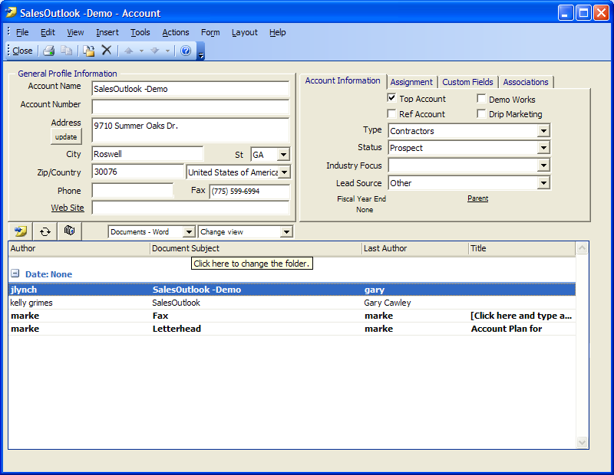
- A list of Word templates will come up. Select the Word template you want to use. In this example we’ve selected the Contemporary Fax document. Note: See the SalesOutlook administrator manual on how to create Word Templates for use in SalseOutlook.

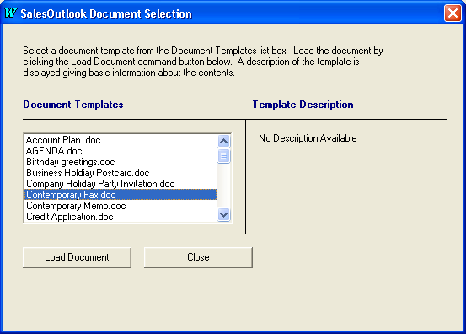

- The document will display on the screen. At this time you can customize the document to suit your needs for the Account if necessary.

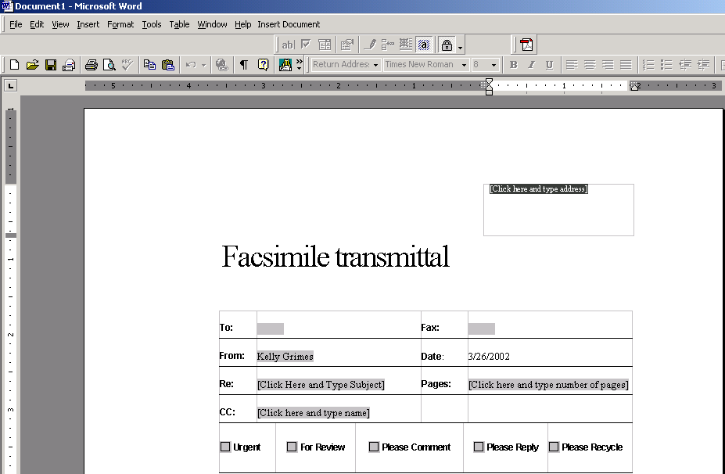

- Exit out of the document by closing Microsoft Word. When prompted to save changes, select Yes to save.

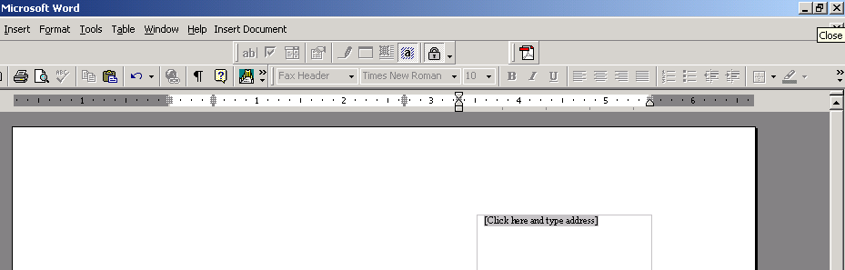
Click upper right hand corner X to close Word

- The document information appears in the view below.

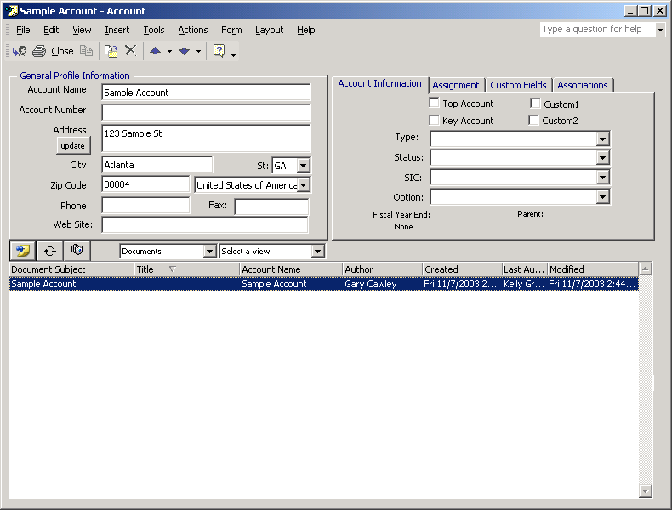

NOTE: Documents that are added to Contacts are performed the same way. However, instead of adding through the Accounts screen, you’ll open up an Account Contact record to add documents to a contact.

- To associate an Excel Template, choose Documents - Excel and select the Spreadsheet to associate to this Account from the Spreadsheet templates provided. In this example we’ve selected the Quote Sheet.

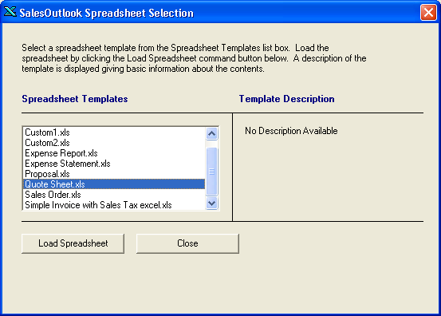

- The document will display on the screen. At this time you can customize the Spreadsheet to suit your needs for the Account if necessary.

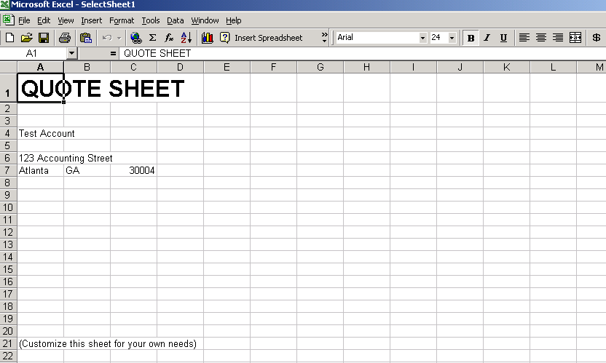

- Exit out of the template by closing Microsoft Excel. When prompted to save changes, select Yes to save.

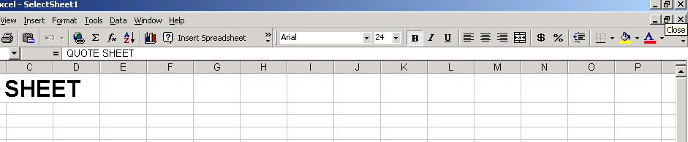
Click upper right hand corner X to close Excel

- The spreadsheet information appears in the view below.

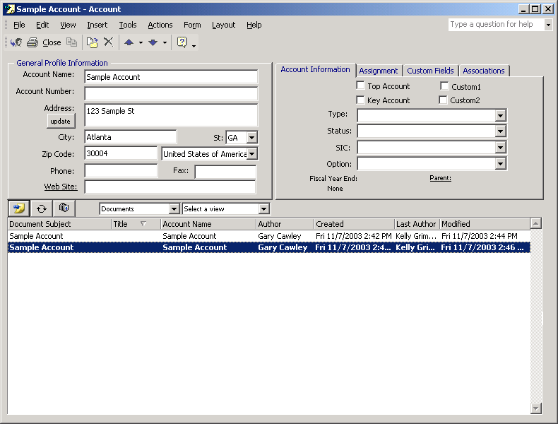

Working With Tasks

Tasks can be created at the Account, Contact, Customer Service, and Opportunity/Project levels. Once a Task is created, it can be reassigned to another user if desired. When assigning a Task to a colleague, the individual assigning the Task may optionally have status updates automatically emailed whenever the Task is updated by its new Owner. Incorporating this feature into your business process and best practices helps to keep action items – whether trivial or important – from falling through the cracks.

Scenarios

Scenario 1 - Creating Tasks

- Click on the “Select a Folder” dropdown and select My Tasks from the list. Next, click the “Add a New Item” icon to display a blank Task form.

Click to create a task

- The task form displays.

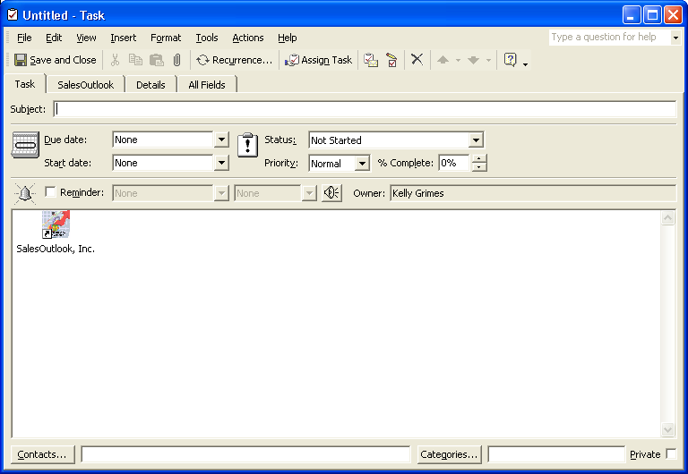

Scenario 2 - Assigning / Reassigning a Task
In the example below a Task relating to a particular service request (Customer Service Inquiry) is reassigned to another member of the team.

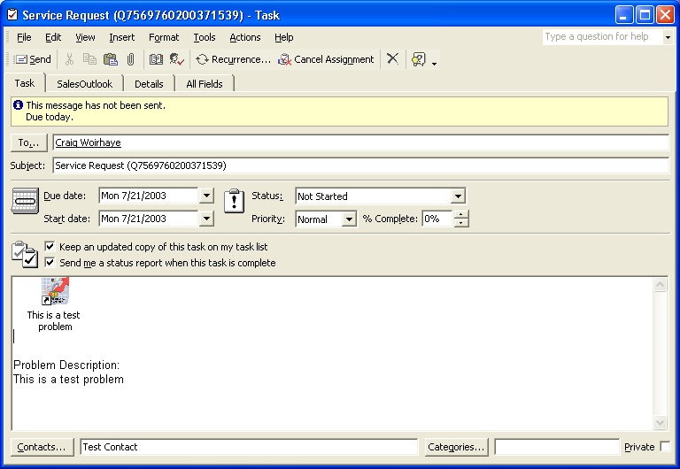
Adjust Due Date, Start Date, and Status when appropriate.
Select the person to assign the task to here
Person receiving the task can double click on the icon to open the ticket.
Note the problem description caries over from the Customer Service ticket

- Click on Assign To in order to reassign this inquiry to someone else. Click OK.

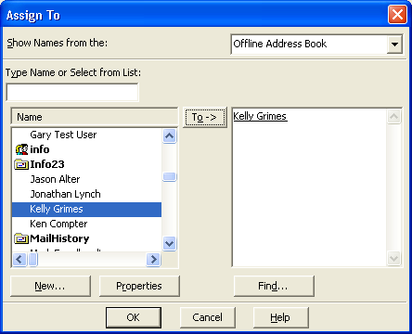

- The task is now assigned to the user you selected.
- Click Search to search an existing customer service item without retyping the information.

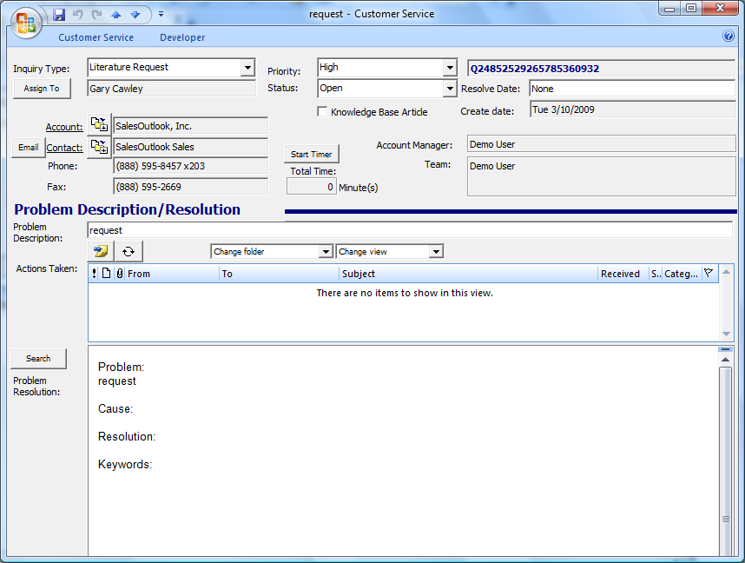

NOTE: A SalesOutlook tab is provided with hot links for the Account, Contact, Opportunity, and Inquiry ID. Click the label for one of these items (if the field is populated with data) to open up the related form directly from the Task form.

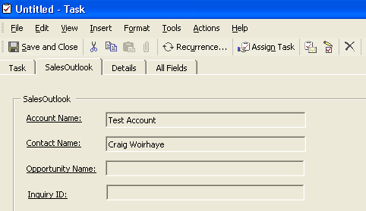

Working With Appointments

Appointments allow you to enter and maintain appointments for Accounts, Contacts, and Opportunities. Many options are available when creating appointments. For example, you can create an appointment to be reccurring so that it repeats according to the criteria you specify. You can also set a reminder when creating an appointment. A reminder is like a built-in alarm clock that goes off to “remind” you about that particular item at the date and time you specify.

Scenarios

Scenario 1 - Adding a new Appointment

To add an Appointment:

- Click on the “Select a Folder” dropdown and select My Appts from the list. Next, click the “Add a New Item” icon to display a blank Appointment form.

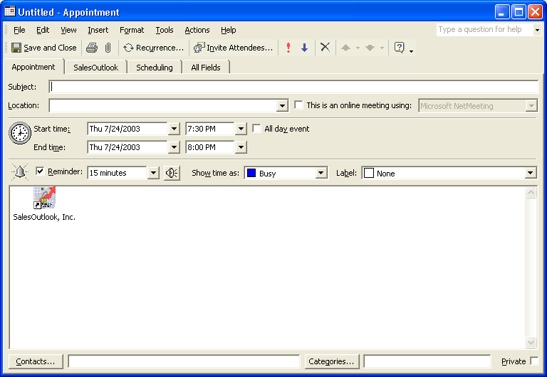
Links to your Account automatically

- The scheduling tab will enable you to invite attendees to your meeting or event.

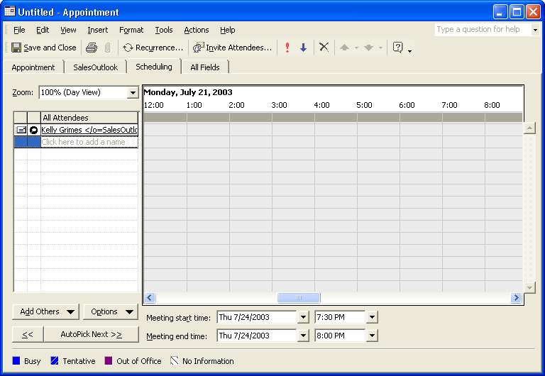

- Click on the button to post the Appointment to your Calendar.

NOTE: A SalesOutlook tab is provided with hot links for the Account, Contact, and Opportunity. Click the underlined label for one of these items (if the field is populated with data) to open up the related form directly from the Appointment form.

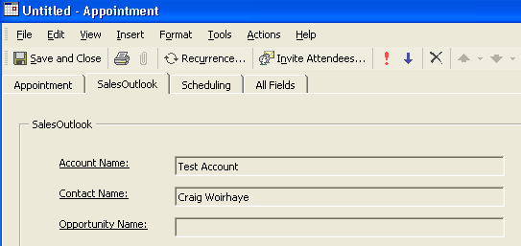

Creating Checklists (Optional with Small Business Edition)
Checklists are a way to create customized processes.

How to create a checklist.
- Navigate to the Drop Downs Folder.
- Create or Change an existing drop down.
- The RecordType is Checklist.
- Enter the name of the checklist.
- Enter the Checklist information in the body.
- Click Update SalesOutlook cache
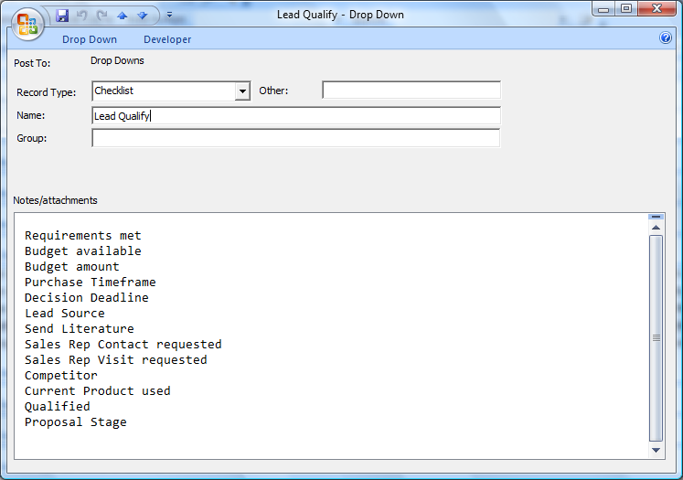

Working With Checklists (Optional with Small Business Edition)
- Open a form such as the opportunity form
- Select the Checklists drop down.
- Click on the post button to create a new checklist.
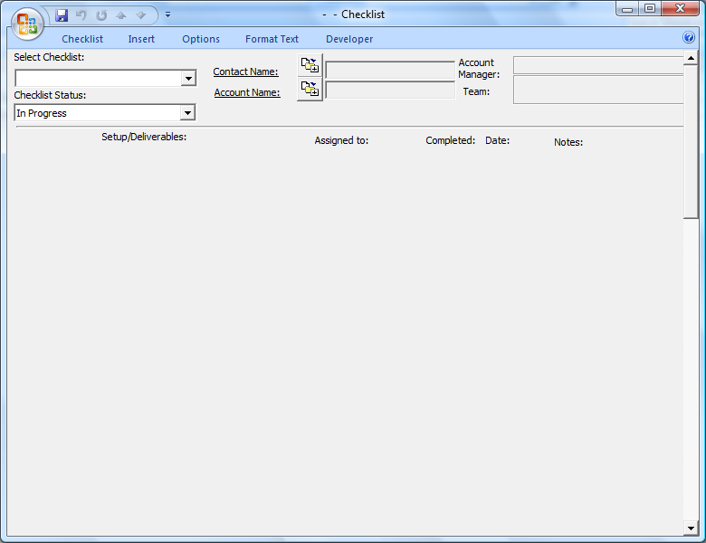
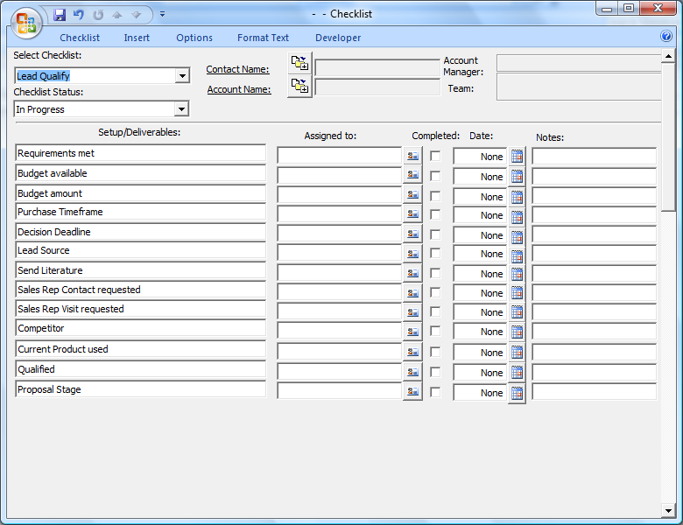

Working With Leads (Optional with Small Business Edition)
Note: The main SalesOutlook database is designed to be a customer and prospect database. The Leads folder is used track unqualified leads. Import Leads using the Import Outlook contacts form or create a new lead from the menu..
- Navigate to the Leads folder.
- Create a new lead and enter the lead source and Checklist to use to qualify this lead.
- Move the lead to the main database when the lead is qualified.
- Move to the Dead Leads fodler if the lead is not qualified.
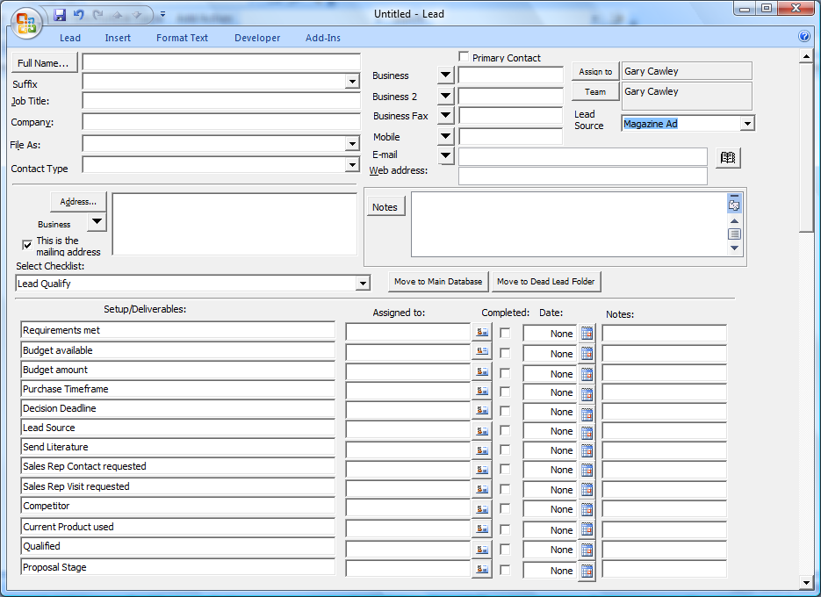
Managing Your Daily Activities

Once appointments and tasks are created, you can view all these activities in one general area.

Scenarios

Scenario 1 - Viewing your Activities (Tasks & Appointments)

- From the Outlook Bar or your Folders List, select the Tasks folder. You can see all of your tasks listed in the workspace to the right.

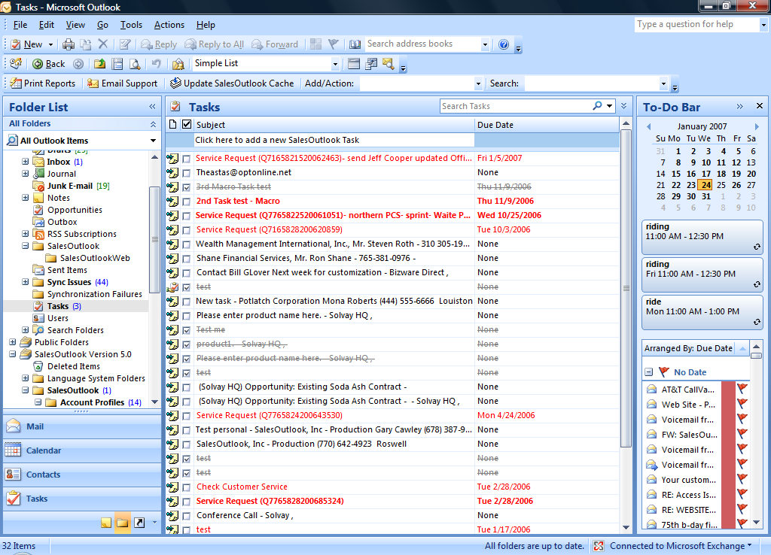

NOTE: You can also select the Calendar from the Folders list or the Outlook bar and view your activities from within the Calendar. 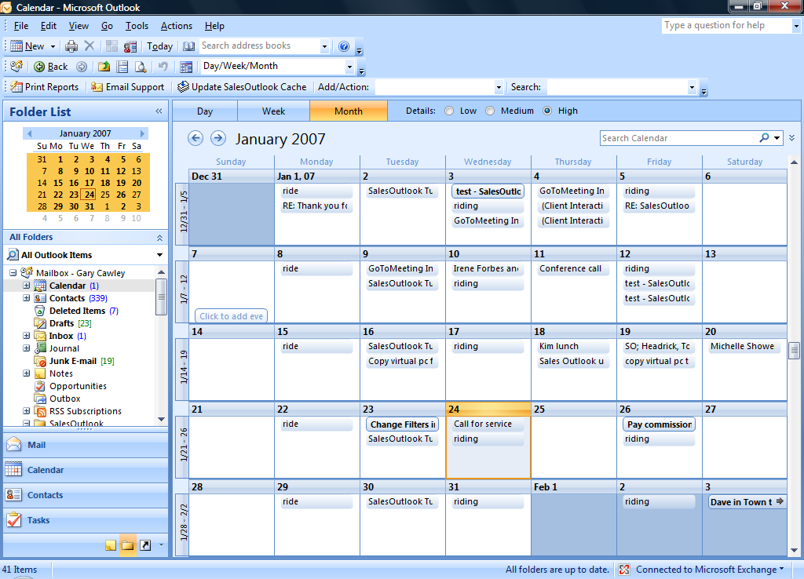
You may change the Calendar View by clicking on the Work Week, Week or Month icon located on the main toolbar

NOTE: You can add Tasks and Appointments from the Calendar area, however they will need to be manually linked to your contacts and Accounts. It is easier to add directly from the Account Profile, Account Contact, Opportunity or Customer Service Inquiry forms as previously demonstrated.

NOTE: If you want to add an activity while viewing your Calendar or Tasks folders, you will need to go to the Menu of the Appointment or Task folder and choose “Actions New SalesOutlook Appointment” or “New SalesOutlook Task”. After the form displays you may then select the appropriate Account Contact and/or Account Profile to link to the activity.

Working with Linked Items (Optional with Small Business Edition)

The Linked Items feature of SalesOutlook enables you to link multiple Accounts and/or Account Contacts to any SalesOutlook Account or Account Contact. This is helpful when tracking multiple relationships between multiple contacts from different organizations is important such as tracking multiple competitors, sub contractors or consultants who are involved with a particular Account or Account Contact. Complete the steps below to link an Account or an Account Contact to a given SalesOutlook Account Profile item. This example shows how to link one SalesOutlook Account to another SalesOutlook Account using the Linked Accounts feature.

- Open an Account profile and select Linked Accounts from the drop downs. 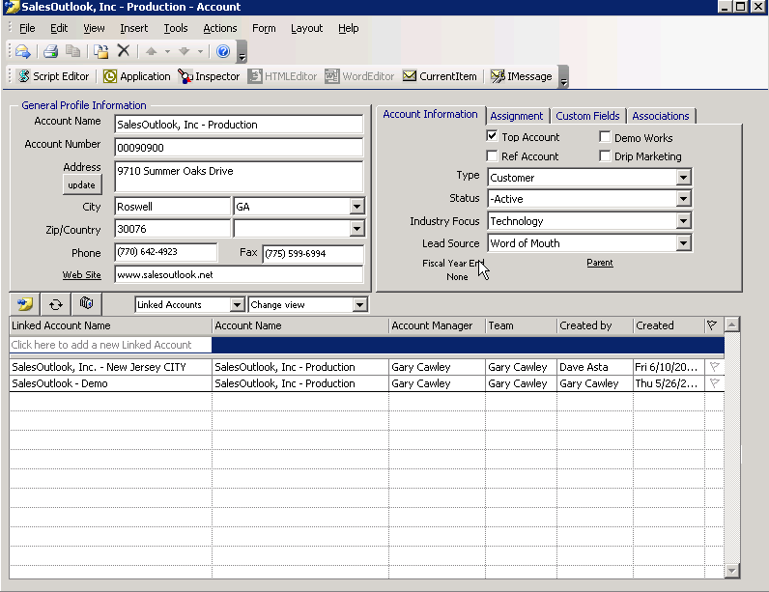

- Click on the Add new button to create a new link. 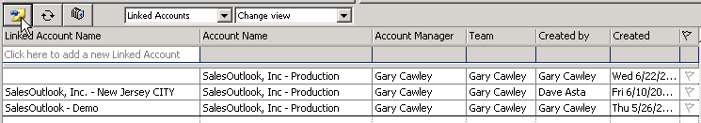
- Enter a search and select the Account to Link. 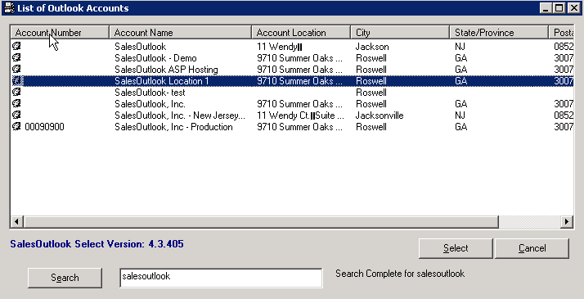

- After the Account is selected you will see the linked account in the list. 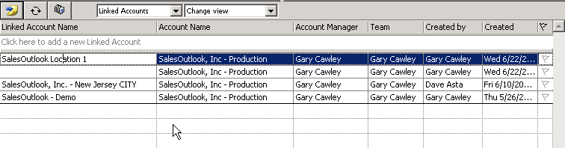
- Double click to open the linked account. 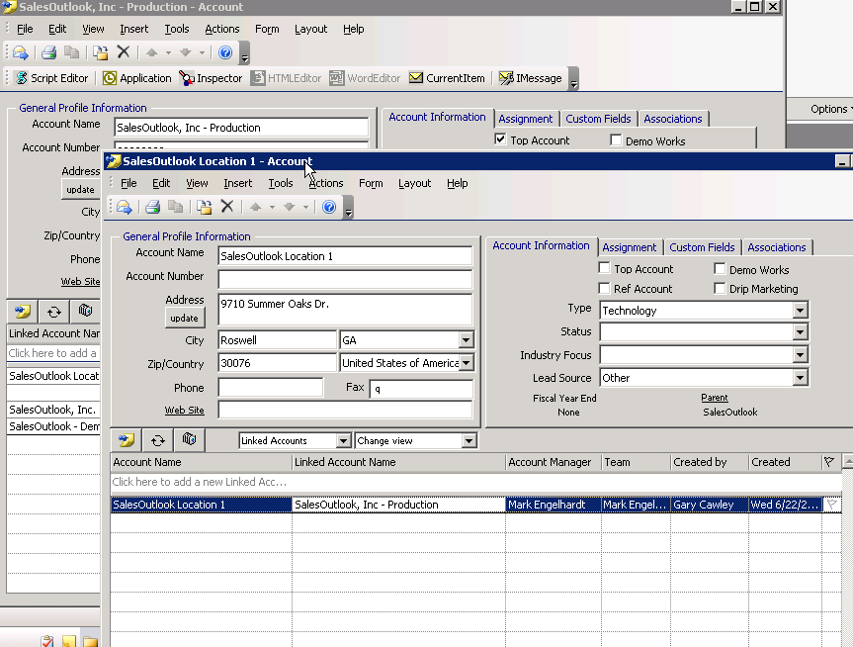

Associating Free-Form Information

The Associations tab enables you to add additional information to your Account, Contact, Opportunity, or other SalesOutlook item. You may add links to contacts and attach various files, including Word documents, PowerPoint files, Excel spreadsheets, CAD drawings, or any other file or Outlook item. Once linked or attached the file or item can be accessed quickly by double-clicking on its icon to open it.

- Within the Account Profiles form, click on the Associations tab. The tab displays a free for all blank page (form below shows actual associations) where you have the ability to add any additional information on the Account.

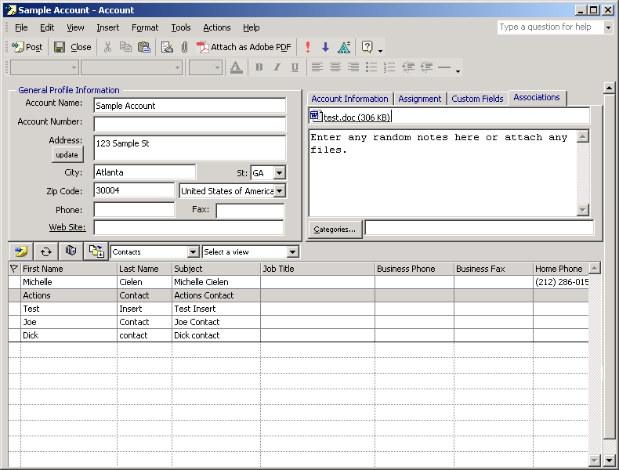

NOTES:
Shortcut - To quickly access files from the Associations tab, you may Insert the file as a shortcut. The shortcut appears as an icon with a small arrow in its lower-left corner. A shortcut keeps the document local to your machine.
Attachment - creates a copy of your document and sends it to the main server, allowing others to share the information.

Inserting / Attaching a File

- From the Menu, Select Insert. You will notice that you can attach a File, Item or Object.

- To add a file (Excel Spreadsheet, PowerPoint, Word Document etc.), from the Outlook Menu, Select Insert and from the list choose File
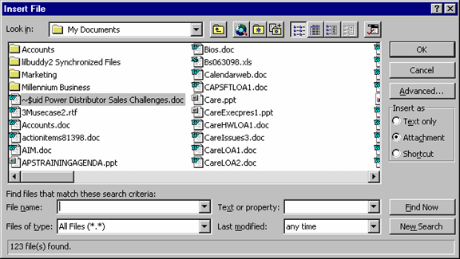
Please use shortcut option unless you want to share the information with the rest of your team.

- Click on the file you want to link or attach to highlight it, and then click the OK button.

Associating an Outlook Item with a SalesOutlook Item

NOTE: Associating another Account is shown in this example, but following the same procedure enables you to associate any Outlook or SalesOutlook item.

If you would like to associate another Account or buying entity to this Account:

- From the menu click on Insert select, Item from the list

- Under the Look in section, click on the + sign next to the Public Folders section

- Then Click on the + sign next to Favorites

- Click on the + sign next to the folders until you see the Account Profiles folder

- Click on the Account Profiles folder

- Double click on one of the listed Accounts in the Items List section located on the bottom half of the form.
Allows you to view all of your folders

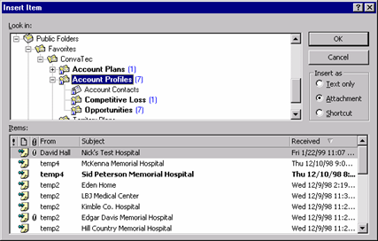
NOTE: Clicking on the + sign in front of any folder allows you to drill down into sub-folders.
Once you select the desired folder above, this section displays the associated items in a list

Converting Email into Notes

The Create SalesOutlook Note button gives you the ability to turn any email message into a Note that is related to the Account(s) or Account Contact(s) you select. A search feature makes it easy for you to locate the individual or account where the note should be created. The text is entered into the Note for text-based searching and attachments are also added as applicable.

- Before sending your composed email, click the Create SalesOutlook Note button located on the toolbar from within the message form.
Outlook 2000-2003
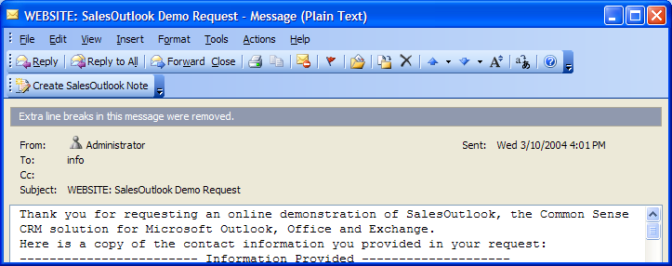

Outlook 2007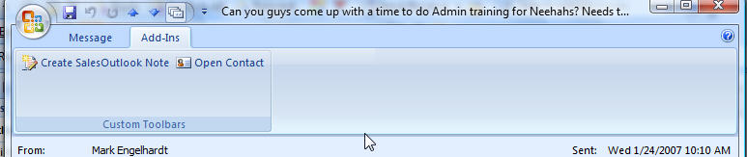

- The SalesOutlook Create Note screen displays. All email addresses and recipients are automatically displayed as items within the list. If the Contact or Account Name is incorrect, you can use the search feature to locate the proper Contact or Account Name.

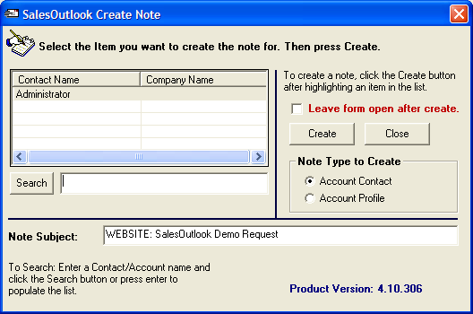

- Once the Account or Contact Name is located, highlight the desired item within the list and verify the Note Type to Create is set to either Account Contact or Account Profile depending on the type of note you want to create. Click the OK button to create the note.

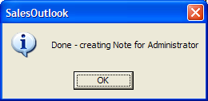

- The SalesOutlook Create Note will remain open for you (if you select the Leave Open after create) to create another note for a different Account or Contact. If another note is not necessary, click in the “X” in the upper right corner to close out the window.
- You can change the note subject by typing into the Note Subject line.

- The Note is now linked to the Account/Contact.

Using the SalesOutlook Quick View

The SalesOutlook Quick View feature enables SalesOutlook users to quickly locate information relating to the sender of an email message.

If the sender is recognized as an Account Contact in SalesOutlook, the Quick View feature enables you to open the Account Contact, the Account Profile the contact belongs to, or to view items related to the Account Contact. If the sender is not recognized as a SalesOutlook Account Contact, the Quick View will enable you to create the Account Contact and link it to an existing Account Profile or create a new Account Profile on the fly.

Scenario 1: Display Sender information using the Quick View

- Select any email message in your Inbox so that it is highlighted. Then, right-click the message and select “SalesOutlook Quick View” from the context menu.

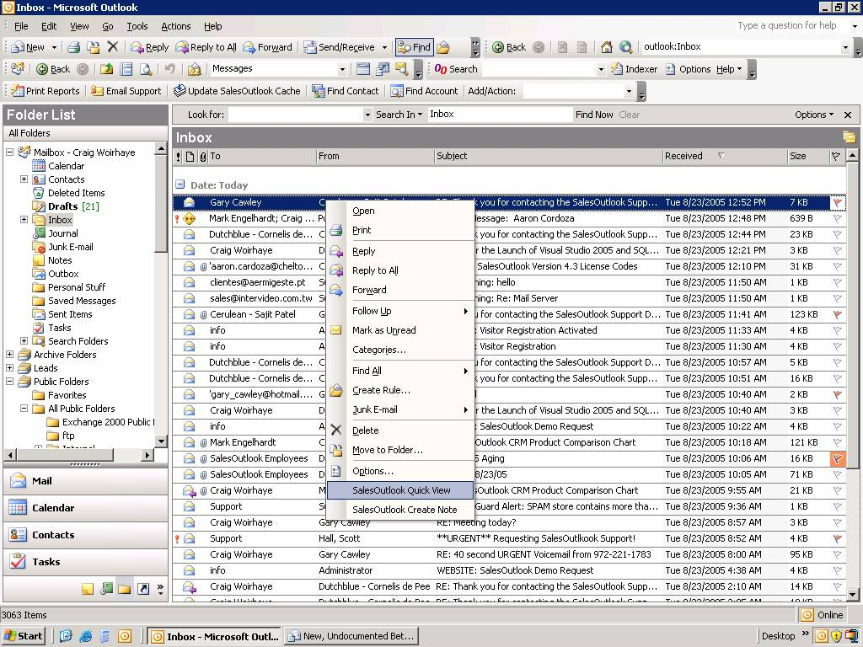

- The Quick View window will appear and will display the sender’s contact information and a drop down to select the key SalesOutlook items that are related to that Account Contact item provided that the sender exists as an Account Contact. If the sender is not recognized as an Account Contact, a prompt appears and provides the ability to create the Account Contact record for that sender (and a new Account if you do not elect to search for an Account Profile).

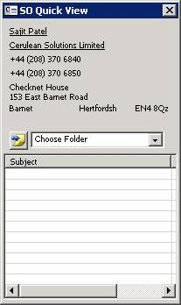

- Clicking the underlined labels on the top half of the Quick View form opens the corresponding Account Profile or Account Contact record.

- Selecting an option in the Choose Folder drop down shows related items of that type, and clicking the new item button (post-it note icon) creates a new related item of that type.

Scenario 2: Create an Opportunity Note or a Customer Service Action
The Quick View makes it very easy to create a Note that is linked to the Account, Contact and Opportunity – or to create a Customer Service Action that is linked to the Account, Contact and Customer Service Inquiry – by just dragging and dropping any email message onto the Opportunity item or the Customer Service item that is displayed in the lower half of the Quick View window.

To file an email message as a Customer Service Action or as an Opportunity Note, complete the following steps:

- Show the quick view window for an Account Contact that has related Opportunities or Customer Service Inquiries.

- Select Opportunities or Customer Service in the Quick View Drop Down.

- Click on an email message in your Inbox or in your Sent Items folder. Drag the email message onto an Opportunity item or Customer Service item in the lower half of the Quick View window. This will create a Note linked to the Account, Account Contact and Opportunity or if a Customer Service Inquiry it creates an Action on that Inquiry. The resulting Note is linked to the Account Profile and/or the Account Contact that the Opportunity or Customer Service Inquiry item is already linked to.

- Double-click the item in the Quick View window that you just dropped the email message onto in order to open the Opportunity or Customer Service item.

- Select either Notes or Actions to view the results. You should see the email message listed under that Opportunity and/or Customer Service Inquiry in addition to under the Account and/or Account Contact records.

Tip: Using the Quick View feature, SalesOutlook users can quickly convert emails into Opportunity Notes or Customer Service Actions that are properly linked to the Contact and the Account in one simple drag-n-drop operation.

Scenario 3: Create / Open SalesOutlook items related to the Sender of an Email Message

To Add or Update information in SalesOutlook that is related to the Sender of an Email Message:
- Right-click the email message and select the SalesOutlook Quick View option from the popup context menu to display the Quick View window.

- When the Quick View window appears it will be populated with the information stored in SalesOutlook related to the Sender of the email message. If the Sender is not recognized as a SalesOutlook Account Contact you will be given the opportunity to have the SalesOutlook Quick View create a new Account Contact record for this individual’s name and email address.

- Select the appropriate option in the Choose Folder drop down to view items of that type or to create a new item of that type.

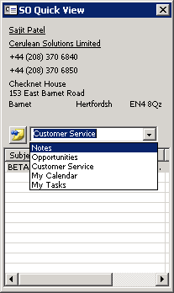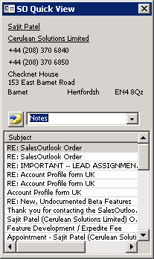

- To open an existing item to make changes, just double-click on the item in the result list shown in the lower half of the Quick View window. To create a new item of that type, click the yellow Post-It Note icon to the left of the Choose Folder drop down.

Working With Automatically Filed Email Notes

Emails can be automatically filed into your notes folder if the from address of the received email or the recipients of a sent email matches the email address of a contacts in your SalesOutlook database.

How to setup Auto Filed Email messages.

- In Outlook choose Tools | Options and click on the SalesOutlook folder settings tab.
- Check the Automatically file inbound emails and/or Automatically file sent emails. 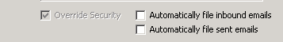

How to tell which emails were automatically filed.

- Open Outlook and navigate to your inbox.
- The completed flag will be checked if the email was automatically filed. 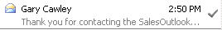
- The email message will also have a header that says “SO Auto Filed”
- The note type for received emails is “Email (Received)” and for sent emails it is “Email (Sent)”

Working With Contact Synchronization

Contact Synchronization allows your PDA to synchronize SalesOutlook Contacts to your personal contacts folder.

How to setup Contact Synchronization.

- In Outlook choose Tools | Options and click on the SalesOutlook folder settings tab.
- Check the Synchronize My Account Contacts to Personal Contacts. 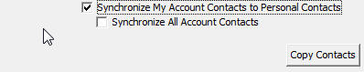
- If you already have contacts in SalesOutlook then click the Copy Contacts button. NOTE: Contact Synchronization starts when you select the Synchronize contacts checkbox. Existing Contacts will not be copied unless you edit them. You can do a one time copy of your contacts to get the synchronization working. 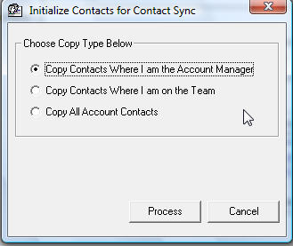

Working With Mailings (Optional with Small Business Edition)

As part of our interaction with Contacts, direct mail is often used as a marketing campaign, or to notify customers of product or pricing changes. SalesOutlook gives you the ability to maintain opt-in / opt-out mailing lists, track responses to mailings and to maintain a history of the mailings sent to your Contacts.

Scenarios

Scenario 1 - Adding an Account Contact to a Mailing list

- Within the Account Contact form, click on the “Select a Folder” dropdown and select Mailings from the list.
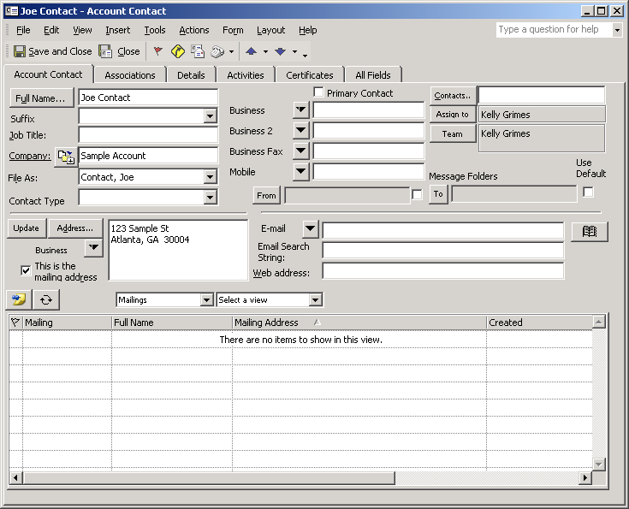
Click the add button to associate a mailing with this contact
- Next, click the “Add a New Item” icon to display a blank Contact Mailings form.
- Once the Add button is selected, the Contact Mailing form appears.

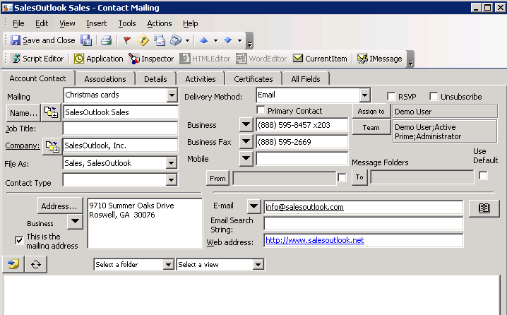

- Select a mailing from the mailing drop down. Also specify the method of delivery.

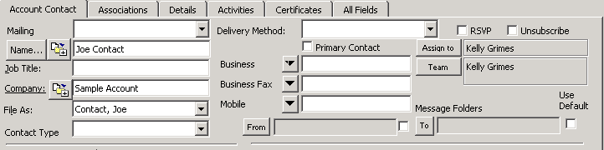

- The mailing is now associated with the contact. For information regarding creating mail merge documents, see the Mail Merge Overview discussed later in this guide.

Create a bulk Mailing

You can create a mailing for a group of users by using the “Create Mailing” Form.

- Navigate to the Account Contacts folder.
- Highlight the contacts you want to create the mass mailing for.
- Select the Outlook menu Actions| New Create Mailings.
- Select the mailing you want and the delivery method.
- Click on Create Mailings.
Note: SBE users must select the contact to send an email to.

Create an Email Blast

The SalesOutlook Email Blast form is used to send an email blast to a group of contacts or mailing. Email blasts can be preconfigured or created on the fly.

Creating a pre-configured Email Blast.

- Navigate to the Drop downs folder.
- Create a new drop down and give it a record type of “Email Blast”.
- Make sure the format of the email is the format that you want to send the Email blast. IE format (plain text, Rich Text or HTML).
- Enter the subject line in the name field.
- Create your email blast in an editor such as Microsoft Word.
- Cut and paste the email from Word into the Body section of the Drop Down.
- Save the drop down.
- Click on Update SalesOutlook cache.
- Click on “Update SalesOutlook cache”.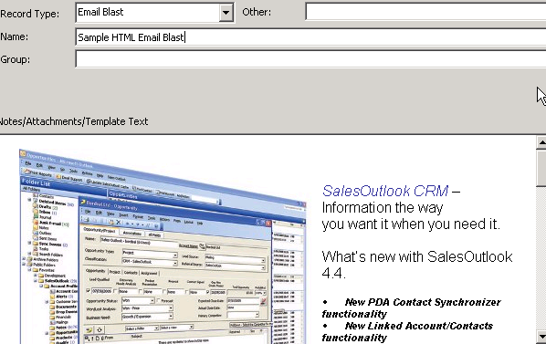

Creating the Email Blast for the Account Contacts folder.
- Navigate to the Account Contacts folder or the Mailings folder.
- Highlight the records you want to send an email blast to.
- Click on the Outlook menu Actions | New Email Blast.
- Select the Email blast template you just created or create an Ad Hoc Email Blast.
- Click on Create Mailings.

Creating the Email Blast for the Mailings folder. (optional for SBE)
- Navigate to the Account Contacts folder or the Mailings folder.
- Click on the Outlook menu Actions | New Email Blast
- Select the Email blast template you just created or create an Ad Hoc Email Blast.
- Select the Mailing to send the email blast to.
- Click on Create Mailings.

Working With Customer Service Inquiries (Optional with Small Business Edition)

Customer Service allows you to log service Inquiries. Service Inquiries normally contain a problem, a cause and a resolution. Inquiries also enable you to assign actions and tasks to another individual, such as a manager or colleague. Customer Service relates all Inquiries to an Account Profile, and normally to an Account Contact as well.

Scenarios

Scenario 1 - Adding a Customer Service Inquiry from an Account form

- Within the Account Profiles form, click on the “Select a Folder” dropdown and select Customer Service from the list. Next, click the “Add a New Item” icon to display a blank Customer Service form.

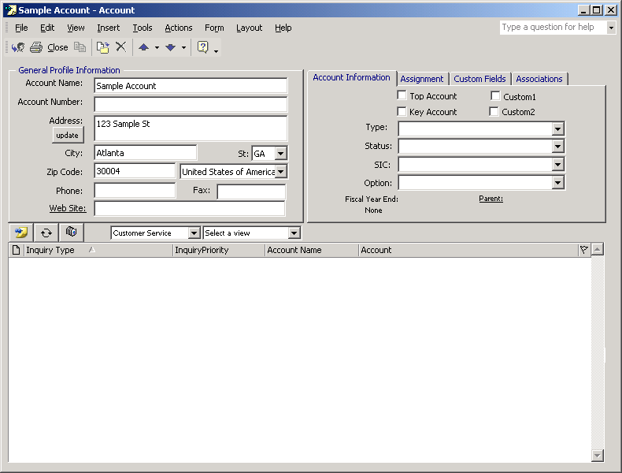
View all Customer Service tickets related to this Contact here
Click the Add button to open a new Customer Service ticket

- The Customer Service form displays with the account information already populated. Add any of the desired inquiry information within the form. Save the form by clicking Post or File/ Save.

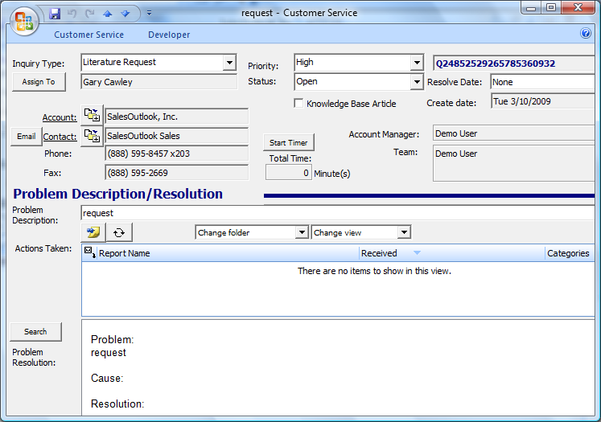

NOTE: You can also add a customer service inquiry by right clicking on an Account or Account Contact from within a view and choosing Add Customer Inquiry. If you later wish to associate an Account Contact with a Customer Service Inquiry, open the Inquiry and click the “Select Contact” button near the Contact quick link label.

Scenario 2 - Adding a Customer Service Inquiry using the Toolbar Drop Down menu

- Click on the Add/Action toolbar drop down and select Customer Service.

- The Customer Service form displays.

- Click the Select button next to Contact. A “List of Outlook Contacts” screen displays.

- Type the desired Contact name in which you want to link to this Customer Inquiry within the search field and click the Search button do display a list of matching Account Contacts.
- Click on the Contact and then click Select to link the Customer Inquiry to the contact.

- The Customer Service form displays with the account and contact information already populated. Add any desired customer service information for this inquiry.

- Save and close the Customer Service form. The inquiry is now added within the Customer Service folder and is linked to the account and contact.
- Use the Search button to search for an existing customer service inquiry and import thr resolution into this inquiry.

Customer Service Inquiry Field Descriptions

Inquiry Type
Select an Inquiry Type using the Drop Down

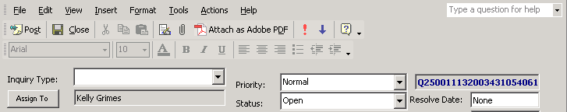

- Use the Inquiry Type drop down to categorize the type of inquiry. This field allows you to track the types of issues within the customer database as well as the amount of same issues occurring over time. It can aid in the development of automated resolutions.

Assign To

- Click on the “Assign To” to assign an inquiry to another service rep.
- Once a new rep is assign, an email is sent to that rep notifying him/her that he/she is now the owner of the Customer Service Inquiry.

Add Action

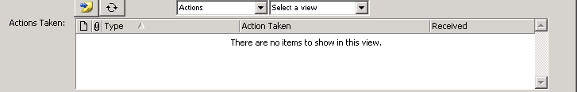
Click to add an Action and steps taken

- Click on Actions from the dropdown folder list and click the Add icon to open the Action form. Once the action for is open, you can assign an action type, and provide details concerning that action.

Create Task

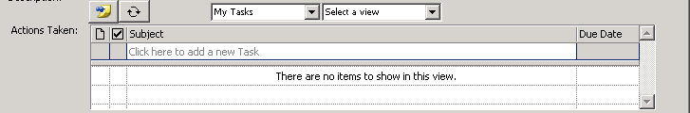
Click to create and assign a task

- Click on My Tasks from the dropdown folder list and click the Add icon to open the Action form. When the task is sent, it’s displayed in Actions Taken. For more information regarding Task, see the Task Overview section.

Knowledge Base Article

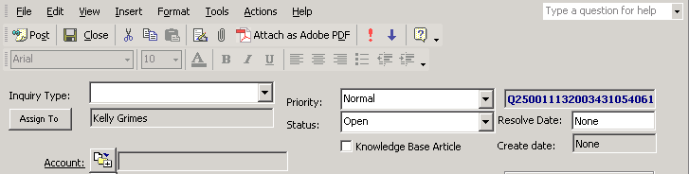

- Selecting the checkbox for the Knowledge Base Article will flag this inquiry as a knowledge base article. Once in the knowledge base, you can search by resolution or problem description.

Start Timer

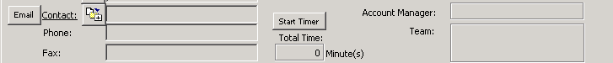

- Click Start Timer to begin timing the inquiry. SalesOutlook will automatically keep track of the time logged to the closest minute. Once the inquiry is saved, the timer will stop. If you reopen the inquiry, you’ll need to click the start timer again to have the timer add to the existing time.

Email (button)

- The email button will launch a predefined email with details concerning the Inquiry and its current status to the Account Contact. Details concerning the inquiry include items such as Inquiry ID, Inquiry Status, Service Rep, Problem Discription and Inquiry Type.

Working With Opportunities

Tracking opportunities and the milestones associated with projects is performed using the Opportunities/Projects form. Opportunities and/or projects can be added at the Account level and/or the Contact level. Even if added at the Contact level, all Opportunities linked to an Account appear in the related items view when accessed through the Account form.

NOTE: The standard Opportunity form that ships with SalesOutlook enables sales opportunities to be managed at high levels and is intended to track the sales process relating to a single product or product interest. For more complex requirements, such as the need to track multiple product interests relating to a single sales opportunity or to automatically enforce volume-level discount policies, the optional Advanced Sales Module may better serve your needs. Please refer to the SO4X_Advanced_Sales documents provided in the SalesOutlook documentation set for product information and details relating to this optional extension to SalesOutlook.

Scenarios

Scenario 1 - Adding an Opportunity and/or Project to an Account

- Within the Account Profiles form, click on the “Select a Folder” dropdown and select Opportunities from the list. Next, click the “Add a New Item” icon to display a blank Opportunity form.

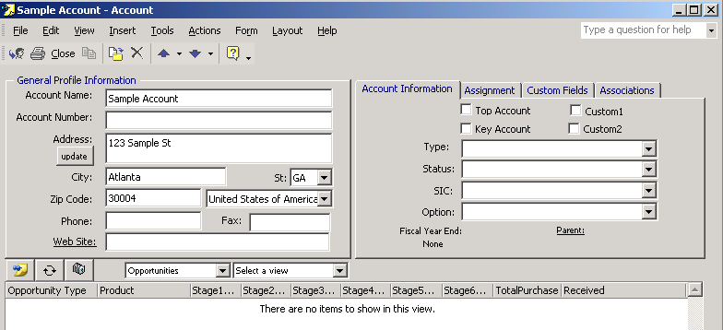

- Once the Add button is clicked, a new Opportunity/Project form is displayed.

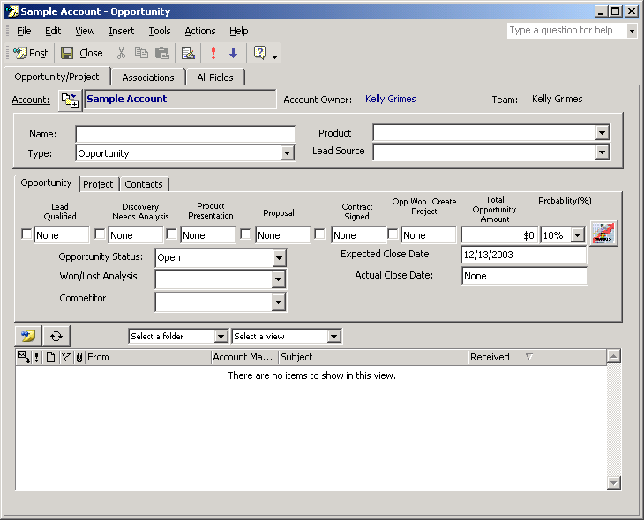

NOTE: You can also add an opportunity by right clicking on either an Account Profile or an Account Contact from within a view and choosing Add Opportunity.

Scenario 2 - Adding an Opportunity using the Actions menu option

- Click on the Add/Actions drop down and select Opportuinities.

- The Opportunity form displays.

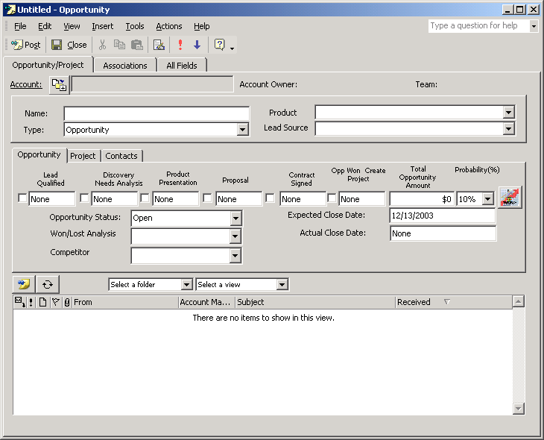

- Click the Select button next to Contact on the Contacts tab. A “List of Outlook Contacts” screen displays. Type in the desired Contact name in which you want to link to this Customer Inquiry within the search feature. Click on the contact and then click select.

- The Opportunity form displays with the account and contact information already populated. Add any desired opportunity and project information within this Opportunity form.

- Save and close the Opportunity form. The opportunity is now added within the Opportunities folder and is linked to the account and contact.

Tab & Field Descriptions

Opportunity Tab

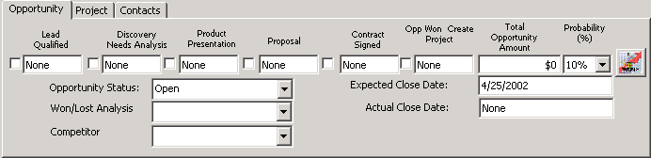

- Click on the first check box below Lead Qualified. Today’s date appears. This signifies this milestone’s been reached.
- Highlight NONE under the Discovery Needs Analysis heading. Enter a future date either numeric (3/15) or written (March 15). SalesOutlook will recognize either method. Entering a future date will automatically create a Task with a reminder for you on the date entered. This helps to keep opportunities moving forward and projects on track.
- Enter future dates for the additional milestones as part of your plan for successfully converting this opportunity or completing the project.
- Complete the information for the opportunity by entering the Total Opportunity Amount. Select your estimate of Probability of conversion by using the Probability drop down. Definitions of the probability can be reviewed by clicking on the icon to the right of the Probability percent. Enter an Expected Close Date that can be used in forecasting future sales.
- Select the Opportunity Status, Win/Lost Analysis, and Competitor Opportunity dropdowns. Opportunity Status defines the current state of the opportunity. Won/Lost Analysis allows us to track whether we’re winning or losing in the marketplace. This information becomes important when creating strategies for competing successfully. Use the Competitor drop down to track the primary competitor for this opportunity

Project Tab

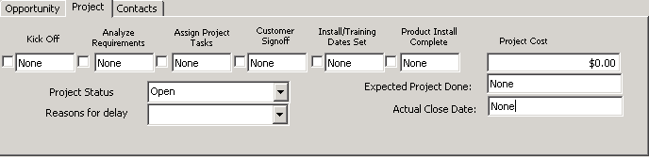

- Enter current or future dates for the milestones above. As stated above, you can enter a future date either numeric (3/15) or written (March 15). SalesOutlook will recognize either method.
- Select the Project Status and Reasons for delay (if any) from the dropdowns provided.
- Enter a dollar amount for the Project Cost.
- Enter a date for when you expect the project to be completed. Once completed, you can enter the Actual Close Date.

Contacts Tab

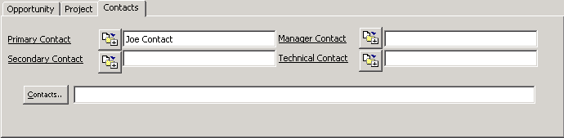

- You can select a Primary, Secondary, Manager, and a Technical Contact from the dropdowns provided. The dropdowns auto-populate from Contacts associated with this Account. If at any time you want to review the contact information for a contact, click the underlined label to launch the contact form within the Opportunity form.
- To associate other Contacts, you can click the Contacts button. Navigate to other folders within Outlook to select other contacts that may not be associated with the Account.

Working with the Global Calendar (Optional with Small Business Edition)

The Global Calendar was designed to be a read only public folder Calendar with all appointments assigned to an account or contact. Appointments created or changed at the personal calendar are created or changed in the global calendar.

Adding an Appointment from the toolbar
- Click on the ▼ next to the Add/Actions button on the SalesOutlook toolbar and select My Appts.
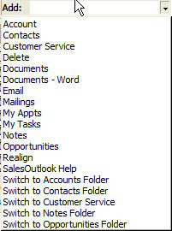
- Enter your appointment information.

Selecting an Existing Contact or Account to an Appointment form

- Click on the SalesOutlook Tab
- Click on Contacts from the Folder Dropdown list within the Account Profiles screen.
- Click on the Select icon. for a contact or account.
- Search for your Contact or Account.
- Choose a contact or account from the list that appears and click on the Select button.
- Your subject line will be appended with the Account Name, Contact name and Phone number.
- Save the Appointment form. The appointment will be added to the Global Calendar as well.

Adding an Appointment from an Account or Contact form

- Click on the Find Account or Find Contact button.
- Type in the account name (partial words are ok).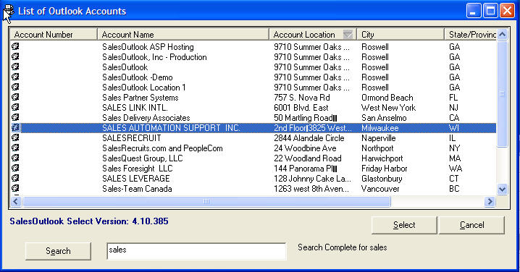
- A list of your Accounts will appear.
- Double click on the desired Account.
- Edit the Account.
- Once edited, save your changes by clicking File | Save from the toolbar.

Adding a New Appointment to an Existing Account

- Go to the Desired Account and open it.
- Click on My Appts from the Folder Dropdown list.
- Click on the Add icon.
- Fill in the information for the appointment that click Save and Close.
- The Appointment will be added to the Global Calendar.

Deleting an Appointment

Note: You must be running Outlook 2002 or greater for the delete function to work.
- Open the Appointment from your personal calendar.
- Click on the X to delete the appointment.
- The Global Calendar Appointment will be deleted also.

Note: Right clicking on an appointment and choosing delete will not delete the Global Calendar item. This is a limitation of Outlook. Deleting an appointment from the Global calendar does not delete the personal appointment.

Viewing Global Calendar information

- Navigate your folder tree to the SalesOutlook\Global Calendar folder
- Change your view to see day/week or month view.
- Double click on a Global Calendar Item to open the appointment.

Global Calendar Item.
Notice the Link back to the Personal appointment. If you are online and you have access to the original appointment then you can click on this link to open the appointment.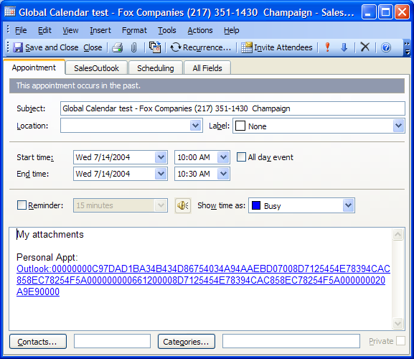No

Normal Appointment form.
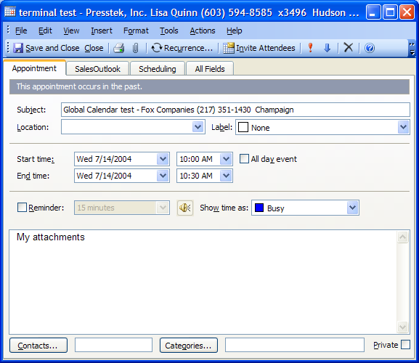

Modifying Global Calendar information

Note: You should always edit appointments from a personal calendar. However from time to time a global calendar item may have to be modified.

- Open the Global calendar item and make the necessary changes.
- Save the Global Calendar item.
- You will receive a message that you should edit the appointment in a personal calendar. 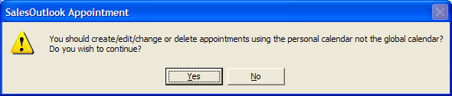
- Click Yes if you wish to save this appointment to the Global Calendar.
- Another message will prompt you for options to copy the Global Calendar item to your personal calendar.
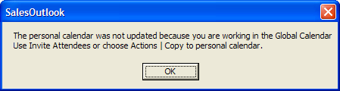
- Click OK.

Setting Global Calendar Registry information

Setup up multiple Global Calendars
You can setup multiple global calendars for groups of users by setting a registry key for the name of the Global Calendar.

Note: The Global Calendar must be created at the same level as the Account Profiles folder right below the SalesOutlook folder.

The registry key is String (REG_SZ) GlobalCalendar. Note: If the key is not found then you will have to create it.

HKEY_CURRENT_USER\Software\Microsoft\Office\9.0\Outlook\Options\SalesOutlook\GlobalCalendar

Example on setting multiple global calendars.

Scenario: Team1 and Team2 both need a global calendar.

- Setup a Windows Security Group called Team1 and Team2. Add the users to Team1 and Team2.
- Copy the Global Calendar to the root of SalesOutlook. Rename the calendar “Team1 Calendar”
- Copy the Global Calendar to the root of SalesOutlook. Rename the calendar “Team2 Calendar”
- Set the permissions of each calendar for the users that need to see it. IE Set Team1 group to the Team1 Calendar etc…
- Change the users registry key and set GlobalCalendar to “Team1 Calendar” for the Team1 users and “Team2 Calendar: for the Team2 users.
- Users will now start saving the SalesOutlook appointments to the correct Team calendar.

Disable the Global Calendar

The Global Calendar is enabled as the default. You can set a registry key to disable the Global calendar by user. String value (REG_SZ) EnableGlobalCalendar.

Note: If the key is not found then you will have to create it.

HKEY_CURRENT_USER\Software\Microsoft\Office\9.0\Outlook\Options\SalesOutlook\EnableGlobalCalendar

1=Enabled
0 = Disabled

Remove the Text on SalesOutlook Toolbar buttons

You have the ability to control whether you want to view the SalesOutlook toolbar buttons with or without their text descriptions. Buttons such as “Print SalesOutlook Reports” and “Email SalesOutlook Support” can have the text hidden by selecting a checkbox within the SalesOutlook Folder Settings tab. If the check box is selected, only the icon will appear on the Outlook toolbar.

To remove the Text from the SalesOutlook Toolbar buttons:

- From the Outlook bar, select Tools / Options / SalesOutlook Folder Settings tab.
- Place a check in the checkbox labeled “Remove text on toolbar buttons” to remove the text descriptions from the SalesOutlook Toolbar buttons.

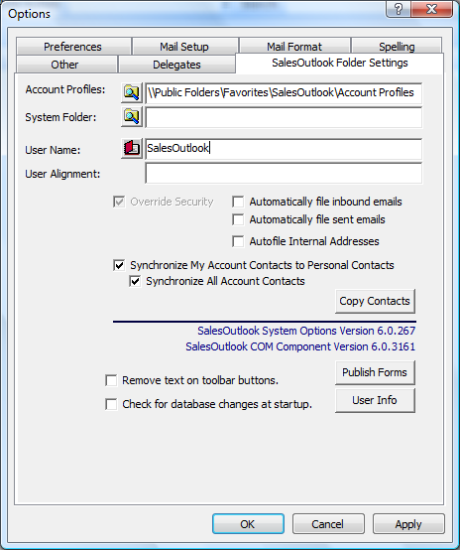

Printing Outlook Views

You can print many documents as a quick reference or as an addition to your personal organization system such as Day Timer. SalesOutlook uses Outlook views, Excel and Crystal Reports for printing SalesOutlook information. As an example, SalesOutlook enables you to print an Account list, Contacts phone list, and even your calendar.

You can even pick any table-style view of a folder (contains rows and columns in a grid), highlight multiple rows, click copy on Outlook’s Edit menu and then paste the data directly into Microsoft Excel. Excel even parses the data so that the data in the Outlook rows and columns appear within individual cells in the spreadsheet.

Print your Account list

- Change the view to the one you would like to print (Rolodex, List style).
- Select the Accounts that you want to print (you may print all or select specific Accounts). Select by clicking on the Accounts while holding down your ctrl key.
- Go to Menu File and select Print.
- Select a Style under the Print Style option.
- Click on the Page Set up button.
- Click on the Paper tab.
- Under the Page section choose the page style you would like (i.e. Executive).
- Click on the Preview button to see the actual document before you print it.
- Click Print to print the document.

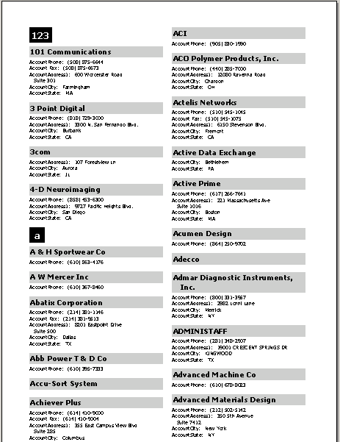

Print your Contacts phone list

Same procedure as printing Account list except start in the Account Contacts folder instead of the Account Profiles folder.

Print your Calendar

- Go to the Calendar.
- Select Print from the File Menu.
- In the print dialog, select the print style (month, week).
- Click on the Page Set up button.
- Again, go to the Paper tab.
- Go to the page section and select the page style you want to print.
- Click on Preview to see your document.
- Click Print to print the document.

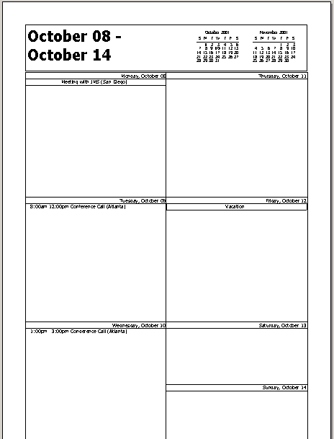

Print your Forecast for this Month

- Click on the Opportunities folder from the Folder List.
- Select ‘Forecast for this Month’ from the current view Dropdown.
- Select Print from the File Menu.
- Click on Table Style as the Print Style.
- To add a header to your report, select the Page Setup button.
- Select the Header/Footer tab.
- Choose from 3 the header boxes and type your header. The left box will have the header appear on the left. The right box will have the header appear on the right, and the middle box will align the header in the center.
- Click on preview to see your document.
- Click Print to print your document.

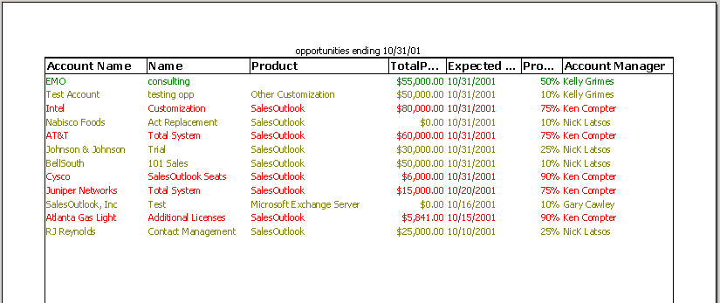

Helpful Hint
You can highlight the records, select copy from Outlook’s Edit menu, open Excel, and paste the data into rows and columns in Excel for further analysis and formatting if desired. This makes for a very simple and powerful way to prepare quick, ad-hoc reports.

Print your Weekly Activity Log

- Click on the Notes folder from the Folder List.
- Select ‘Weekly Activity Log’ from the current view Dropdown.
- Click on the plus sign (+) next to the account manager to expand the view information in detail.
- Click on the plus sign (+) next to the account manager to expand the view information in detail.
- Select Print from the File Menu.
- Click on Table Style as the Print Style.
- To add a header to your report, select the Page Setup button.
- Select the Header/Footer tab.
- Choose from 3 the header boxes and type your header. The left box will have the header appear on the left. The right box will have the header appear on the right, and the middle box will align the header in the center.
- Click on preview to see your document.
- Click Print to print your document.

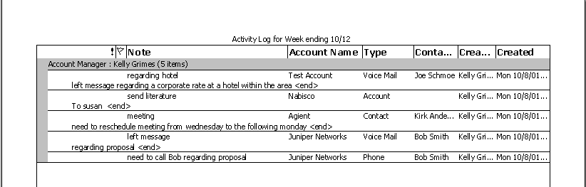

Crystal Reports for SalesOutlook

Crystal reports is a way that you can customize your SalesOutlook environment with high powered, high quality reports. Crystal Reports are typically defined by your system administrator and are ideal for even the most complex reporting requirements.

To print a SalesOutlook Crystal Report:

- Click on the Print SalesOutlook Reports button located on your Outlook toolbar. 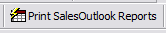

- Select the report you want to print and click on Run Report.

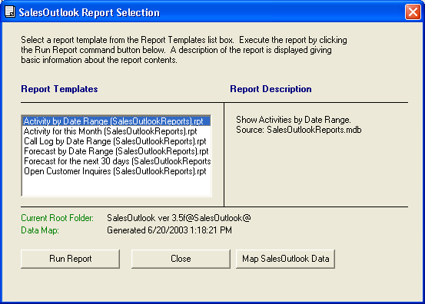

- The Crystal report will run and you can close out of the report selection windows to go back to SalesOutlook. The Crystal report will remain open.

The following pages contain examples of several “out of the box” SalesOutlook Crystal Reports.

Sample Forecast for this Month Report

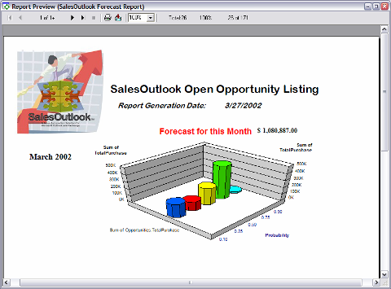

Sample Monthly Call Log Report

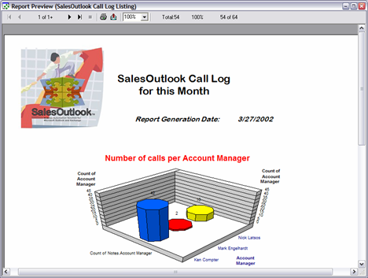

Sample Open Customer Service Inquires Report

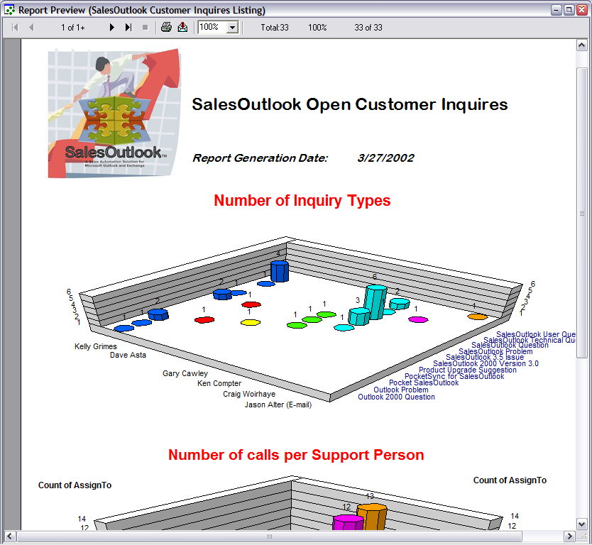

Reporting via an Access (ODBC) Database

The SalesOutlook version 3.5f and later adds the ability to report on SalesOutlook data via an ODBC link to a Microsoft Access database. This new functionality opens up SalesOutlook to use any report writer that can read an Access database or ODBC System Data Source, such as Crystal Reports, Buiness Objects, FRx, MapPoint, Word, Publisher, Excel and etc. When the Account Profiles path is set within the SalesOutlook Folder Settings, the user is prompted to map their database to establish dynamic links from the Access database to their SalesOutlook data. If the database is not mapped at this time, the user will then be prompted when he/she attempts to run a Crystal Report.

Below is a sample of an Excel report created via the ODBC System Data Source Name of SalesOutlookReports. To generate a report like this, open a new Workbook in Excel and click the “New Database Quer” option “Get External Data” or “Import External Data” (depending on whether you use Office 2000 or XP) to launch the data query wizard. Just follow through the steps in the wizard to create a variety of “point and click” reports.

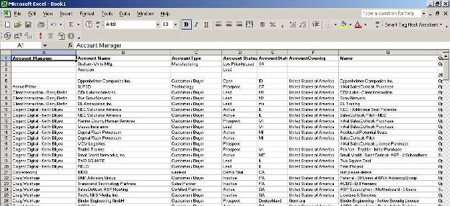

For additional information concerning reports using the SalesOutlook ODBC link to the SalesOutlookReports Access database, please consult our reporting documentation. The SalesOutlook Reporting Guide is available on our website in the Library section of our online Support Center.

NOTE: See the SalesOutlook reporting guide for more information.

Working With Views (Saved Queries) in SalesOutlook

An Introduction to Microsoft Outlook Views

What are Views?

Microsoft Outlook views represent a list of items contained in a folder. These lists can be defined as to display different fields defined within the folder, they can be grouped, sorted and filtered as well. Most importantly, views can be saved for reuse at a later time. Administrators have the ability to define global views that are available to all users while individual users have the ability to define and save views that are only available for their own use.

When you first open your Inbox in Outlook, you normally see a view listing the messages sent to you. The fields composing this view could include such items as the sender’s name, subject, date and time of receipt etc. Every Outlook component (Inbox, Calendar, Tasks etc.) has more than one possible view. For example, from your Inbox, open the View menu at the top of the screen and select Current View. MS Outlook displays a list of pre-defined views to choose from and an indication as to which view is currently displayed. By choosing an alternate view from this list, you change the look of the items in your Inbox, as well as possibly limiting (filtering) which items to display.

Users are able to change any view available to them, and they can create their own views. In this way users can maintain a “library” of views that help them quickly access the information they want to see and see in it the way that they want to see it without requiring system administrators to program and publish changes to the system.

Views are a very powerful feature that can be designed to filter out data that does not meet specific conditions. For example, the results for common questions like “Show me all my Western Region contacts in upper management arranged by Job Title”, or “Show me all the Primary Contacts for National Defense type contacts grouped by department” can be returned by clicking on the folder and then selecting the “saved” view from the list of views defined within the folder.

What parameters define a View?

The user can choose what fields (data items) should appear in the view list, the sort order, groupings (e.g. by account manager and then by company), the filter (restriction criteria) and even the font settings of how messages are rendered in the result list.

Who can define Views for everyone to use?

Only those with sufficient permissions can create views for global use. As we have it set up now, you can only create views for your own use. If you can define a globally useful view, contact your administrator.

For more information about using this powerful Microsoft Outlook feature, refer to the Microsoft Outlook online help.

Customizing Outlook Views

A currently defined view may not capture all the fields you are interested in, be sorted or grouped as you require, or it may be too general a definition that does not allow you to easily locate (limit) the records you are searching for. Before we create an entire new view, how can we change what we currently see?

Scenario 1 - Displaying additional fields in a View
Looking at your Inbox, you would like to know the size of each of the email messages, and then to sort on this value.

- Right-click on any of the column headings and a popup menu appears. For example we clicked next to From column below:

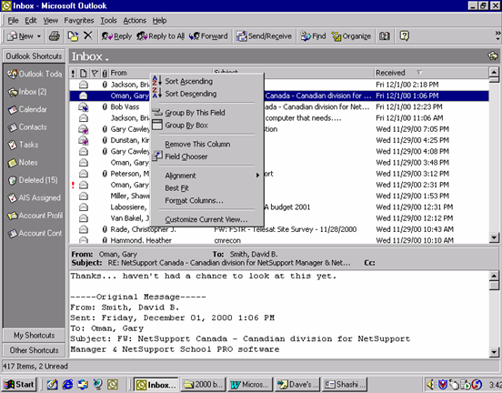

- Right away we see several means of altering the current view. We could group or sort by the From field, change the From column alignment (justification) or width etc. In our case, we want to add a column. To do this, choose Field Chooser from the menu.

- You will see the following screen appear:
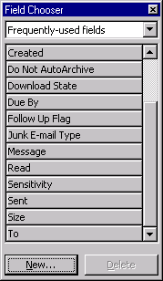
- If we scroll to the bottom of the above list, we see Size as one of the entries. To include size in your current view, click and drag the size item from the list to the inbox view, and drop (release mouse) on top of the Inbox view column where you want size to appear.

- For example, if we drag the size item over to the From column heading mentioned above and release, we get the following:

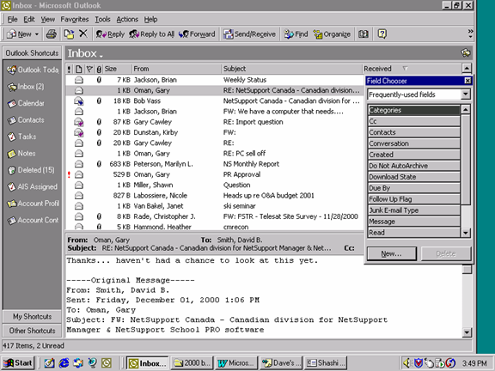
- Size now appears to the left of the From column. Notice that Size no longer appears in the list of fields from the overlaid screen.

- To now sort your messages on this field, simply click the Size column heading.

Scenario 2 - Reordering the Columns in a View

Taking the above example, perhaps we didn’t want Size to appear before the From column. Simply click and drag the Size heading to another heading. For example, let’s drop the Size heading over top of the Received field to have Size appear prior to Received:

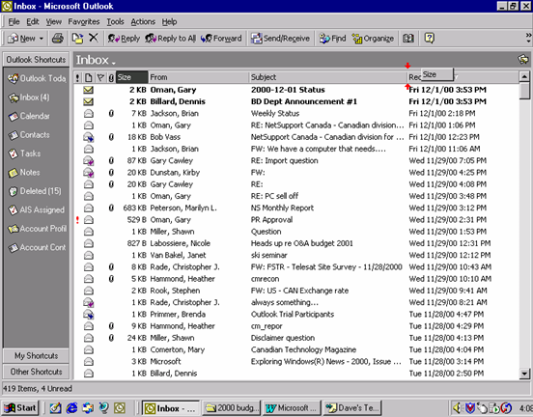

Scenario 3 - Removing fields from a View

Two of the easiest ways to remove a field are:

- Left click on the column header of the column to remove and drag and drop it above the column headers. For example we could click on the Size heading and drag it to the area directly above the headings where the word Inbox is:

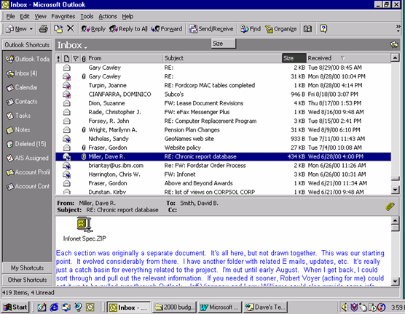

- Right click on the column heading to be removed and choose Remove this Column.

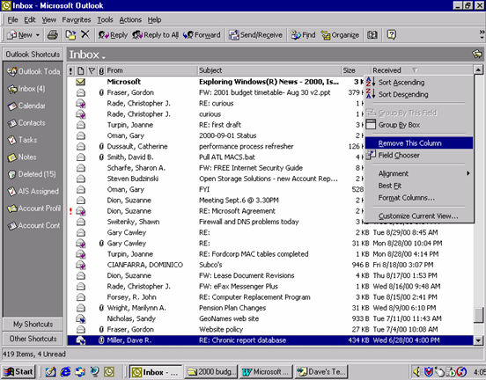

Scenario 4 - Grouping Items in a View

As we noted in scenario 1 previously, we have the option in the popup menu when right-clicking on a column heading to “Group by this Field”. This is the simplest means of grouping items.

What if we wanted multiple levels within the grouping? For example “group my inbox by sender and by type of conversation”. We will cover this in more detail later, but as a sneak peek, try this.

Using scenario 1 above, add “Conversation” to the view.

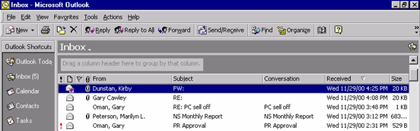

- Right-click on any column heading and choose “Group By Box”. At the top of your screen a drop area appears:

- Click and drag the From column into this drop area:

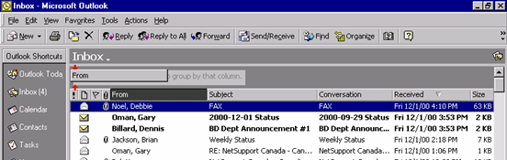
- Repeat this process with the Conversation column:

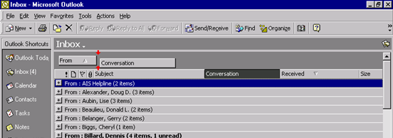

- You should now have your messages grouped by sender and conversation. If you click on the + symbols on the items, you can expand each grouping:

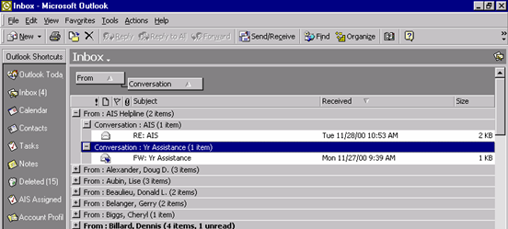

- To remove this grouping, drag the From and Conversation fields back down to the columns. To remove the drop area, right click on the columns and choose the Group By Box item again.

Creating a New View

We will turn our attention to creating views within SalesOutlook, although the same methodology can be applied to any Outlook folder.

Presently, the two key folders in SalesOutlook are Account Profiles (which define the companies), and Account Contacts (describing contacts within companies). These folders should appear as shortcuts on the Outlook toolbar.

You can create views from scratch, but the common practice is to define new views as modifications of existing views. In other words, you copy an existing view and make your changes to the copy.

Where do the fields exist?
Perhaps the most confusing part of defining views is knowing where the fields reside in order to choose whether to include or exclude them in the view. Refer to this table for a list of fields to choose from for creating views. This will avoid having to locate a field from the Outlook utilities. Scenario 3 will cover a situation where you need to locate non-standard fields when creating a view and the source column in the following table will be helpful.

Fig 1. Company Fields:

Field | Description | Source
Account Manager | The "owner" of the company | User-defined fields in folder
AccountCity | City portion of the company address | User-defined fields in folder
AccountState | State or province portion of the company address | User-defined fields in folder
Alignment | See APPENDIX A | User-defined fields in folder
Subject | Name of the company | Frequently-used fields
Key Account | A means of flagging a company as key (your description) | User-defined fields in folder
NumberOfContacts | A count of how many contacts a company has | User-defined fields in folder
AccountType | Qualifier on the company: Project, Customer, Inactive, Call Back… | User-defined fields in folder
AccountCreditLine | Credit limit associated with a company | User-defined fields in folder
AccountOnHold | A flag on a company to indicate activities (sales) are suspended | User-defined fields in folder
OThisYearsSales | What we anticipate will be the Sales for this company this year (manually updated | User-defined fields in folder

Fig 2. Contact Fields:

Field | Description | Source
Account Manager | The "owner" of the contact | User-defined fields in folder
Alignment | See APPENDIX A | User-defined fields in folder
Contact Language | Contact’s preferred language | User-defined fields in folder
Contact Type | Either Emergency, Operations or Senior/Upper Management | User-defined fields in folder
Mailings | Mailing lists (e.g. President’s Tour – Ottawa,XMAS List | User-defined fields in folder
Sales Field | Sales Broadcast, Sales Carrier, etc. | User-defined fields in folder
Birthday | Contact’s birth date | All contact fields
Business Address Street |  | All contact fields
Business Address City |  | All contact fields
Business Address State |  | All contact fields
Business Address Postal Code |  | All contact fields
Company |  | Frequently-used fields
Country/Region | Country | Frequently-used fields
Department | Contact’s department (e.g. NDHQ within National Defense) | Frequently-used fields
Full Name | Contact name in form lastname, firstname | Frequently-used fields
First Name |  | Frequently-used fields
Last Name |  | Frequently-used fields

There are many other fields available to be used, and others can be added. For the time being, the above fields will serve as a starting point as you begin creating your own views.

Scenario 1 - Creating an Account Profile view for your companies

The starting SalesOutlook Contact Profiles view includes all companies. You can create a view that limits (filters) the view to include only those assigned to you. We will use the SalesOutlook Account default view as our starting point and create our own modified view.

- Open the Account Profiles folder. From the View menu, choose Current View, Define Views…

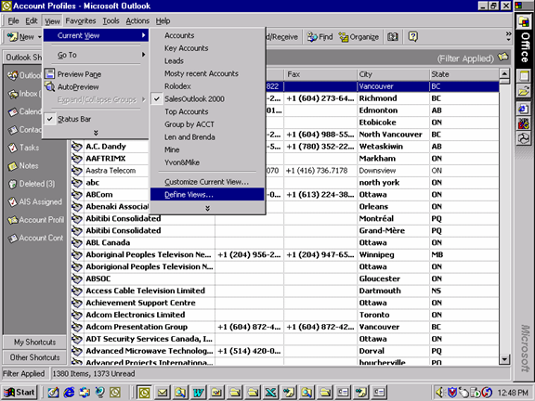

- You will see a list of defined views. Highlight the Sales Account View and press the Copy button.

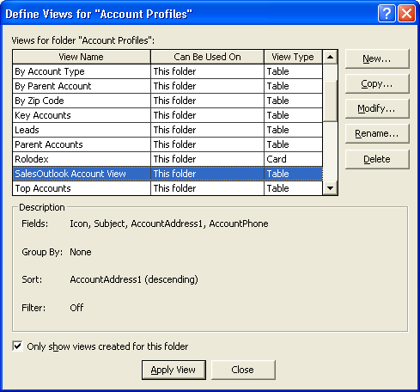

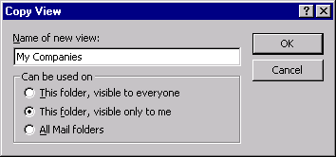

- On the next screen, provide a new name for your view, choose the second radio button (This folder, visible only to me), and press the OK button:

- Let’s assume that the fields displayed are acceptable for now. From here you want to define the filter to be placed on the view. Press the Filter… button:

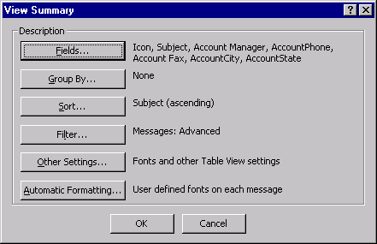

- From the following screen, choose the Advanced tab. Account Manager is the field we will use to limit our view. Type Account Manager in the Field box, choose a comparison operator, (this case “contains”), and type your last name in the value field, (see below). Finally, press the Add to List button.

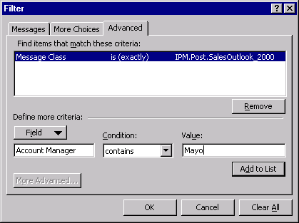
- Press the OK buttons to exit the screens back to the Define Views screen. Your new view will appear in the list. You can click the Apply View button to make this new view the active view.

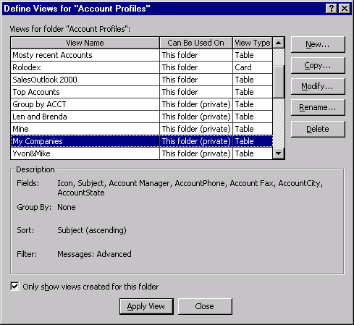

Scenario 2 - Creating a View for Account Contacts

In this case, we want to construct a contacts view (on the Account Contacts folder) that limits the contacts to those within National Defense, but grouped by department, sorted by last name.

In this case we need to define filter, sort and group-by conditions:

- Open the Account Contacts folder. As in Scenario 1, open the Views | Current View | Define Views screen. We can choose any current view that is similar to what we want. For this scenario, choose By Company and press the Copy button. You will next be prompted to name your new view. Remember to choose the second radio button (This folder, visible only to me).

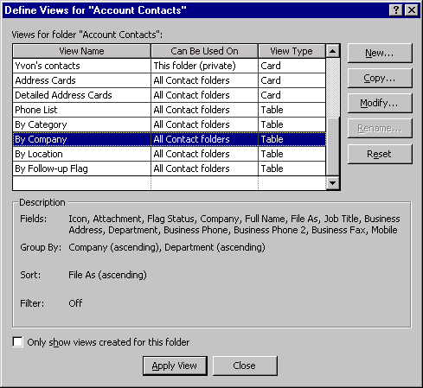

- On the following screen we will specify the filter, sort and group by conditions. Click the Group By… button.

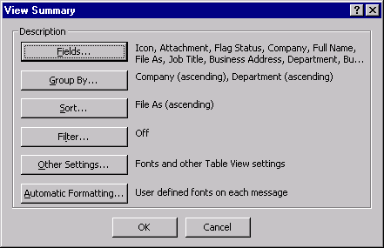
- On the next screen, choose Department from the list box. Click the OK button:

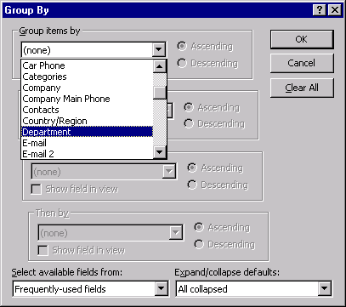

- You will have returned to the View Summary screen. Choose the Sort… button. You will see the following screen. Choose Last Name from the list box and press the OK button. If Last Name was not already one of the fields in our view, you will be asked if you want to include this field. You can specify No for this scenario.
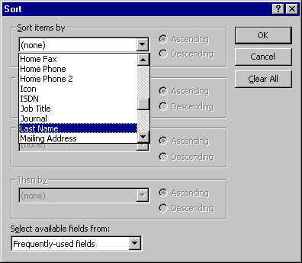

- Again we return to the View Summary screen. Now click the Filter button. Choose the Advanced tab and specify Company in the Field box, is (exactly) as the Condition, and National Defense as the Value. Click the Ok Buttons until you arrive at the Define Views screen. Here you can click the Apply view button to make this new view the active view.
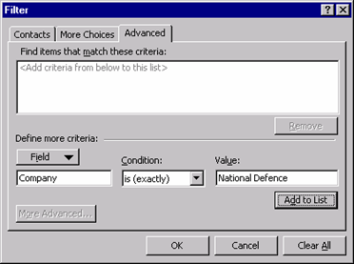

- The new view will look similar to the following:

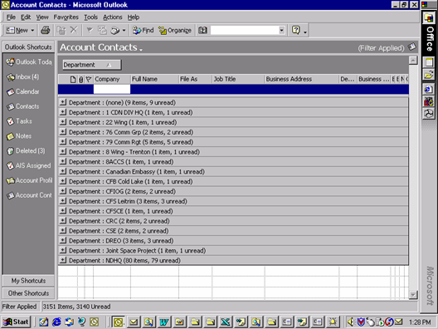

Scenario 3 - Choosing non-standard fields

This scenario will require that you specify the source of the field(s) in order to create a view. Let’s assume we want to create a view of the Senior/ Upper Management contacts that are also designated as Primary Contacts. We want the view to group by company and to display and sort by the Account Manager. For this scenario, we will copy the Phone List view as the starting point for creating our new view.

- Open the Account Contacts folder. As in Scenario 1, open the Views | Current View | Define Views screen. We can choose any current view that is similar to what we want. For this scenario, choose Phone List and press the Copy button. You will next be prompted to name your new view. Remember to choose the second radio button (This folder, visible only to me) unless you are an administrator of your system.

- On the View Summary screen, we will use:
- Fields to add the Account Manager to the view
- Group By to group the listing by company
- Sort to sort the contacts by last name
- Filter to choose only those contacts who are senior management and designated as Primary Contacts

- Click on Fields. On the following form you want to add the Account Manager. Referring to the table in Fig 2, we see that the source of this field is "User-defined fields in folder”. On the screen below, you must locate ”User-defined fields in folder” in the list box at the bottom of the screen entitled Select available fields from:

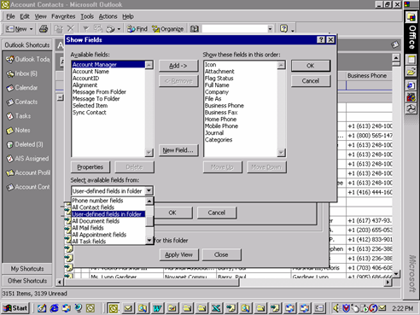

- From the Available Fields list to the left of the above screen, highlight Account Manager and press the Add button. You can re-order the fields in the right list area (Show these fields in this order), by highlighting a field and pressing the Move Up and Move Down buttons. Press the OK button to return to the View Summary screen.

- Click the Group By… button. Choose Company from the list box (assuming Frequently-used fields is in the source list box at the bottom) and click OK to return to the View Summary screen.

- Click the Sort… button. Choose Last Name from the first list box and click OK to return to the View Summary screen.

- Click the Filter… button. Click on the Advanced tab. Here we will specify 2 criteria that must be true for a record to be a member of the view. We want to specify Mailings and Account Type fields. Referring to Fig 2, both of these fields are in the “user-defined fields in folder” source. We could simply type in these field names, or press the Fields button to locate the “user-defined fields in folder” source and choose one of these fields from the list of fields available in the folder. Either way, you need to specify the following:
Primary Contact Equals Yes

- Click Add to List

Account Type Contains Senior

- Click Add to List

- Click OK on each of the returning screens, and apply the view.

Final Thoughts About Views

We should review what additional fields we may need when defining our views. Existing fields could be used or additional fields could be added. Note that not all fields are visible on the SalesOutlook forms; to do so would not be practical. However, if a much needed field is not currently defined, it is not a large task to add new fields to a form. Please see your system administrator for assistance with adding new fields to forms. Regardless of whether a field is visible on the form, all fields within the folder are available when creating views.

A view of Account Contacts (or Contact Mailings) can be used to generate mail-outs (letters, address labels, etc.). You can even choose a subset of contacts from a given view to produce a letter or other merge-type mailing. Producing a bulk, merged mailing is covered in the next section.

Creating MailMerge Documents in Outlook

Mail Merge Overview

What are MailMerge documents?

Within the SalesOutlook Contacts folder, you can create various forms of documents that can be merged with the contacts information for mail-out purposes. Microsoft Outlook can create:
- Mailing labels
- Envelope addressing (addresses printed directly to an envelope
- Name badges
- Form letters (including fax sheets etc.)
- Contracts and Legal Agreements
- Etc.

Creation of a mailmerge document template is performed once. This merge template is then saved for future use.

The merge template will provide a stepwise guide to creating some of the above mail merges. These scenarios could similarly be applied to creating documents from the Contacts in your Mailbox Contacts folder.

Helpful Hints:
Selecting a range of contacts:
- Highlight the first contact (in the desired range)
- Hold down the Shift key
- Highlight the last contact (in the desired range)

Selecting multiple contacts
- Highlight the first contact
- Hold down the Ctrl key
- Highlight each contact you want included

- Once you have created and saved a mail merge document, save it before merging the contact data. After the contact data has been merged, DO NOT save the document when prompted. If you do, the document will be linked to a data file created by Outlook. If this data file is lost, you will see an error message or prompt indicating the data file is missing. If this happens, follow these steps:

- Open the document using Word. You will see a message similar to the following:

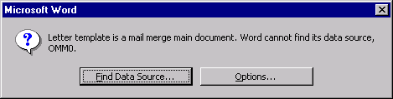

- Press the Options button. The next screen should look like:

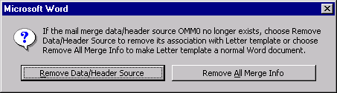

- Press the Remove Data/Header Source button
- The document will open. Save the document. You should now again be able to use the document with SalesOutlook mail merges.

Scenarios

Scenario 1 - Creating Address Labels

Before you begin, you will need to know what mailing labels (Avery label number) you will be printing. In this example, we will assume we have Avery Standard 5261 1” x 4” labels on standard 8 ½” x 11” sheets.

- Choose Mail Merge from the Tools menu:

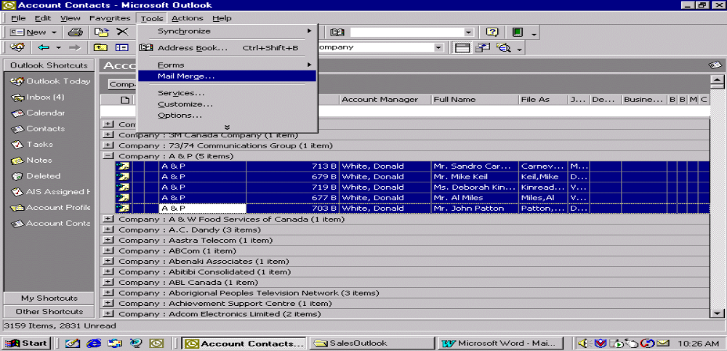

- On the Mail Merge Contacts screen, choose mailing labels from the Document Type list near the bottom of the screen. Leave the Document File as New document. Press the OK button.

WARNING: Make sure the radio button near the top of the screen labeled Only selected contacts is chosen.

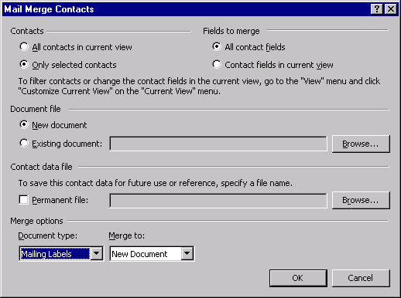
- You will see an informational message advising you to choose the Setup button for the next screen. Simply press the OK button:

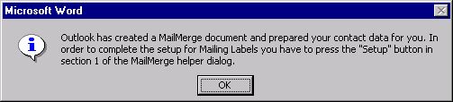
- On the following screen, press Setup:

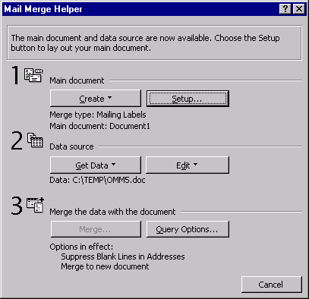

- On the following screen Choose the type of mailing label you are working with from the list indicated and press the OK button:

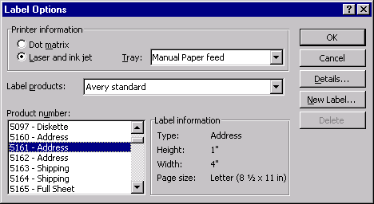
- On the next screen you will select the contact fields you want merged into the document. In this example, we want to include a contacts full name, job title, and business address in the example format:

Full Name
Job title
Company Address

- Click the Insert Merge Field button.

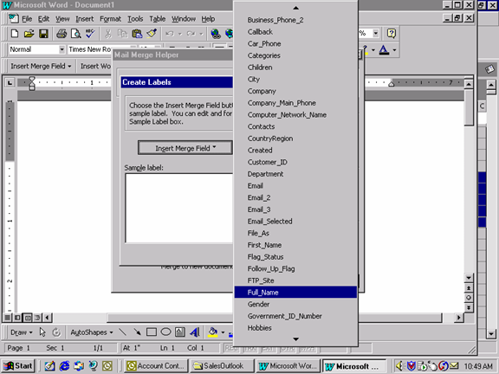
- From the fields listed, locate and click on Full_Name (you may need to point your mouse to the arrows at the top or bottom of the list in order to scroll through the list). The Full_Name field is subsequently placed in the Sample label box as shown below:

- Since we want to have the next field appear on a new line, position the cursor after the <<Full_Name>> entry and press the Enter key.
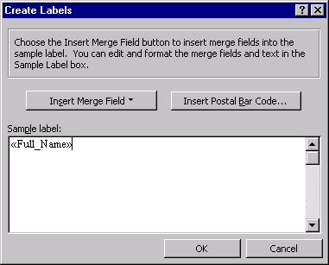
- Repeat from the beginning of this step to choose the Job_Title field and Business_Address field. Once these have been selected, your sample label will look like the following. Click the OK button:

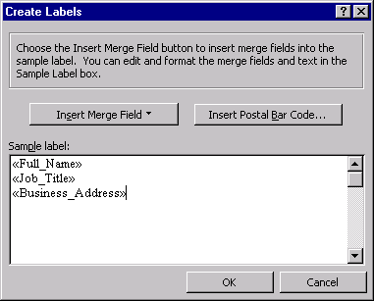

- You will return to the Mail Merge Helper screen. There are several other options available to you via the Merge and Query Options button. We will not change any of the settings for this example. Press the Close button:

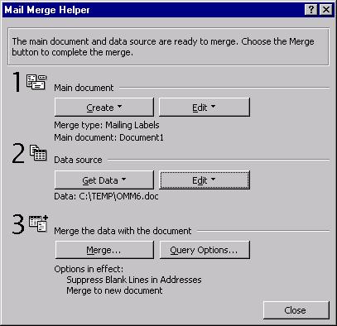
- You will now see the Word document created for your labels. If this is a document you intend to re-use, you should save this file now.

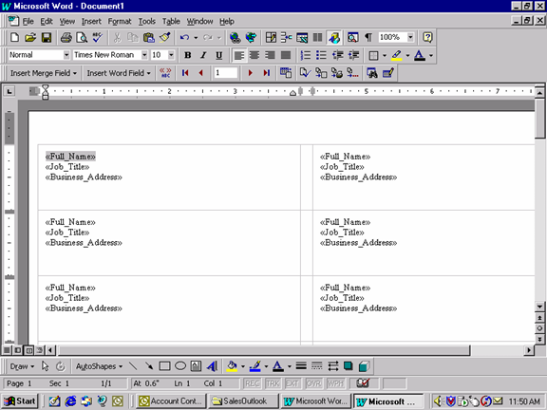
- This template shows the exact placement of the contacts fields that will be merged.

- At the top of the screen (indicated by the arrow) is the button to pull in the contacts you originally selected in step 1. Press this button to see the final data. From here you can choose to print the labels. Note that the printer will wait for a manual feed of the label sheet.

In the future, you will not need to perform all these steps in order to create the mailing label document. Refer to Scenario 3 – Reusing Mail Merge documents to see how we can reuse the above labels for a new set of contacts.

Scenario 2 - Creating a Form Letter

Let’s assume you already have a form letter that you prepared that will have a format similar to the following:
___________________________________________________________________________
December 12, 2000
Full Name (eg. Ms. Jennifer Kane)
Job Title
Company
Business Address

Dear <title> <last name>

BODY OF THE LETTER GOES HERE

If you have any question, please call me at 748 0123.
Yours truly
Your name,
Your Title etc….

- 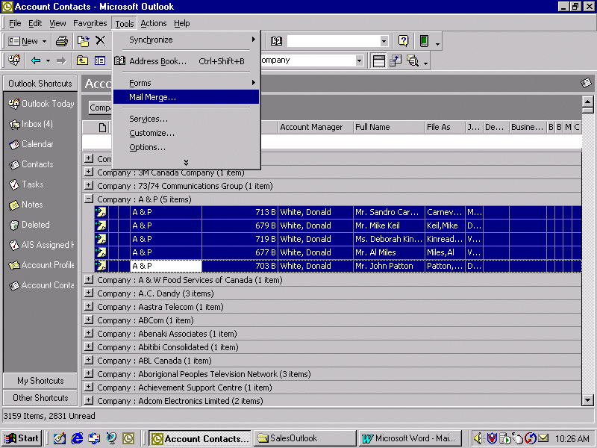Select one or more contacts from the SalesOutlook Account Contacts folder. We will use the same contacts as in Scenario 1 (see step 1 of Scenario 1)

- Select Mail Merge from the Tools menu:

- From the Mail Merge Contacts screen, choose Form Letters from the Document Type list near the bottom of the screen.

WARNING: Make sure the radio button near the top of the screen labeled Only selected contacts is chosen.

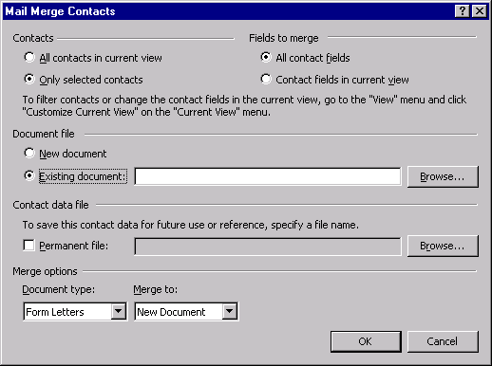
- Use the Browse button to locate the form letter you currently use. Once you have selected this file, You will return back to this screen. Press OK to continue.

You will now be in your Word document, as iillustrated on the following scrreen:

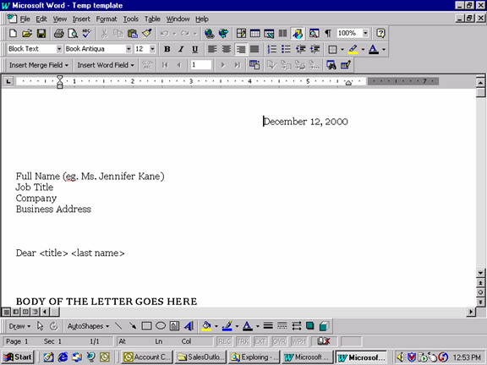
- Where we indicate the Full Name, we will add a Mail Merge field called full_name. Highlight this line in the document and press the Insert Merge Field button.

- You will be shown a field list similar to the following. Click on the field full_name.

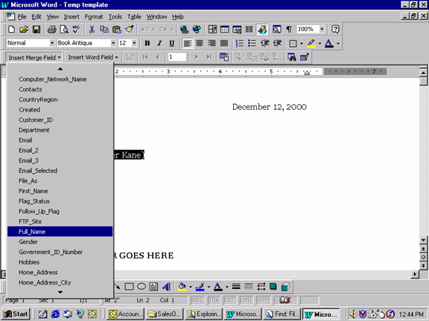

- Your document will now look like:
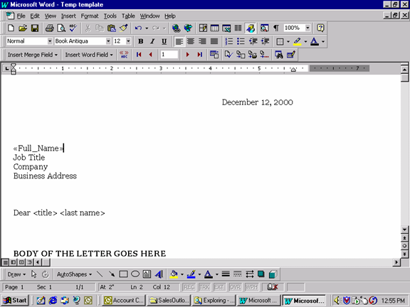
- Repeat this step for each field to be merged into your document. The fields to choose from the list for this letter are:

- Job_title
- Company
- Business_Address
- Title
- Last_Name

- Your document should look similar to:
1
2
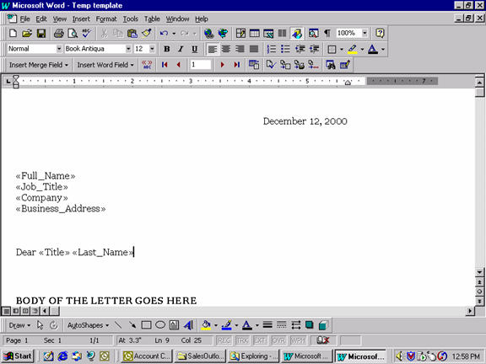
- If this document is to be re-used at a later time, save this document now.

- Press the <<ABC>>> button at the top of the screen (arrow 1) to populate the fields with the contacts chosen in Step 1. To see all the documents produced, press the record navigation buttons (arrow 2).

- At this point, you can complete any other changes you want and print the document.

- To re use this document in subsequent mail-outs, you will not need to perform all these steps. Refer to Scenario x – Reusing Mail Merge documents to see how we can reuse the above letter for a new set of contacts.

Scenario 3 - Reusing Mail Merge Documents

Once a document is created as in the prior scenarios, they can be re-used against a different contact list. The same steps are used, no matter what type of mail-out was created.

- Let’s look at the steps to re-send the letter created in Scenario 2 above.

- Select one or more contacts from the SalesOutlook Account Contacts folder.

- Choose Mail Merge from the Tools menu

- On the Mail Merge Contacts screen, use the Browse button to locate the file you saved from Scenario 2

NOTE: By choosing an existing file, it will default the Document type at the bottom of the screen. For example, if this was a mailing label document as created in scenario 1, the Document type field should change to mailing labels.

- The document will open. You can then merge the contact data as in the earlier scenarios by press the <<ABC>> button. (See step 5 of Scenario 2)

