SalesOutlook®
Reporting Guide

SalesOutlook, Inc.
9710 Summer Oaks Drive
Roswell, GA 30076
(770) 642-4923

Table of Contents

Creating an Excel Report 3
Creating Pivot Charts and Tables 12

Creating an Excel Report

You can import SalesOutlook data into Excel to create a variety of reports with features such as Pivot Tables, Charts, Summaries, and Tables. The following example will walk you through creating a query in Excel that extracts SalesOutlook data and puts it into Excel for further “what if” analysis:

- Open Microsoft Excel new worksheet or workbook.
- From the Toolbar, select Data | From Other Sources Data | From Microsoft QUesry if you use Excel 2000, or select Data | Import External Data | New Database
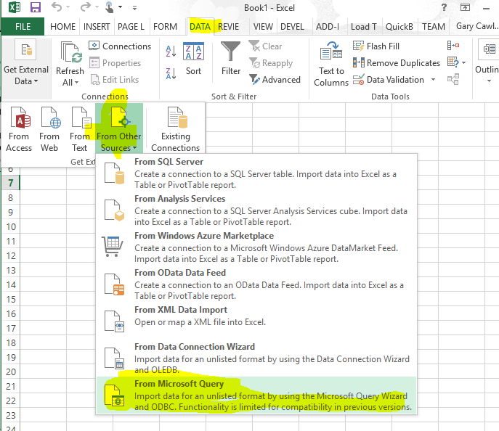

- Choose the SalesOutlookReports data source name and click OK.

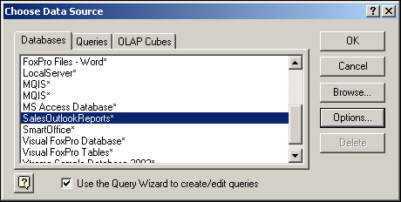

5. Choose the fields you want to display on the report and click Next.
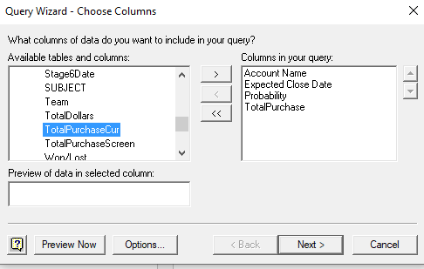
NOTE: Selecting multiple tables/folders is allowed so long as the same field exists in both Tables/Folders and you have the Microsoft Query components installed so that you are able to edit the query and link the tables together using a common ID (key) field.

For example, it is possible to select fields from the Account, Account Contact, and the Opportunity folders within the same report since the AccountID exists in the Account, Account Contact and Opportunity folders and since the ContactID exists in both the Account Contact and the Opportunity folders. If you do not define the correct relationships between tables your report will not produce the expected (correct) results.

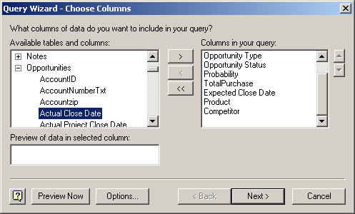

If you select data from more than one Table/Folder, then you will be warned that you must create the relationships, and the Microsoft Query interface will open automatically to enable you to build complex queries or refine simple ones.

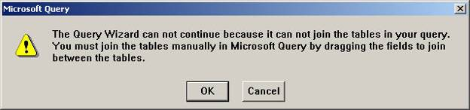

NOTE: See the Fields on the forms for reporting section toward the end of this document for a “map” of the SalesOutlook form labels to the corresponding names of the underlying Outlook fields. An Entity Relationship Diagram (ERD) is included at the end of this document to help you determine the relationships used by the SalesOutlook data store.

- Optional: Filter the data and set the desired options for the report by clicking the Options button, or edit the query with Microsoft Query by clicking the Edit Query button. You can also save the query if you like by selecting the Save As menu option on the File menu within Microsoft Query.

NOTE: If you selected fields from more than one table/folder then you will receive a warning message that the query wizard is unable to join the two tables because a relationship does not exist. In this case, Microsoft Query will open automatically once you click OK on the warning message. You can create a join between the two tables by dragging the Primary Key field from the Parent table and dropping the field on corresponding Foreign Key field of the Child table as shown in the following two images.

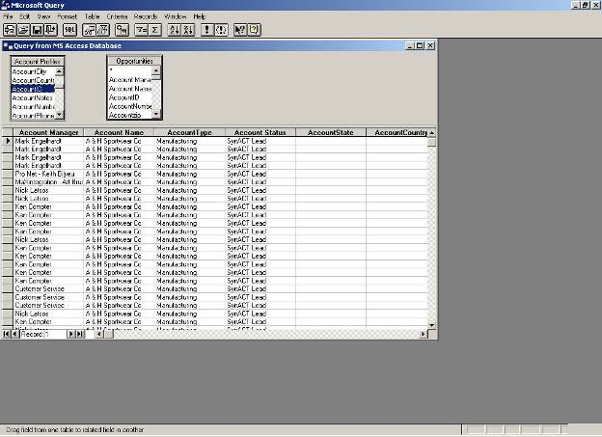

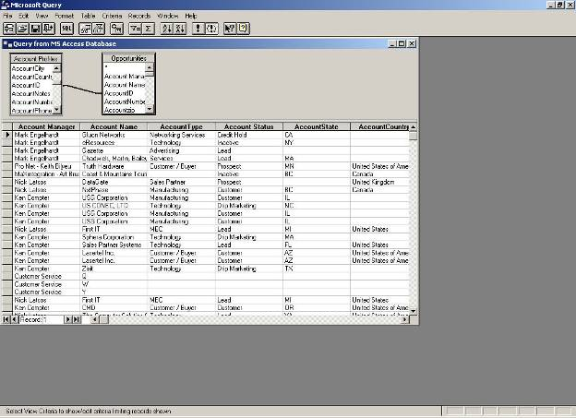

- Edit your query as desired and select the Return Data to Microsoft Excel option found on the File menu of Microsoft Query.

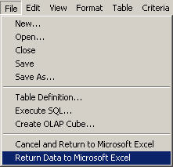

- Select the location in the Excel workbook where you would like to return the resulting data.

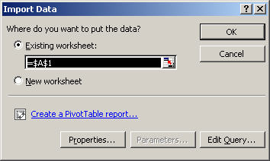

- Click the Properties button to name your query and define the output range (Named Range in Excel). In the Properties dialog, select the options that are most appropriate for the report you’re designing. If you would like to create a Pivot Table of your data, click the Create a Pivot Table Report link now. Review the section “Creating Pivot Charts and Tables” noted later in this document for further details on creating Pivot tables.

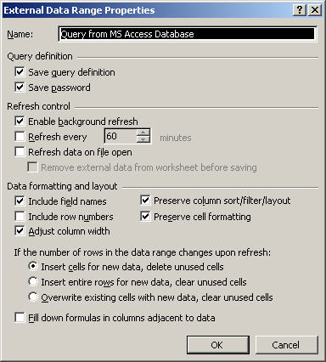
If this report is for your personal use and it does not contain confidential information, you may leave the Save Password checkbox checked. However, if this report template will be used by others, or if it contains confidential information, be sure to uncheck the Save Password checkbox.

- You can then use the features of Excel to modify your query results, create a chart, or print/email the workbook. A few examples are shown below.

Sorting Data  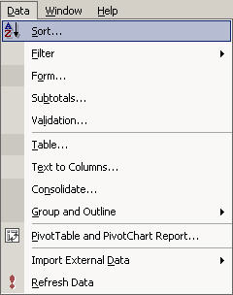  Filtering Data | 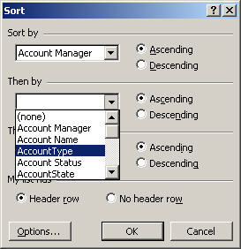
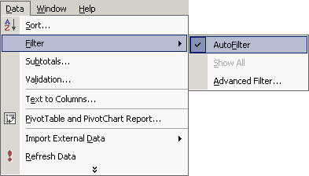 | 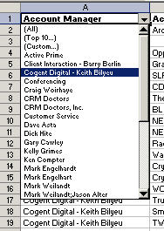

Sample Excel Report – Example Results

Before filter/sort is applied
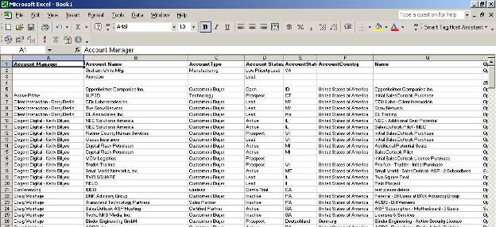

After filter/sort applied
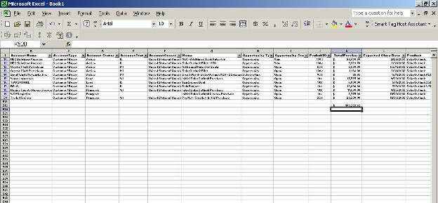

Optional: Adding Subtotals

From the toolbar, select Data |Subtotals |Total by Account Manager | Sum Total Purchase

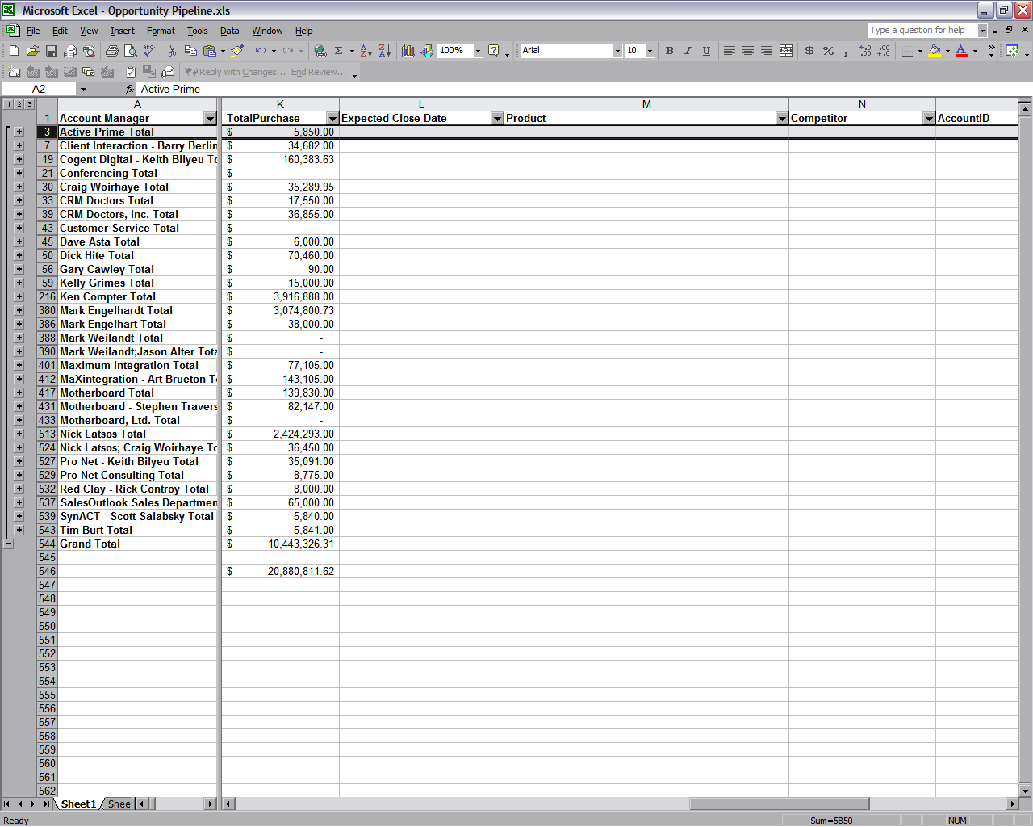

Creating Pivot Charts and Tables

- Open Microsoft Excel. Be sure you’re at a place to create a new worksheet or workbook.
- From the toolbar, select Data | PivotTable and PivotChart Report.

NOTE: If you already linked your database using the Ad-Hoc Excel Reporting it is not necessary to perform the steps listed to link your database. Start with instruction # 12 to begin building the PivotTable.
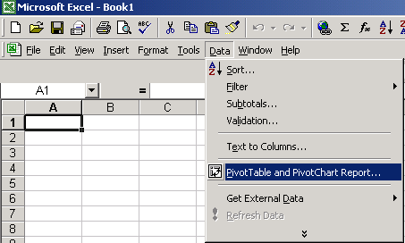

- Select the radio button for “External data source” for the data you want to analyze. You will also need to select whether to create a PivotTable or PivotChart (with Pivot Table).

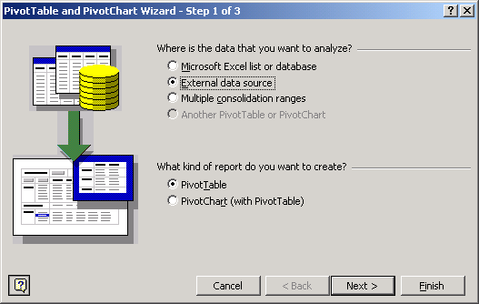
- Click the “Get Data” button to extract your external data.

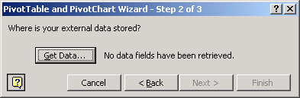

- Choose SalesOutlookReports and click OK.

- Choose the fields you want to display on the report and click Next.

NOTE: Selecting multiple tables/folders is permissible so long as the same field exists in both Tables/Folders and you have the Microsoft Query components installed so that you are able to edit the query and link the tables together using a common ID field.

For example, it is possible to select fields from the Account, Account Contact, and the Opportunity folders within the same report since the AccountID exists in the Account, Account Contact and Opportunity folders and since the ContactID exists in both the Account Contact and the Opportunity folders. If you do not define the correct relationships between tables your report will not produce the expected (correct) results. Refer to Appendix B appearing at the end of this document for an Entity Relationship Diagram (ERD) that will help you determine how to link the various SalesOutlook tables.

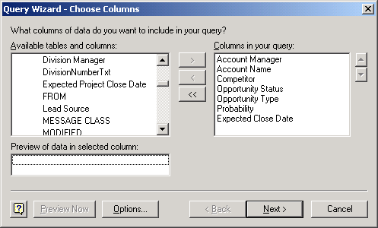

If you select data from more than one Table/Folder, then you will be warned that you must create the relationships and the Microsoft Query interface will open automatically to enable you to build complex queries or refine simple ones.

NOTE: See the Fields on the forms for reporting section below for a “map” of the SalesOutlook form labels to the corresponding names of the underlying Outlook fields.

- Optional: Filter the data and set the desired options for the report by clicking the Options button, or edit the query with Microsoft Query by clicking the Edit Query button. You can also save the query if you like by selecting the Save As menu option on the File menu within Microsoft Query.

- Optional: Sort the data and select the desired options for the order of the data.

- Click the radio button “Return Data to Microsoft Excel” when prompted what to do next.

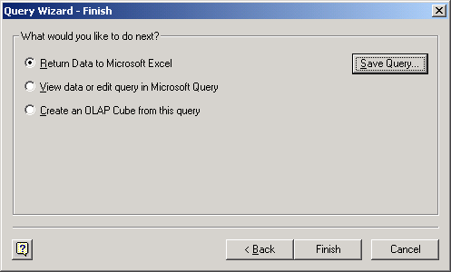

- After selecting Finish, a message appears that the data fields have been retrieved. Click Finish again to view the fields and data.

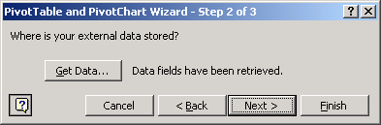

- A blank pivot table appears for which we must decide how to view the data.

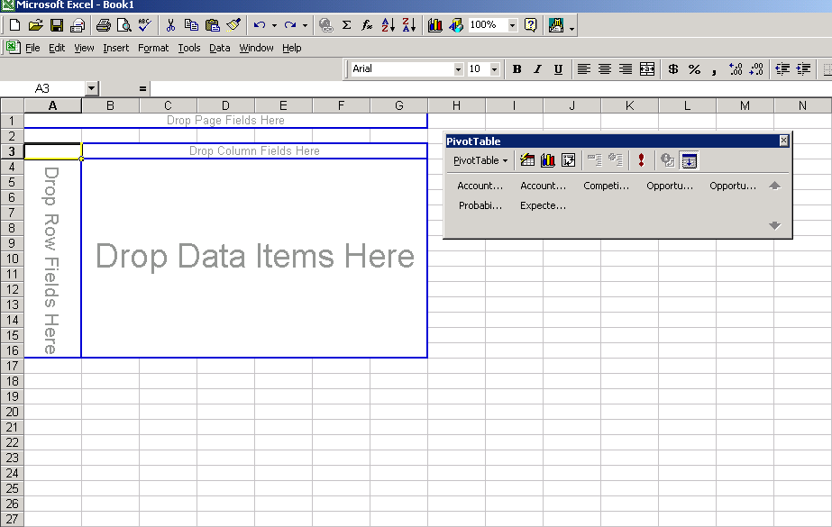

- Construct your PivotTable by dragging the fields on the right to the diagram on the left. The “Drop Page Fields Here” area is used as a filter for the entire PivotTable. Consider an example of a Sales Forecast Report, one might put Account Manager so one could sort by specific territories or view all territories.

- The “Drop Column Fields Here” area is where one drops the data that one would like to see down the side of the table. For example, Probability.

- The “Drop Row Fields Here” area is where one drops the column headers. For example, Account Manager.

- The “Drop Data Fields Here” area is where one drops the data one would like to see in the report. For example, Forecast Amount.

NOTE: For further information concerning PivotTables, consult Microsoft Excel or other resources since PivotTables and PivotCharts are functions of Microsoft.

