SalesOutlook®
Administration and Installation Guide

SalesOutlook, Inc.
9710 Summer Oaks Drive
Roswell, GA 30076
(770) 642-4923

Copyright Notice

© 2005 SalesOutlook, Inc. All rights reserved.

This document contains highly confidential information considered by SalesOutlook, Inc. to be a proprietary trade secret and is intellectual property that is owned solely by SalesOutlook, Inc.

This document and the information it contains is protected by international copyright laws and treaties and additional intellectual property laws and treaties as they apply to confidential information and trade secrets. Unauthorized distribution, transmission, disclosure or other use is expressly prohibited.

Individuals, and the individuals and/or organizations they represent whether through a formal or informal relationship, may face criminal and/or civil litigation that may result in severe fines, monetary damages and/or even imprisonment for disclosing the information contained in this document to any unauthorized person or entity.

No portion of the information contained in this document may be disclosed or distributed to any person or entity that is not a lawfully licensed user of the software product described by the technical characteristics and specifications contained in this document without first obtaining the express written permission of SalesOutlook, Inc. A SalesOutlook, Inc. representative may be contacted by visiting www.salesoutlook.net in your web browser.

Trademark Notice

SALESOUTLOOK®, SalesOutlook CRM, SalesOutlook SBE, SalesOutlook Web Access, SalesOutlook Active Security, Pocket SalesOutlook, SalesOutlook Reports, Common Sense CRM and other SalesOutlook, Inc. brand names, product names and marketing slogans are either trademarks, service marks or registered trademarks of SalesOutlook, Inc. in the United States and/or other countries.

All other company, product and brand names are owned by other companies and/or individuals.

Legal Disclaimer

Information in the document is subject to change without notice and is offered “As Is” and without any warranty whatsoever, including warranties relating to merchantability or fitness for a particular purpose or use.

The software described in this document is furnished under a license agreement. The software may be used only in accordance with the terms of the license agreement. It is against the law to copy the software on any medium except as specifically allowed in the license agreement.

No part of this document may be reproduced or transmitted in any form or by any means – electronic or mechanical – including photocopying, recording, or information recording and retrieval systems, for any purpose without the express written permission of SalesOutlook, Inc.

Those who violate the intellectual property rights of SalesOutlook, Inc. will be prosecuted to the fullest extent allowed by applicable law.

Table of Contents

Installing SalesOutlook 5
INSTALLATION STEP ONE – Run the setup.msi 5
INSTALLATION STEP TWO – Copy the SalesOutlook database 6
INSTALLATION STEP THREE - Configuring Exchange Permissions 7
INSTALLATION STEP FOUR - Configuring SalesOutlook 9
Administration 12
Assignment Tab Options 12
Overriding SalesOutlook Security 13
Setup Tab Options 15
Support Email Tab 16
Customizing SalesOutlook 18
Customizing The Account Profile Form 18
Changing & Creating Drop Downs 19
Creating the - Account Type 22
Creating the Note type for an automated note 23
Customizing/Adding New Folders 25
Modifying Power User Interface Quadrants 28
Customizing/Adding Language settings 36
Translation Record Quick Reference 36
Changing Translation records 36
Creating a New Language 38
Maintaining Products 39
Creating Word Templates 40
How to Create a Text Form Field Using a Bookmark 41
How to Create a Text Form Field Using a Bookmark 42
Alternative Method of Using Bookmarks in Document Management 45
Creating Excel Templates 45
How to create Defined Names 47
How To Create Custom Document Management Fields 49
Designing A Form 51
How to Design a Form 51
How to Change a Field Label in Design Mode 56
How to Add a Field to a Form within Design Mode 57
Publishing a Form 59
How to Publish a Form 59
Add a Crystal Report to SalesOutlook 63
Creating Reports via an Access Database 63
SalesOutlook Built In Tools 64
Realigning Account Managers (Territory Realignment) 64
How To Realign SalesOutlook Records 64
Deleting Account Profiles 69
How To Use The SalesOutlook Delete Utility. 69
Move Account Profiles Records 75
How To Move Account Profiles 75
Copy Account Profiles Records 77
Add The Same Note To Multiple Contacts and Accounts 78
How To Use The SalesOutlook Create Note Utility 78
Importing Outlook Contacts Into SalesOutlook 83
Understanding User Alignment 84
How it Works 84
Defining the Organizations Structure 84
How To Use The SalesOutlook Email Blast or Html Blast Utilities. 86
Appendix A: Advanced Data Import 87
Launching The SalesOutlook Data Import Screen 87
Creating The Import Staging Tables 87
Identifying The Import Staging Tables 88
Processing A Data Import 89
Appendix B: Setup Exchange 2000 Full Text Indexing for SalesOutlook 91
Configure a Full Text Index 91
Generate the Full Text Index 92
Appendix C Exchange Mailbox can be used instead of Public Folders 98
Setting up additional clients to share the database. 98

Installing SalesOutlook

INSTALLATION STEP ONE – Run the setup.msi
Preparing to Install SalesOutlook

Before attempting to install SalesOutlook in your environment, please refer to the SalesOutlook System Requirements document and ensure that all servers and client computers meet or exceed the minimum system requirements and that all systems are patched with the appropriate service packs.

In addition, for SalesOutlook to operate properly each SalesOutlook user must be given local “Administrator” rights in order to successfully install the ClientSetup.msi file. Furthermore, all SalesOutlook users must maintain Read, Write, Modify, Create, Delete, List Folder Contents and Execute rights within the \Program Files\SalesOutlook folder structure on the installation hard drive. SalesOutlook will not function properly unless these rights are granted to the end-user running SalesOutlook.

Running the Setup.msi

- Double click on the Setup.msi located in the Zip file provided by SalesOutlook and install SalesOutlook on an administrators PC. Choose CRM for the complete database or SBE for the Small Business Edition (SBE) of the database. Choose client only if you already have a database installed. A PST file named SalesOutlook ver X will be automatically added to your Outlook profile as the Setup.msi file executes.

- After the installer is complete, click the Finish button.

- Restart Outlook. SalesOutlook will search for your database. Click Yes. 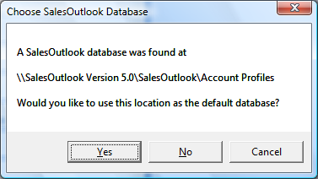

NOTE: STAND-ALONE AND DEMO USERS please skip to INSTALLATION STEP FIVE. Multi-user implementations require Microsoft Exchange Server. The Exchange Server administrator should continue with the setup process defined in INSTALLATION STEP TWO below.

INSTALLATION STEP TWO – Copy the SalesOutlook database
NOTE: Please see Appendix C on setting up a Delegate mailbox.

Copy the SalesOutlook Database to your Exchange Server Public Folders
- Navigate to the SalesOutlook Version # PST. Expand the folders by clicking the plus sign. Right Click on SalesOutlook and choose Copy SalesOutlook Folder.

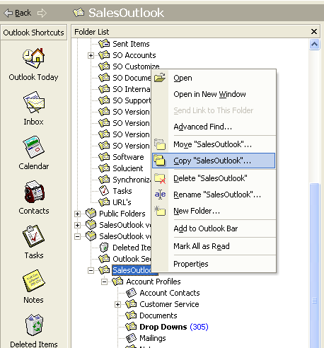

- Copy the folder to the Public Folders | All Public Folders directory (See appendix C for a Delegate Mailbox). It does not matter where the folder is copied. You can, for example, create another Public Folder called Sales and copy SalesOutlook to that directory.

INSTALLATION STEP THREE - Configuring Exchange Permissions
Setting the Folder Permissions on Exchange Server

Purpose: Allows you to assign permissions to each SalesOutlook folder for all users. Note: You can skip this step if you are running a local database. A local database is installed by default.

- Create two mail enabled security groups (Global or Domain level) in active directory using Active Directory Users and Computers administrative utility. The security groups must be mail enabled security groups of Universal or Domain scope, and you must not hide them from the Exchange Address book in order to select them when defining the folder permissions for SalesOutlook users.

NOTE: You may need a Windows Domain Administrator to create the two groups. You can name the groups the way you want to but for the purposes of this document create two groups named “SalesOutlook Admins” and “SalesOutlook Users”. You can create the group names that make most sense for your security needs. Some examples would be Sales, Marketing, or Service. You can then add individual SalesOutlook users to these groups and set the Exchange Server folder permissions by selecting the mail enabled security group from the address book.

- Connected online and within the Folder List, navigate to the SalesOutlook folder.
- Right click on the SalesOutlook folder and select Properties.
- Within Properties, select the Permissions tab.
- Add each user and select the appropriate permissions.
- Repeat for all SalesOutlook folders within the SalesOutlook folder structure.

NOTE: These are recommended suggestions for default security permissions and Active Directory security groups. You may grant the security permissions that are appropriate for your environment, users and security needs. However, some permission settings may prevent certain features from functioning as expected if the SalesOutlook user does not have sufficient rights to create, modify and/or delete the items affected by the SalesOutlook operation.

The following list contains the recommended Exchange security permissions for the SalesOutlook folders for the SalesOutlook Users group:

Folder Edit Delete Checked choices

SalesOutlook None Own Read items, Folder visible, Create Items

Account Profiles All Own Read items, Folder visible, Create items

Account Contacts All Own Read items, Folder visible, Create items

Customer Service All Own Read items, Folder visible, Create items

Actions All Own Read items, Folder visible, Create items

Documents All Own Read items, Folder visible, Create items

Drop Downs Own Own Read items, Folder visible

Mailings All Own Read items, Folder visible, Create items

Notes All Own Read items, Folder visible, Create items

Opportunities All Own Read items, Folder visible, Create items

Dead Leads All Own Read items, Folder visible, Create items

Products Own Own Read items, Folder visible

Checklists All Own Read items, Folder visible, Create items

Reports Own Own Read items, Folder visible, Create items

Leads All Own Read items, Folder visible, Create items

System Folder Own Own Read items, Folder visible

The following list contains SalesOutlook folder recommendations for SalesOutlook Admins:

Folder Edit Delete Checked choices

SalesOutlook All All Read items, Folder visible, Create items

Account Profiles All All Read items, Folder visible, Create items

Account Contacts All All Read items, Folder visible, Create items

Customer Service All All Read items, Folder visible, Create items

Actions All All Read items, Folder visible, Create items

Documents All All Read items, Folder visible, Create items

Drop Downs All All Read items, Folder visible, Create items

Mailings All All Read items, Folder visible, Create items

Notes All All Read items, Folder visible, Create items

Opportunities All All Read items, Folder visible, Create items

Dead Leads All All Read items, Folder visible, Create items

Products All All Read items, Folder visible, Create items

Checklists All All Read items, Folder visible, Create items

Reports All All Read items, Folder visible, Create items

Leads All All Read items, Folder visible, Create items

System Folder All All Read items, Folder visible, Create items

INSTALLATION STEP FOUR - Configuring SalesOutlook

Using the SalesOutlookSetup Form to Configure SalesOutlook
Purpose: The SalesOutlookSetup form allows administrators to enter in users and the license key generated by SalesOutlook, Inc. In addition, the SalesOutlookSetup form allows the administrator to set certain properties and customizations for the Account Profiles form. Global options are specified and field labels for the Account Profiles form are defined using the SalesOutlookSetup form.

Important Note: The SalesOutlook software automatically configures itself for evaluation (30-day) use until valid license key information is provided. Therefore, you do NOT need a license key to use SalesOutlook for evaluation purposes.

- Navigate to the SalesOutlook Folder within the Folder List and select the view Grouped By Type.

- Double Click on the SalesOutlook Setup form.

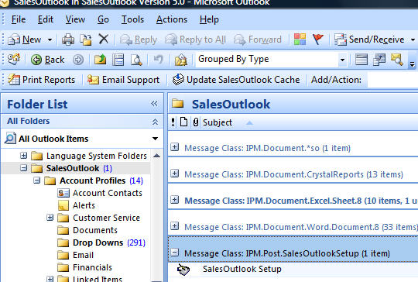

- The SalesOutlookSetup form displayed.

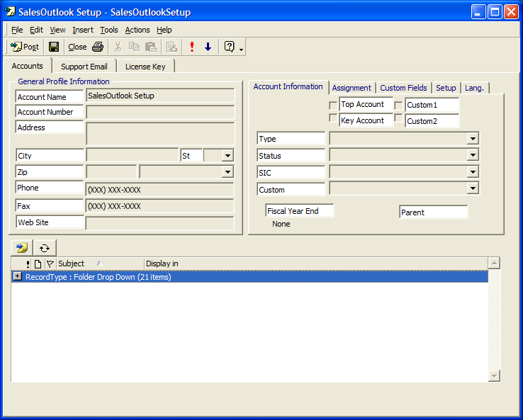

INSTALLATION STEP FIVE - Setup license keys and users.
Installing the SalesOutlook License Key and Users
(Not Required for Demo / Evaluation Use)

- Open the SalesOutlookSetup form from the SalesOutlook folder within the folder list.
- Select the License Key Tab. Office 2007 users click on SalesOutlook Setup then License key.
- Enter the License Key provided by SalesOutlook, Inc.
- Enter your company name in the Account Name field.
- Enter the Number of Users corresponding to the License Key.
- Enter the SalesOutlook users’ names. Use the “Users” button to select from the address book. You can also type in the user names separated by a semicolon. To delete a user, simply highlight the name and delete it.
- Save the form by clicking Post.

Note: At any time you can verify the number of users entered by clicking on the “User Count” button. INSTALLATION IS COMPLETE when the SalesOutlook setup form has a valid license key and all SalesOutlook users are added. Please proceed to the SalesOutlook Office 200X client setup manual to install and configure the client computer(s).

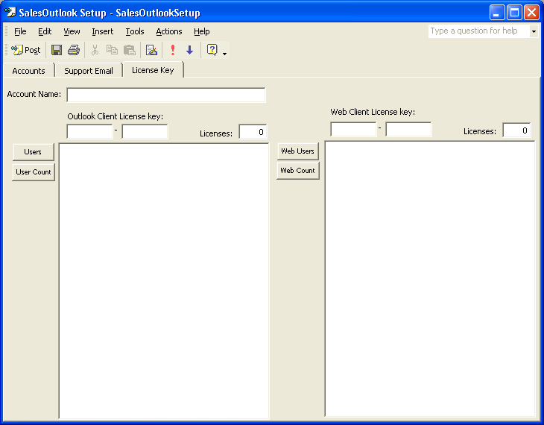

Administration

Assignment Tab Options
Open the SalesOutlookSetup form from the SalesOutlook folder within the folder list if it is not already opened..

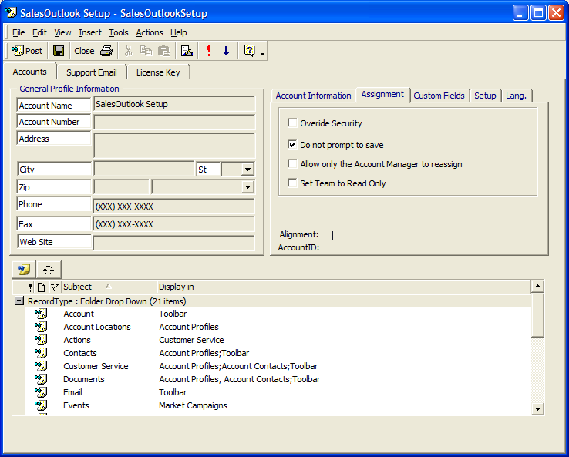

Overriding SalesOutlook Security

Allow all users to edit Account Profile Forms
Purpose: To override the built in SalesOutlook security for the Account Profile form. By default the security only allows the Account Manager and Team members to change basic Account information. In addition, by default all users can change notes, contacts, opportunities, and all other sub forms. SalesOutlook does not recommend overriding security.

- Open the SalesOutlookSetup form from the SalesOutlook folder within the Folder list.
- Click on the Assignment tab
- Check the Override Security checkbox to over ride the default SalesOutlook security.

Note: In general, the out of box security is designed to reduce conflicts for offline users. Enabling this feature could result in receiving more conflict messages.

Do not prompt to save
Purpose: This feature when enabled will NOT prompt the user to save after making changes to forms within SalesOutlook. To enable this feature, simply check the box “Do not prompt to save” on the Assignment tab within the SalesOutlookSetup form.

Allow only the Account Manager to reassign
Purpose: This feature when enabled will only allow the Account Manager to reassign their Accounts. To enable this feature, simply check the box “Allow only the Account Manager to reassign” on the Assignment tab located within the SalesOutlookSetup form.

Set Team to Read Only
Purpose: This feature when enabled will only allow the Account Manager to edit Accounts. Team members will only be able to read accounts. Useful with the optional SalesOutlook Active Security module further enhance security. To enable this feature, simply check the box "Set Team to Read Only" on the Assignment tab located within the SalesOutlookSetup form.

Setup Tab Options

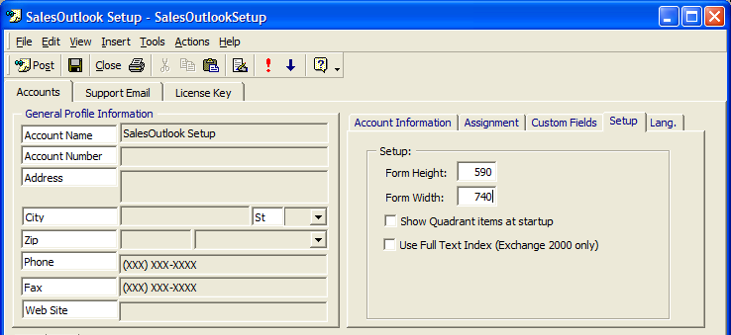

Form Height and Form Width
Purpose: This feature will allow you to set the parameters of the Account Profile form.
Simply enter new parameters within the Form Height and Form Width to change the size of the Account form. By default, the Form Height is 590 and the Form Width is 740. The Form Height and Form Width fields are located on the Setup tab within the SalesOutlookSetup form.

Show Quadrant items at startup
Purpose: This feature when enabled will default to the Quadrant default settings. By default this is set to list contacts. To enable this feature, simply check “Show Quadrant items at startup” on the Setup tab within the SalesOutlookSetup form.

Lang. Tab
Purpose: This tab allows administrators to change default properties relating to operations of SalesOutlook. These properties include the Select a Folder and Select a View found on forms such as account profiles and account contacts. Language versions would normally change these settings but you could also change these values to something like “Change Folder” and “Change View”.

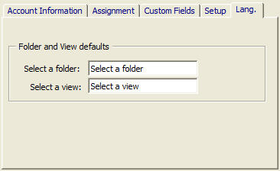

Support Email Tab
Purpose: This tab allows administrators to change properties relating to the “Email SalesOutlook Support” button. These properties include the support email address, support subject, and body of the support email. For example, administrators may choose to have users email an internal support help desk before contacting SalesOutlook support. The email address may be changed to reflect an internal email address for your company.

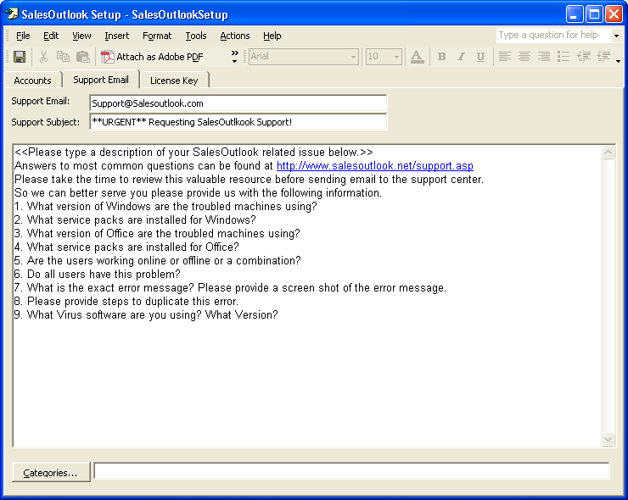
Customizing SalesOutlook

Customizing The Account Profile Form

Use the SalesOutlookSetup form to change field labels on the Account Profile form, including the drop down, checkboxes and custom text fields.

- Open the SalesOutlookSetup form from the SalesOutlook folder.
- Enter the information to change labels for the drop down text, or the checkbox text. Additional field label changes may be made via the Custom Fields tab.

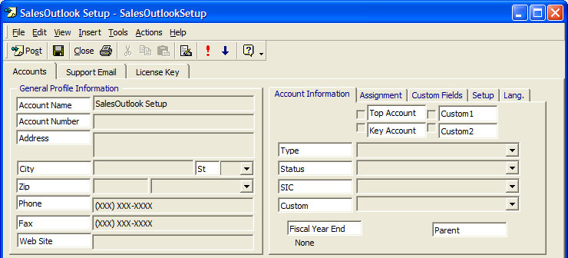

Offline users must sync their systems, and all users must click the Update SalesOutlook Cache button or re-map their SalesOutlook database fields in order for the new settings to take effect.
Note: Blank out the state label to have the Account Profile form resize the State drop down as in the following screen shot:

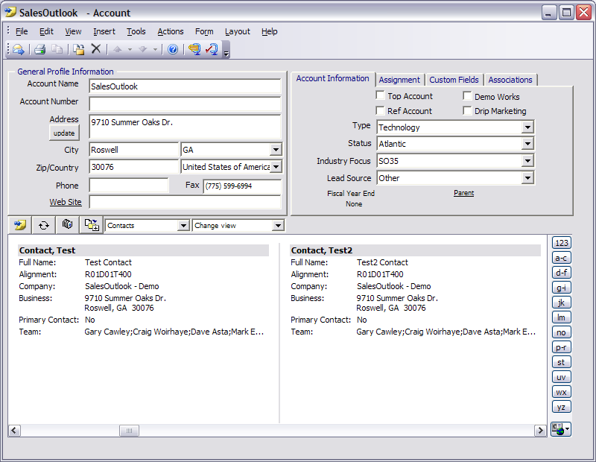
If the state label is blank then the city state fields resize as shown. Non US customers may want to blank out the state label to get this functionality.

Changing & Creating Drop Downs

Purpose: SalesOutlook forms allow you to customize the drop drown information. Users can customize the SalesOutlook drop downs by adding, changing, or deleting items in the drop downs folder.

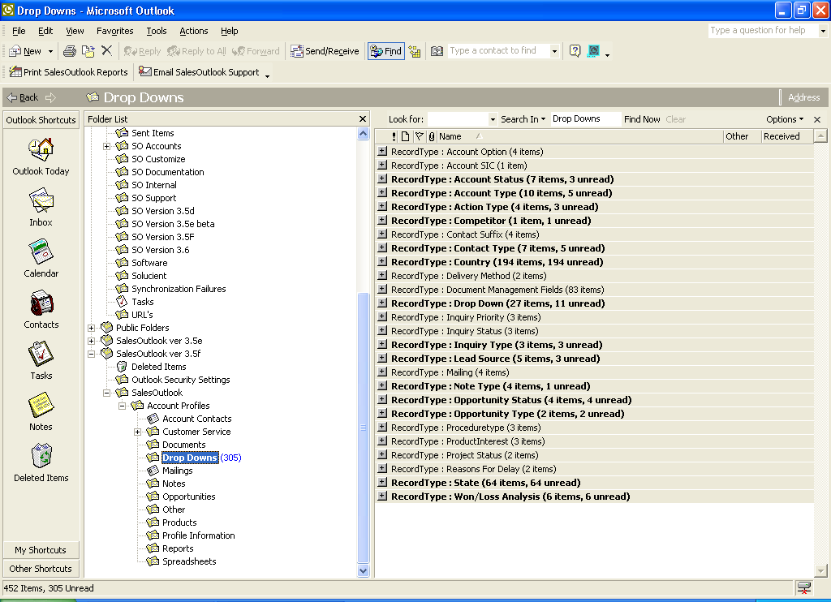

Changing existing Drop Downs
- Navigate to the Drop Downs folder located underneath Account Profiles from the folder list.
- Choose the Drop Downs by Type view. (IE View | Current View | Drop Downs by Type).
- Navigate to the drop down record type you wish to change.
- Double click on that drop down record type.
- Change the name of the drop down and save the record.
- Offline users must sync their systems, and all users must click the Update SalesOutlook Cache button or re-map their SalesOutlook database fields in order for the new settings to take effect.

Creating new Drop Downs
- Navigate to the Drop Downs folder located underneath Account Profiles within the folder list.
- Click on New (Standalone users must choose Actions/ New Drop Down.
- Select the drop down Record Type.

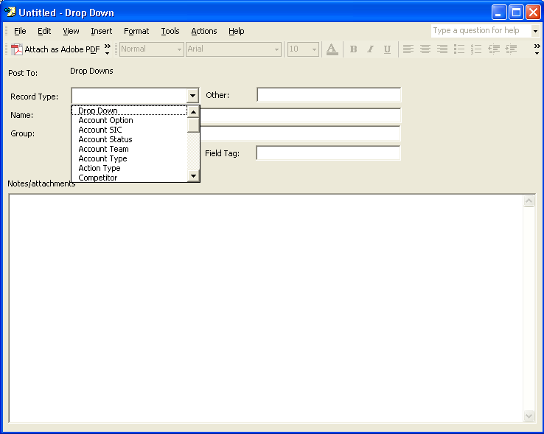

4. Enter the Drop Down name and save the dropdown by clicking Post.

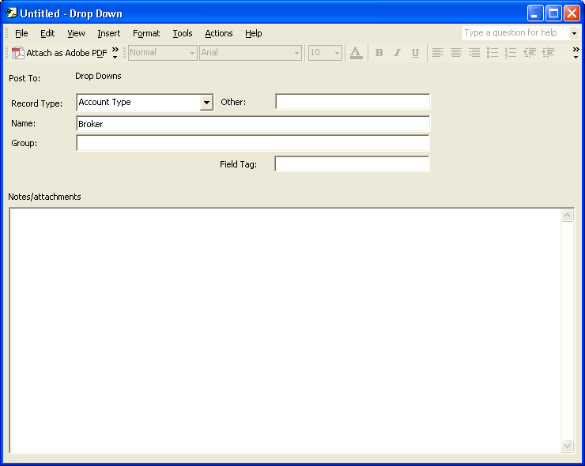

- Offline users must sync their systems, and all users must click the Update SalesOutlook Cache button or re-map their SalesOutlook database fields in order for the new settings to take effect.

Creating the - Account Type

Purpose: The “-“ account type is a special Account Type used primarily for linking customer information with an external database, such as an accounting system. When an Account Profile has an Account Type of “-Customer-“ (or any account type with a “-“ at the beginning, then the account name, account number, account type, and account status cannot be changed. This improves the integrity of the account information by matching the external database Account data to the SalesOutlook Account data. The AccountNumbertxt field is typically used to store the external database record primary key to establish the link between the two systems.

- Select or type an account type of “-Customer-“and save the record, or import SalesOutlook accounts with “-Customer” as the account type.

Creating the Note type for an automated note

Purpose: The “Note Type” is used for the drop down for the notes form field Note Type. The notes form will automatically put the text from the message body of the drop down to the note when the note type is selected.

For example: Create a record type of “Note Type” with a name of “Billable Time” and enter “Total time:” and “What was done:” into the Notes/Attachments section.

- Create a new drop down and select “Note Type” as the record type.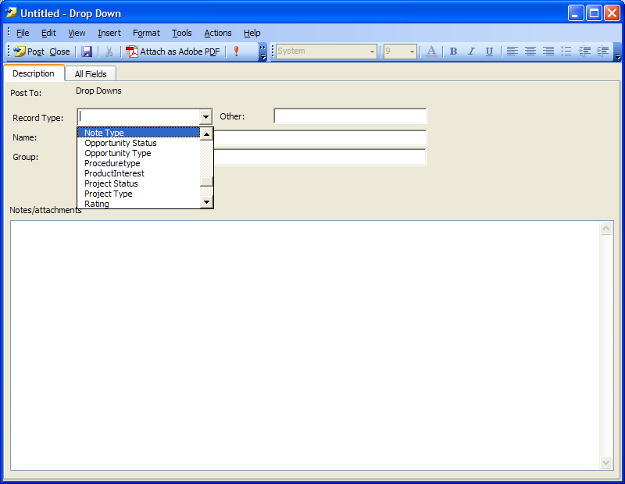
- Enter “Billable Note” in the name field (This is the name that shows in the drop down) Enter the Subject of the Note in the Other field. Enter “Total Time:” and “What was done” to the Notes section. 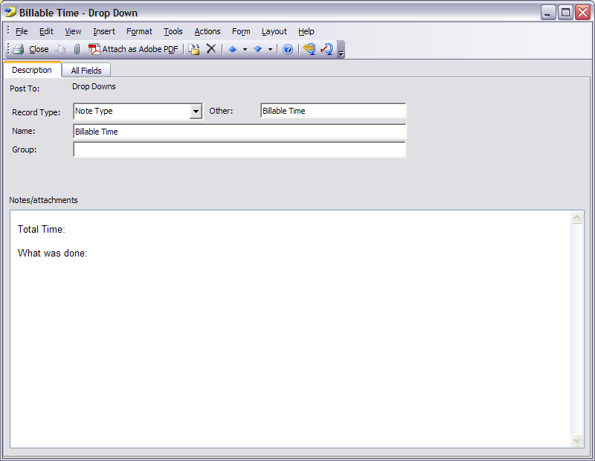
- Post the form and click on the build cache button.
- Create a new note and select the Billable Time for the note type. You should get the Total time and What was done to the expanded note section of the note.
- Offline users must sync their systems, and all users must click the Update SalesOutlook Cache button or re-map their SalesOutlook database fields in order for the new settings to take effect.

Customizing/Adding New Folders

Purpose: SalesOutlook allows you the ability to add or change folders without programming. This allows you to customize the system and increase your system performance. A new folder should be created once the items approach 20,000 items.

Add / Change folder settings:

- Navigate to your systems folder located underneath Account Profiles within the folder list.

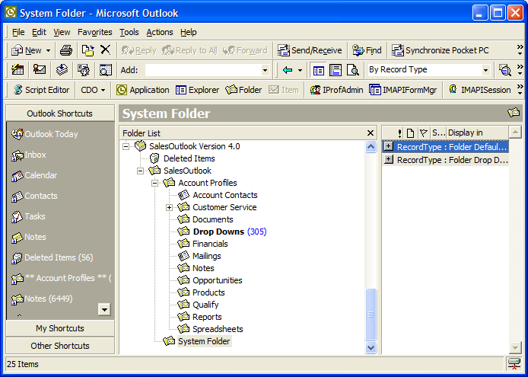

- Click on New or double click an existing folder record type of Folder Drop Down

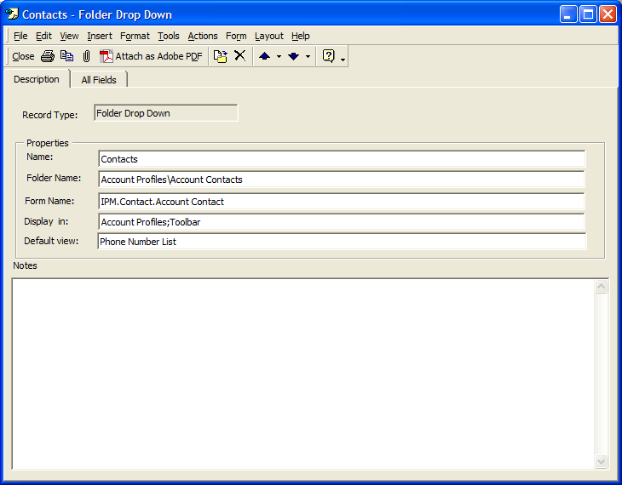

- The name field is the display name that will show up in the pulldown list.
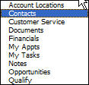
- The Folder Name field is the folder path starting from the SalesOutlook folder. Note: do not include the SalesOutlook folder name. Use a backslash to separate the folders.
- The Display in field is the folder that you want this folder to be displayed in. Note: Use toolbar if you want this item to appear in the toolbar pulldown. Use only the folder name here. Be careful not to name folders the same so this item will only show for the folder you want.
- The Default View field is the name of the default view you want when you navigate to this folder item.
- The Notes field is used for reference only and it is optional.
- Offline users must sync their systems, and all users must click the Update SalesOutlook Cache button or re-map their SalesOutlook database fields in order for the new settings to take effect.

IMPORTANT NOTICE: SalesOutlook is a very open and flexible system. SalesOutlook, Inc. designs SalesOutlook in this way so that it can be customized and extended to fit into the way your organization does business. However, this flexibility also enables you to BREAK existing functionality when you make changes. Therefore, you should take great care and design your modifications with great care. This includes setting up development and test environments that are separate from your production environment.

BEST PRACTICES: As a best practice, existing fields and folders should not be renamed. It is normally safe to change the text, or the Caption property, of a field label on a form but not the name of any control on the form. It is safe to add new controls on the form, and this is generally how SalesOutlook forms are enhanced to incorporate new data points and functionality. It is safe to add new fields and functionality, but caution must be taken to prevent “one-off forms” and to use the Outlook Object Model and CDO judiciously. All user defined fields must be defined within the folder (as opposed to only within the message item) and the folder field must be bound to the message item using a control on the form that will display the item. See the Microsoft Outlook online help, the Microsoft Knowledgebase, MSDN, SlipStick.com and OutlookCode.com for more information on developing Outlook forms and add-ins.

Most importantly, the correct operation of SalesOutlook’s DLLs and forms requires that the following “default” folders are always available with the same names and in the same locations as they ship “out of the box” with SalesOutlook:

- SalesOutlook
- SalesOutlook\Account Profiles
- SalesOutlook\Account Profiles\Sticky Notes
- SalesOutlook\Account Profiles\Account Contacts
- SalesOutlook\Account Profiles\Customer Service
- SalesOutlook\Account Profiles\Customer Service\Actions
- SalesOutlook\Account Profiles\Documents
- SalesOutlook\Account Profiles\Drop Downs
- SalesOutlook\Account Profiles\Linked Items
- SalesOutlook\Account Profiles\Linked Items\Linked Accounts
- SalesOutlook\Account Profiles\Linked Items\Linked Contacts
- SalesOutlook\Account Profiles\Mailings
- SalesOutlook\Account Profiles\Notes
- SalesOutlook\Account Profiles\Opportunities
- SalesOutlook\Account Profiles\Products
- SalesOutlook\Account Profiles\Reports
- SalesOutlook\System Folder
- SalesOutlook\Global Calendar

Note: The SalesOutlook SBE does not ship with all of the folders listed above. They are available as optional, add-on modules for SalesOutlook SBE edition systems. The folders above ship “out of the box” with the SalesOutlook CRM edition.

For the Advanced Sales System, an optional SalesOutlook module, this folder is also required:

- SalesOutlook\Account Profiles\Opportunities\Opportunity Products

Modifying Power User Interface Quadrants

Purpose: The Folder Default or Quadrants are used to set the defaults for the four quadrants of the Account Profile form when displayed in the enhanced Power User mode.

Changing the Quadrants

- Double click on one of the folder default record types.

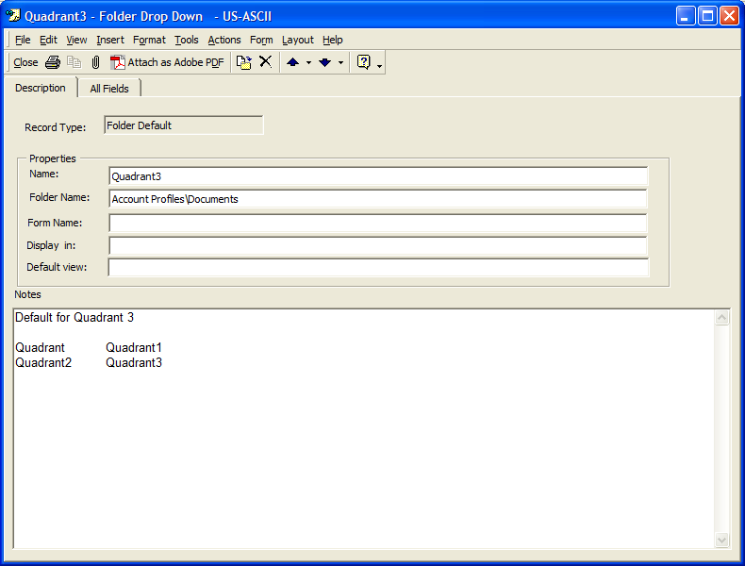

- Change the folder name to the folder that you want to show in the quadrant and save the form. NOTE: The folder name is the only field that needs to be changed.

Exercise: Create a new custom system folder for customer service and a new notes history folder.

- Right click on system folder and choose copy. Copy this folder to the root of SalesOutlook.
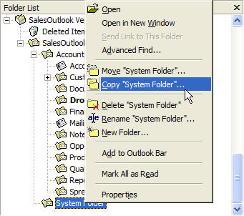

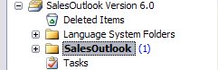

- Right click on Notes and choose copy. Copy the notes folder under Account Profiles.
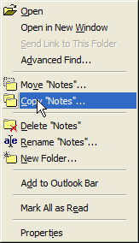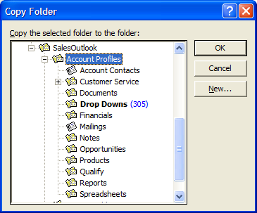

- You should have a System Folder1 and a Notes1 folder.

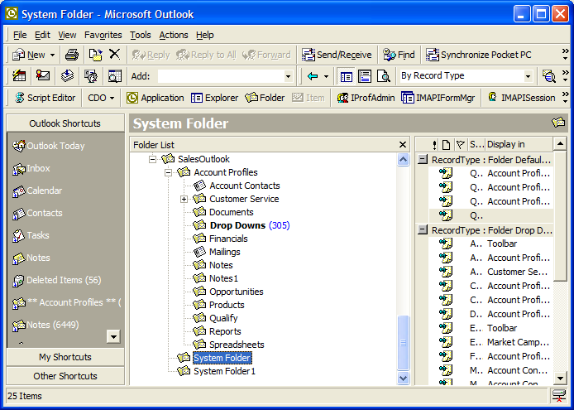

- Right Click System Folder1 and rename it to “Customer Service System”. Right click the Notes1 folder and name it “Notes History”

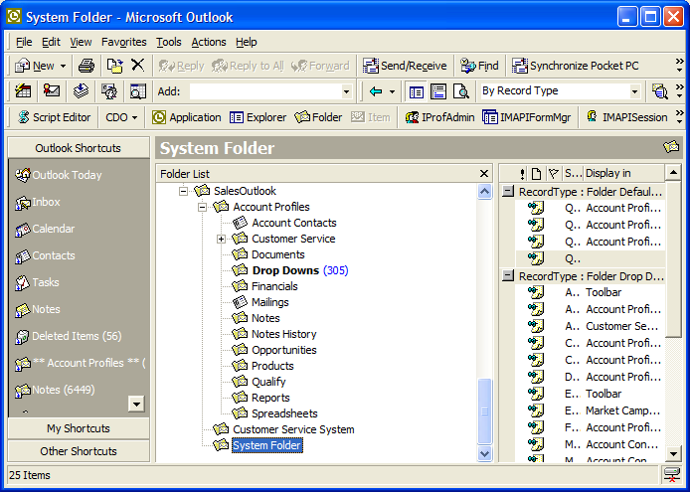

- Click on Customer Service System folder and click new. Enter Notes History as the name, Account Profiles\Notes History as the folder, IPM.Post.Note as the form name, Account Profiles;Account Contacts as the Display in and SalesOutlook Account View as the default view. Post the form.

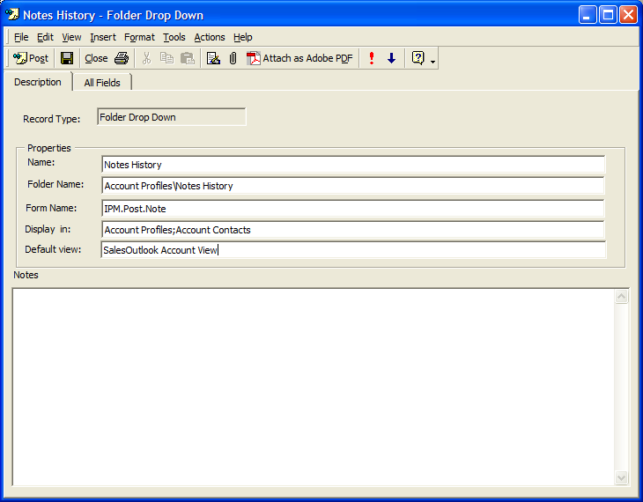

- Open up Quadrant1 in the Customer Service System folder and change opportunities to Customer Service. Save this form.

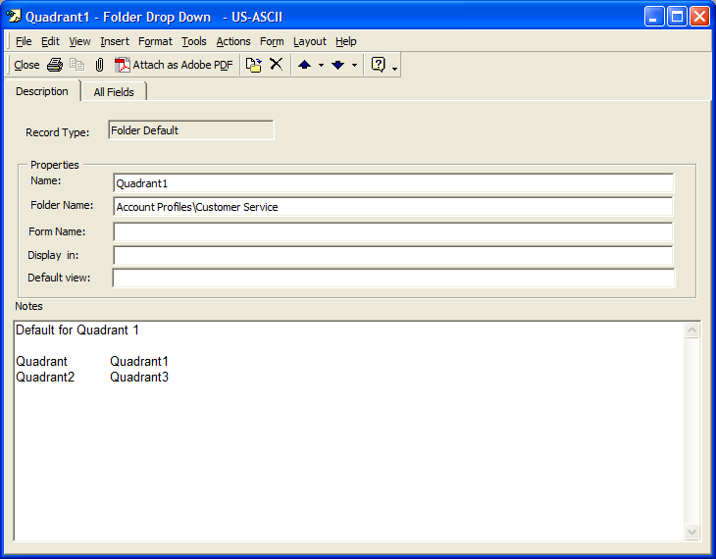

- Test the new system folder by choosing tools | Options | SalesOutlook folder settings and change select the new system folder.

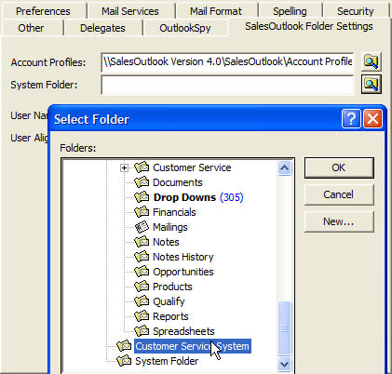

- Open the Account Profiles form and check to make sure Notes History is present and that customer service is the default for Quadrant1.

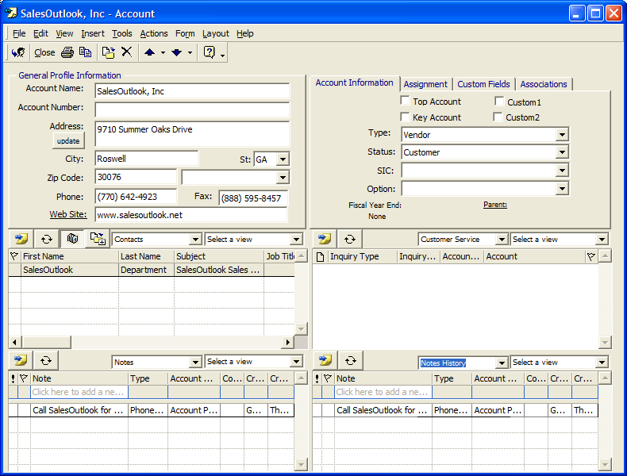

Note: SalesOutlook recommends copying an existing SalesOutlook folder for creating new folders. You can then customize the form and change the form name (Message class).

Customizing/Adding Language settings
Purpose: SalesOutlook 4.1 adds the ability to override the field labels on any form with out programming. This is useful in creating different language versions of SalesOutlook and allows customization of the “out-of-box” forms with out programming. Translation records in the system folder are used for storing the new field labels.

Translation Record Quick Reference
Displays the logical name of the Language.

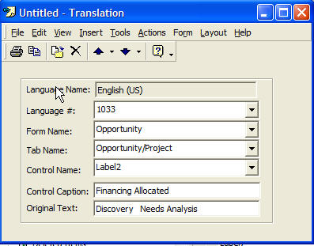
1. Click here to select the language number.
2. Click here to select the form to change.

4. Click here to select the label name.

3. Click here to select the Tab name on the form.

5. Click here to change the display name of the field.

This should reflect the original value of the field.

Changing Translation records
Example: Change the Opportunity forms labels for sales and project stages. Change sales stage “ Discovery Needs Analysis “ to “Financing Allocated“ and change project stage “Kick Off “ to “Project Start”
- Navigate to the System folder
- Choose the view “Language”.
- Expand the English(US) translation records.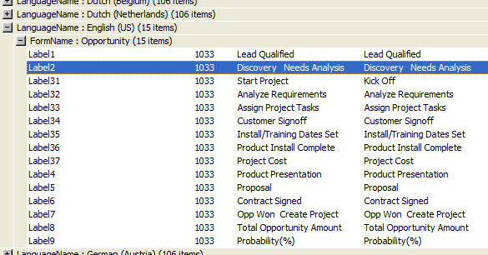
- Find “Discovery Needs Analysis“ and double click to open the record.
- Change “Discovery Needs Analysis“ control caption field to “Financing Allocated“ and save the record.
- Find “Kick Off “ and double click to open the record.
- Change “Kick off“ control caption field to “Project Start “ and save the record.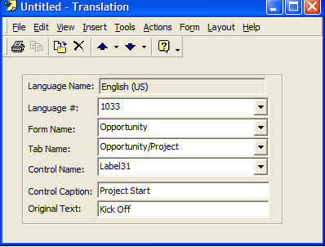
- Open the opportunity form, you should now see “Financing Allocated” and “Project Start”.

Creating a New Language
If your language is not available in SalesOutlook then you can create a new language with the following instructions:

Step one: Create the language drop down.
- Navigate to the Drop Downs folder.
- Create a new Drop Down.
- Select Language as the record type.
- Enter the number of the language in the Name field. Example: “1033” for English(US)
- Enter the name of the language in the Other field. Example: “English (US)”.
- Save the record.
- Click on the Update Cache button.

Step two: Create the Language records.
- Navigate to the System Folder.
- Select a current language group and either:
  - change the current records
  - copy an entire record set by highlighting a group and selecting from the menu edit | copy then edit | paste.
- Double click on the first records in the group to open the record.
- Click on the language number and choose the language number entered in step one.
- Change the control caption to the new language equivalent.
- Save the record.
- Repeat for each unique record from #2.

Maintaining Products

Purpose: The product folder is used as a product catalog. Product names are used within the opportunity module so that you can select a product while creating a sales opportunity.
NOTE: SBE uses the Drop Downs folder (Product Group)
- Navigate to the Products folder located under Account Profiles from within the Folder List.
- Click on New (Standalone users must choose Actions/ New Product).
- Enter the new Product name
- Electronic product literature can be attached to the product form.
- Additional product information shown can be entered here as well.

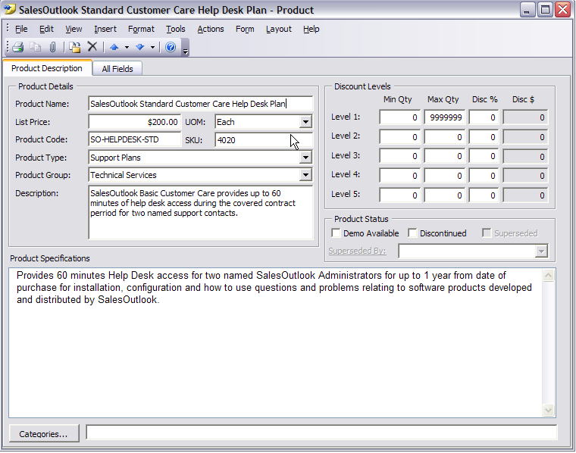

Creating Word Templates

Purpose: The Word template feature was designed to manage Word forms such as common company forms. It was not designed to be a full document management system. Caution: Too many documents can cause slow sync times. Document templates can be created and managed by an administrator and sent to the remote field.

Recommended: Start by saving your original document within the SalesOutlook Folder. After modifying your document, keep a backup within the Administrator’s local hard drive. Delete the original document within the SalesOutlook folder and Drag and Drop the modified document to the SalesOutlook Folder.

- Build your Word Document. Copy your document into the SalesOutlook folder.
- Your document name appears in alphabetical order within the SalesOutlook Document Selection for a user to select when adding a document to an account or contact once placed within the SalesOutlook folder.

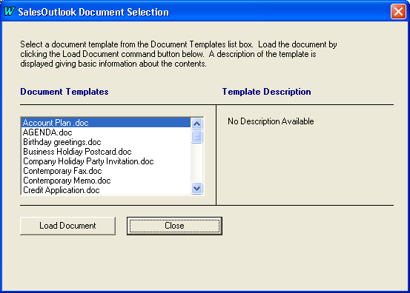
- Create a BookMark in your template if you want to populate the template with data from any of the SalesOutlook forms.

Note: The following template bookmark field names are used for both the Account and Account Contact document template types:

AccountName
Address
City
State
Zip
Country
Phone
Fax

Note: There are specific bookmarks for contacts fields such as (contactname, lastname, firstname, etc in the manual). Please see the drop downs folder for a complete list of bookmarks located in the Document Management Fields. For custom fields refer to the section ”How to Create a Custom Document Management Field” that appears later in this manual.

How to Create a Text Form Field Using a Bookmark
- Select Insert | Bookmark and enter the bookmark name that corresponds to the document management field located in drop downs.

How to Create a Text Form Field Using a Bookmark

- Select View | Toolbars | Forms from the toolbar

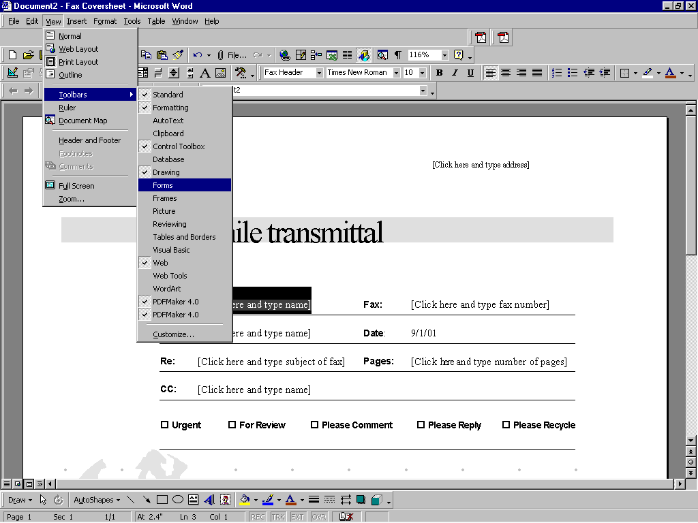

- Click on the Text Form Field icon

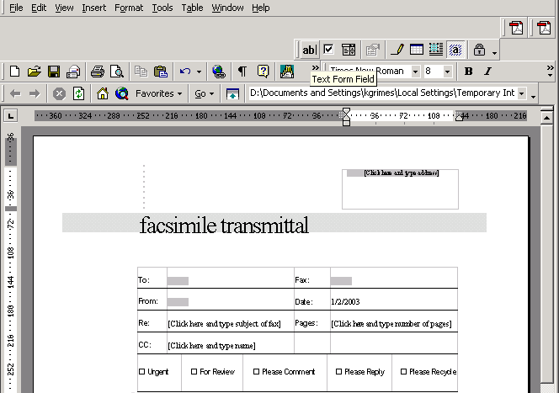

- Click on the Form Field Options icon

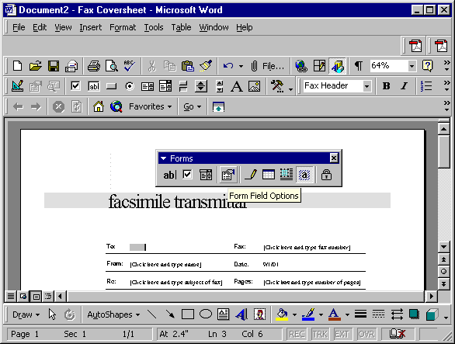

- Within Field settings, enter the Bookmark Name.

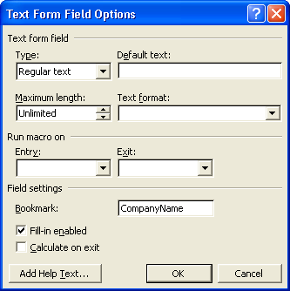

- Say OK if creating a BookMark and save any changes to your document. Be sure updated changes are reflected within the document held within the SalesOutlook folder.
- Your document is now ready to be used the next time a user synchronizes or connects directly to the Exchange server.

Alternative Method of Using Bookmarks in Document Management

Within Office 2000 / Word 2000 or Office XP / Word XP (2002):
- Click where you want to insert the information within the document.
- On the Insert menu, click Field.
- Click Document Information in the categories section.
- Click DocProperty in the Field Names.
- In the Field Codes textbox put the name of the field you are pulling from SalesOutlook in quotes.
IE: DOCPROPERTY “Address”

Creating Excel Templates

Purpose: The Excel template feature was designed to manage Excel forms such as common company forms. It was not designed to be a full spreadsheet management system. Caution: Too many spreadsheets can cause slow sync times. Spreadsheet templates can be created and managed by an administrator and sent to the remote field.

Recommended: Start by saving your original template within the SalesOutlook Folder. After modifying your template, keep a backup within the Administrator’s local hard drive. Delete the original template within the SalesOutlook folder and Drag and Drop the modified template to the SalesOutlook Folder.

- Build your Excel Template. Copy your template into the SalesOutlook folder.
- Your template name appears in alphabetical order within the SalesOutlook Spreadsheet Selection for a user to select when adding a template to an account or contact once placed within the SalesOutlook folder.

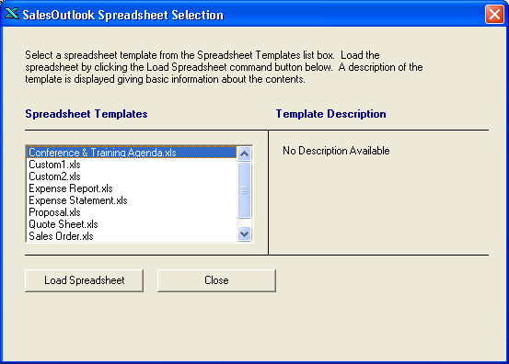

- Create Defined Names in your template if you want to populate the template with data from any of the SalesOutlook forms.

Note: The following template bookmark field names are used for both the Account and Account Contact document template types:

AccountName
Address
City
State
Zip
Country
Phone
Fax

Note: There are specific bookmarks for contacts fields such as (contactname, lastname, firstname, etc in the manual). Please see the drop downs folder for a complete list of bookmarks located in the Document Management Fields. For custom fields refer to the section ”How to Create a Custom Document Management Field” that appears later in this manual.

How to create Defined Names

- Select Insert | Name | Define

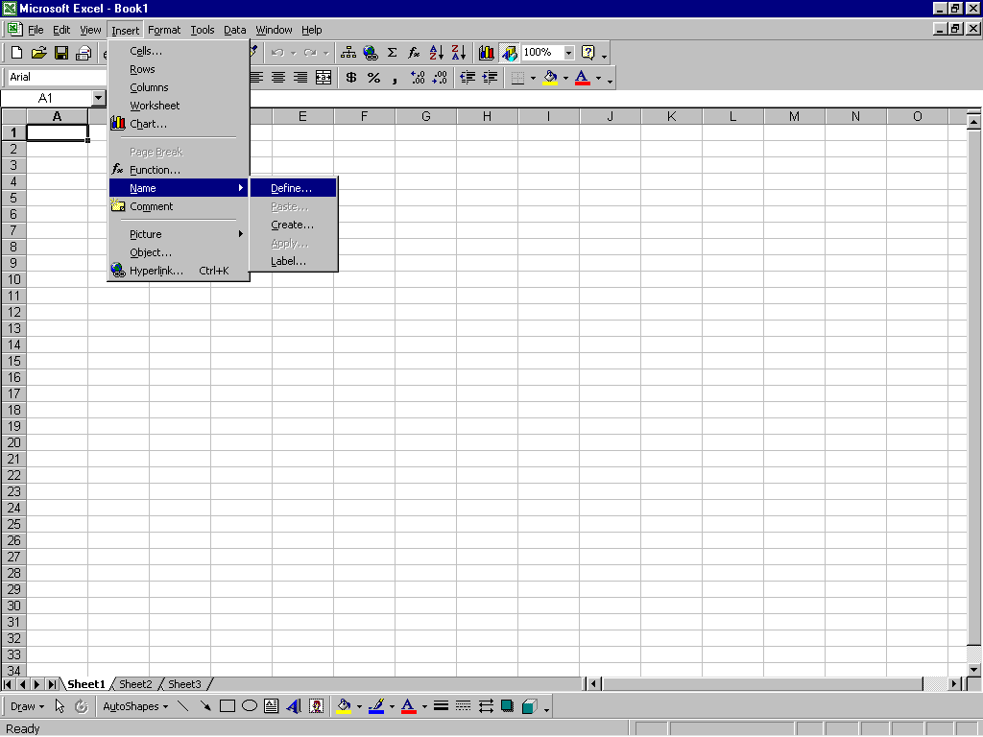

- Enter one of the defined names from the Document Management Fields with the dropdown list.

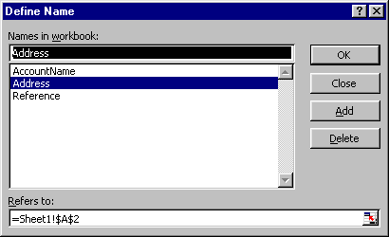

- Say OK if creating Defined Names and save any changes to your template. Be sure updated changes are reflected within the template held within the SalesOutlook folder.
- Your template is now ready to be used the next time a user synchronizes or connects directly to the Exchange server.

How To Create Custom Document Management Fields

To properly manage the document fields for SalesOutlook, each desired field must be defined as a “Document Management Fields” dropdown within the Drop Downs folder.

- After creating your custom field on a SalesOutlook form, navigate to the dropdowns folder within the folder list. Select Actions / New Drop Down.

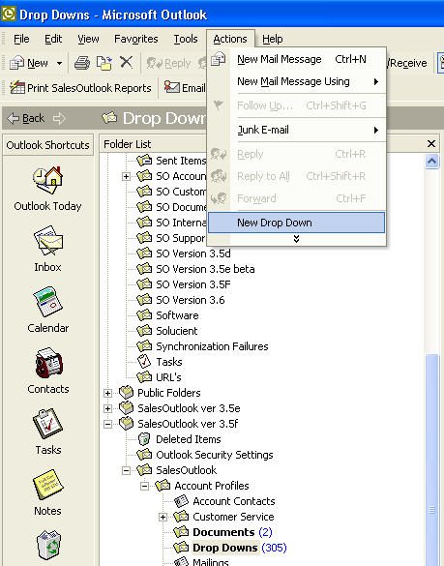
- Create a new Drop down and give it a Record Type of Document Management Fields. Type the name of the bookmark in the Name field. IE: CustomField1. NOTE: Bookmarks cannot have spaces in them. Type the name of the field in the Other field. IE: Custom Field 1. NOTE: This is the Outlook custom field name. Save the form. You can now use the custom field as a bookmark in your documents and templates.

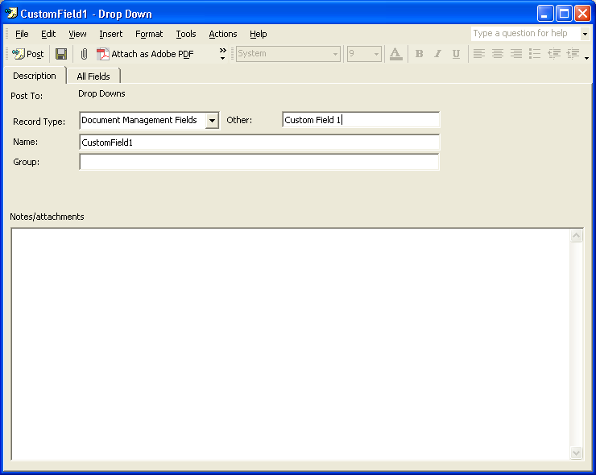
Word Bookmark or Excel Named field
(The Name should have no spaces)
Actual name of form field / public folder field

NOTE: On the All Fields tab is a field “FieldTag:” This special field is for use with those Outlook fields which require extended MAPI tags to extract the field values. These fields are normally “built in” Outlook fields and are most commonly visible on a standard Contact form within Outlook.

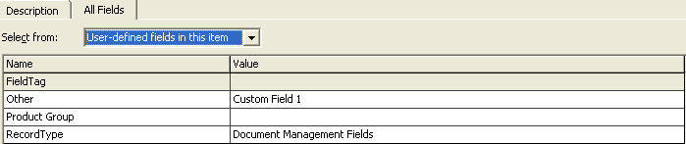
Extended MAPI Tag for integral Outlook fields.

Designing A Form

Purpose: SalesOutlook allows you the ability to fully customize all forms except the Account Profiles form which is customized through the SalesOutlook setup form. Therefore, any of the sub forms, such as Customer Service and Opportunities, can be customized. Customizing these forms gives you the ability to change labels, add text, fields, automate workflows and etc. For additional information concerning the designing of forms, consult an Outlook reference guide.

How to Design a Form

- Access the form you want to customize by first selecting the folder from the Folder List. In the example below we selected the Opportunities folder since the form we want to customize is the Opportunity form.

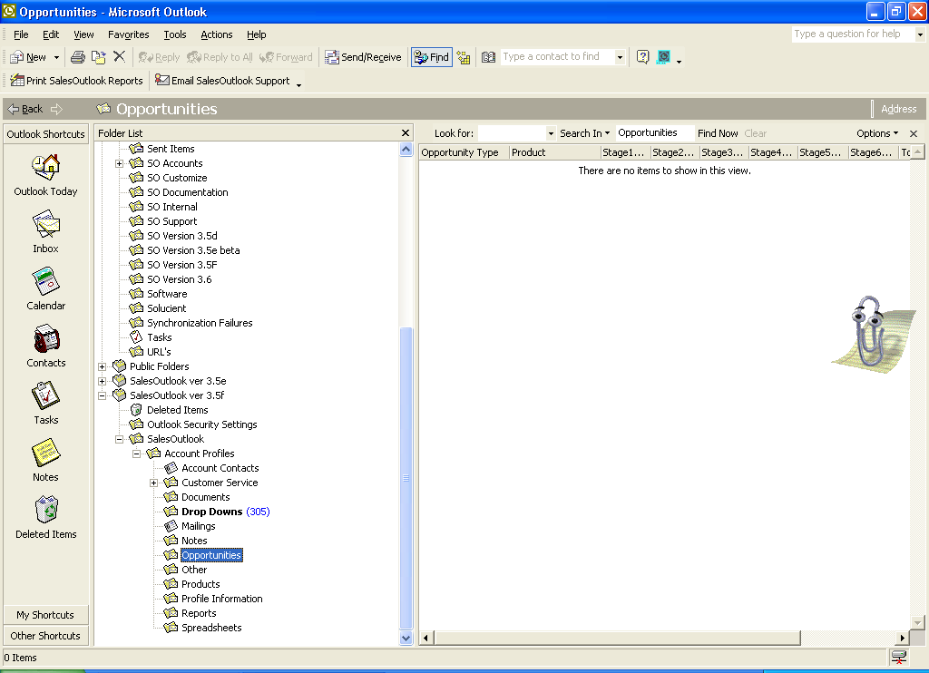

- NOTE: Very Important instructions follow. Hold down the shift key and select Actions/ New (form name). In this case we selected Actions/ New Opportunity to customize the Opportunity form. Once the form is pulled up to the screen, you can let go of the shift key.

Note: The shift key allows the form to pull up without running the code. This will keep any ID’s and other data, like the Created, Conversation, or Modified fields from being populated with data and stored with the form when it is published.

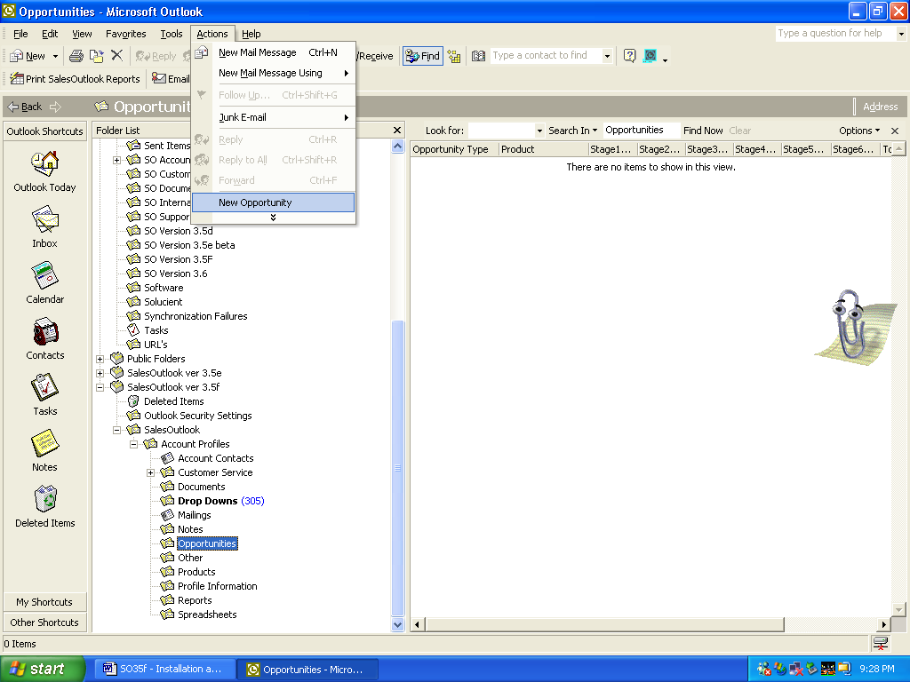

- Select Tools/Forms/Design This Form

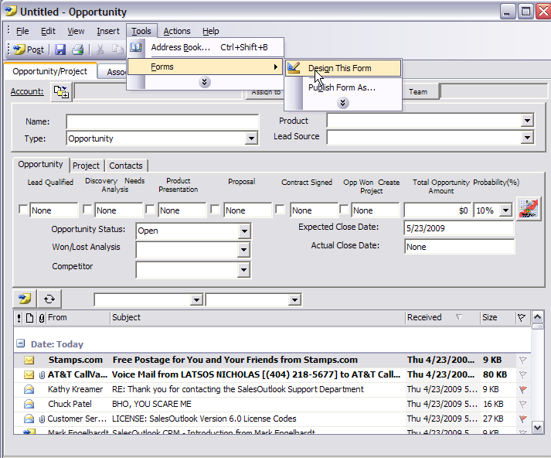

- Enter the form design password. Licensed SalesOutlook customers may obtain an authorized password by contacting SalesOutlook, Inc.

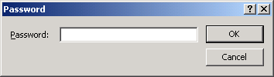

- The form displays in design mode.

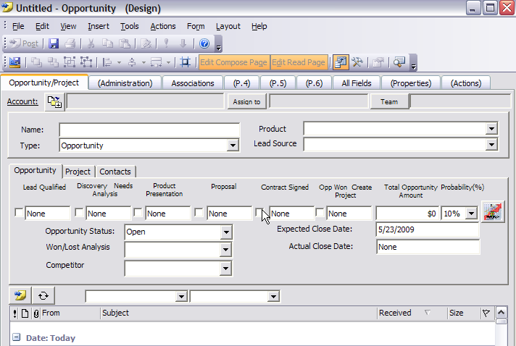

Note: The section below gives some basic information for designing the SalesOutlook forms. The links below are provided as an additional resource for customizing forms and other information pertaining to Exchange and Outlook.

http://www.salesoutlook.net/support.asp
http://support.microsoft.com
http://msdn.microsoft.com
http://www.microsoft.com/technet
http://www.microsoft.com/servers
http://www.microsoft.com/office
http://www.microsoft.com/windows
http://www.slipstick.com
http://www.outlookcode.com
http://www.msd2d.com

How to Change a Field Label in Design Mode

- After opening the form within Design Mode, simply click the label and place the cursor within the box to change the label.
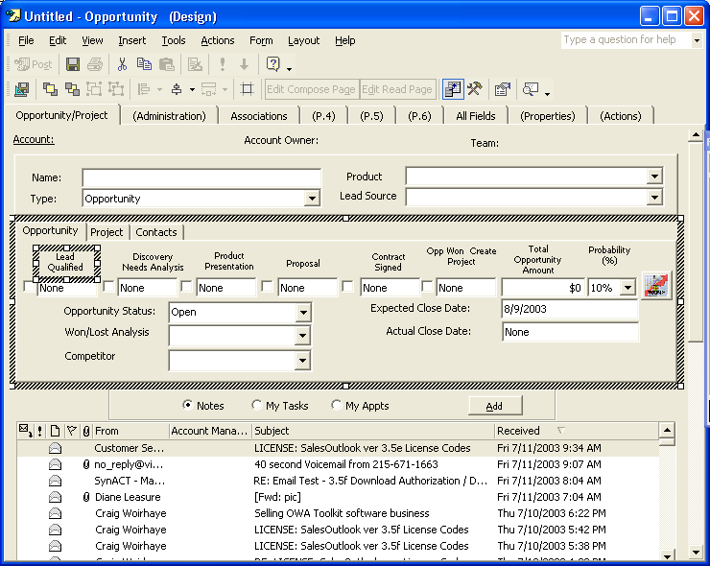

How to Add a Field to a Form within Design Mode

- After opening the form within Design Mode, select New from the Field Chooser box. Note: If the Field Chooser box is not displayed, select Form/ Field Chooser to display the Field Chooser box.

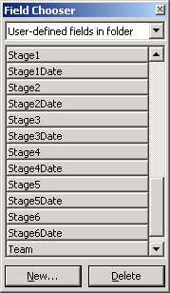

- Enter the Name, Type, and Format of the Field.

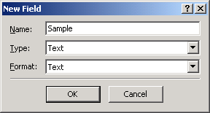

- Click the drag the field just added from the Field Chooser box onto the Form.
Note: New fields are located within the “User-defined fields in folder” category of fields.

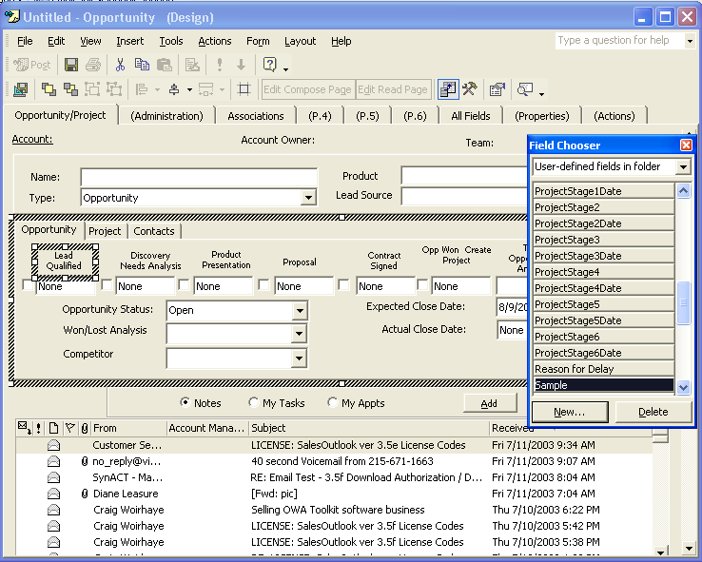

Publishing a Form

Purpose: Once a form’s been customized it must be published in order for its changes to take affect. Although forms may be customized offline, it’s important for an administrator to publish forms ONLINE to ensure the form publishes properly. Offline users will receive the updated forms once they synchronize their SalesOutlook folders so long as the “Synchronize Forms” checkbox is checked within the “Define Send/Receive Groups” option in Outlook.

How to Publish a Form

- Open Outlook and work “connected” (online)
- Open the form to be published in design mode

IMPORTANT NOTE: When publishing a form to a folder other than the one it was designed within, you must verify that all fields defined as “User-defined fields in Item” on the All Fields Tab on the form to be published exist and are defined with EXACTLY the same names (including spacing and capitalization) and data types as the list of “User-defined fields defined in folder” in the folder where the form will be published. This prevents the form from becoming a “One Off Form”. By default, Microsoft has configured Outlook so that it will not execute code within One-Off forms. For more information on One-Off forms, refer to the Microsoft Knowledgebase at support.microsoft.com.

If there are fields defined within the form item to be published that do not exist within the folder the form will be published to, create the fields in the destination folder BEFORE publishing the form.

- From the Toolbar select Tools/Forms/Publish Form As.

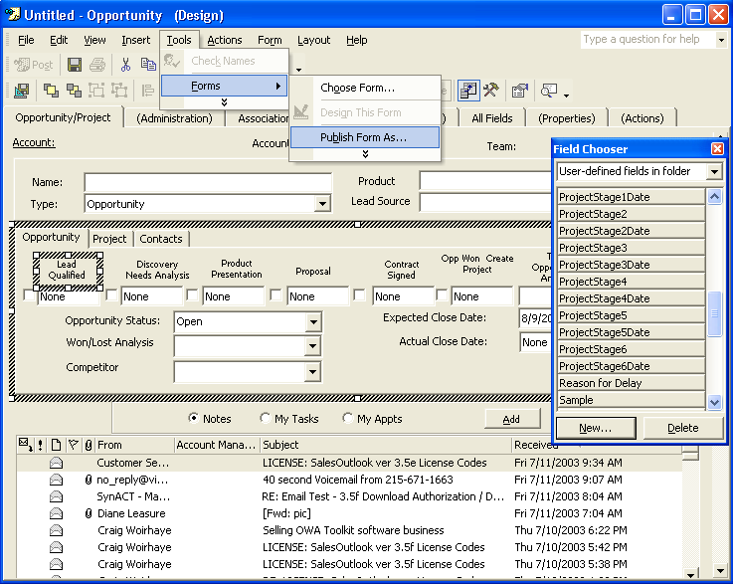

- The Publish Form As window box displays.

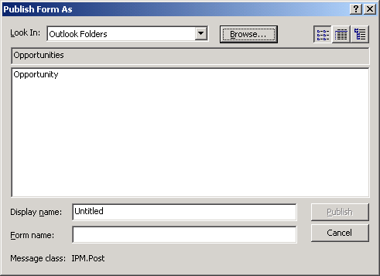

- Select “Outlook Folders” if it does not already appear in the Look In dropdown, and then click the Browse button. The Go To Folder window box displays. Navigate to the Folder in which you want to publish the form to and click OK. In this example we’ve selected the Opportunities Folder since we’ve customized the Opportunity form.
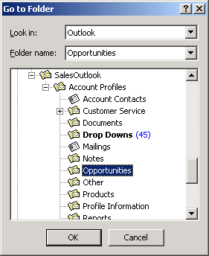

- The Go to Folder window box is automatically closed and the Publish Form As box is again displayed. Highlight the form displayed within the box. The Display and Form name fields will populate with the form selected. Verify you have the proper form and click Publish. You can now exit the form.

NOTE: You can also make a backup of the form by selecting File/Save As from the toolbar and saving the form with an OFT format.

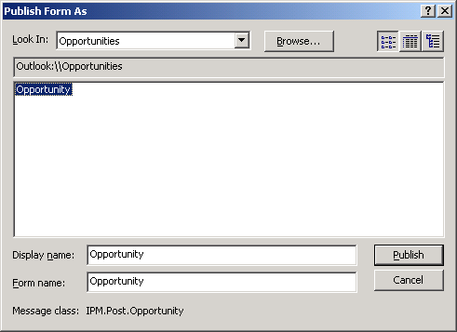

Add a Crystal Report to SalesOutlook

- Create your Crystal Report
- Copy your Crystal Report to the SalesOutlook folder
- SalesOutlook will automatically find the report and put it in the list of reports

Note: The report summary information of Crystal Reports is read from the description of the report for the list of SalesOutlook reports.

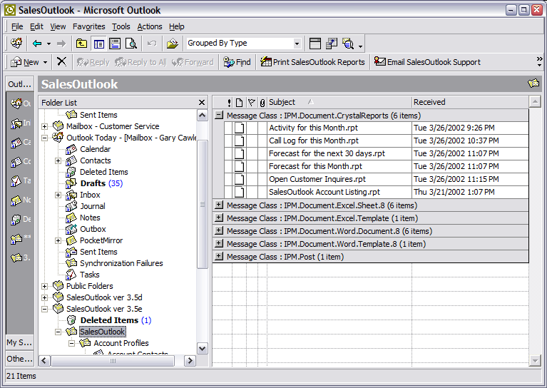

Creating Reports via an Access Database

SalesOutlook developed an entirely new reporting engine that uses a backend Access database. Administrators and users can develop reports using this new reporting tool. Since this utility is powerful and contains many options, SalesOutlook created a separate document entitled “SO4X – Reporting Guide”. Please consult this document for details relating to the configuration and use of the SalesOutlook Reporting Engine.

SalesOutlook Built In Tools

Realigning Account Managers (Territory Realignment)

Purpose: SalesOutlook data is stamped with an Account Manager, Team, and Alignment (optional) in order to synchronize data offline and to provide ownership to records. The realignment tool allows you to change the ownership of multiple SalesOutlook records in one bulk operation. If a sales person changes territories or leaves the company, then the realignment tool enables you to easily change all records for that Account Manager to another Account Manager within the system.

How To Realign SalesOutlook Records
- Open the SalesOutlook Realign form from the SalesOutlook folder. (IE Navigate to the SalesOutlook folder and choose Action | New SalesOutlook Realign.
- Minimize this form and go back to Outlook.
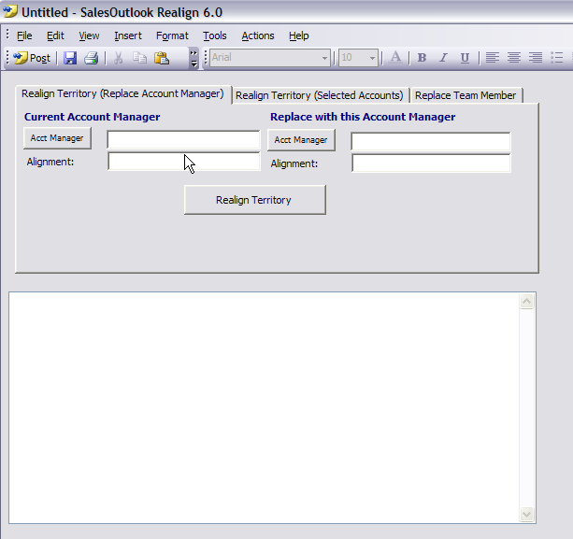

- Navigate to the Account Profiles folder from within the folder list.
- Change the view to “By Account Manager”, or any other view that enables you to easily identify and select the records to be aligned, by selecting View/Current View from the main Outlook menubar.
- Highlight the Account(s) you want to realign.

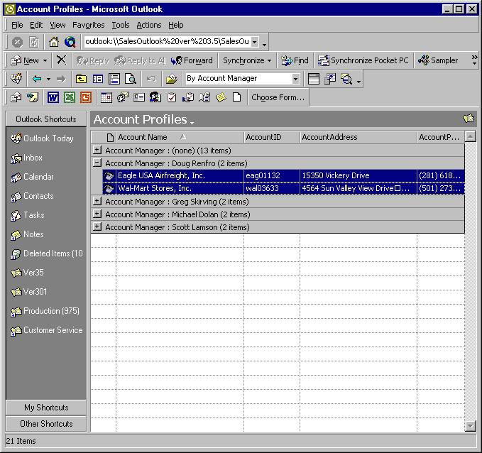

- Restore the SalesOutlook Realign form by clicking its icon on the windows taskbar at the bottom of your screen and select the new Account Manager on the Realignment form using the button provided. Specify the appropriate Team members, and if using Alignment, enter the alignment value in the Alignment field.

Note: The “Update Sub Folder Items” checkbox is automatically checked. SalesOutlook recommends this box to remain checked to enable SalesOutlook to automatically update any sub items associated with the Account. Sub items include all items related to an Account Profile, such as Account Contacts, Opportunities and Notes.
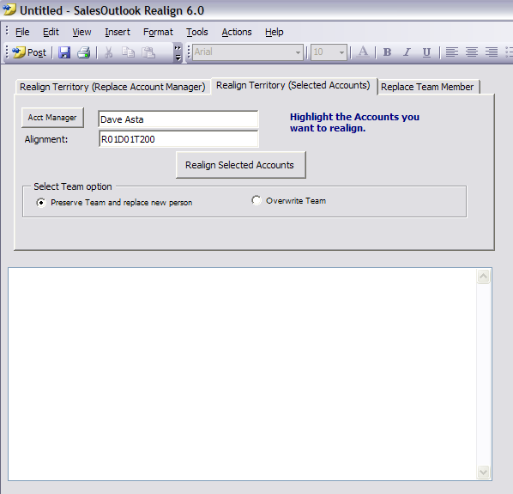

- Click on the Realign Selected Item(s) button to begin the realignment process. You will receive a message confirming the number of records to be affected and the folder they are in. Verify this information and choose Yes to continue the Realignment operation.
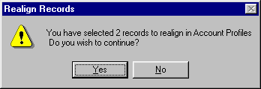

- Wait for the “All Done” message, and then click the OK button.
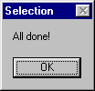

- You can close the Realign form or choose to align other items.

Deleting Account Profiles

Purpose: By default a user can delete the subfolder items (depending on Exchange security). However, it’s recommended that delete none should be setup as the security for the Account Profiles folder. If an Account Profile is deleted, then orphaned sub items in the sub folders will remain with no related Account Profile. Therefore, SalesOutlook designed the SalesOutlook Delete form to cascade delete all information for an Account, including the sub items stored in related folders.

You can also right click on an account profile and choose Delete this Account and all sub items.

How To Use The SalesOutlook Delete Utility.
- Open the SalesOutlook Delete form from the SalesOutlook folder. (IE Navigate to the SalesOutlook folder within the folder list and choose Action | New SalesOutlook Delete.)
- Minimize the form and return to Outlook.
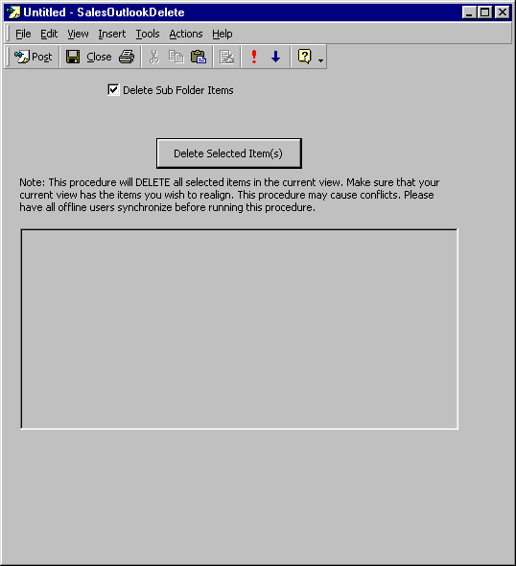

- Navigate to the Account Profiles folder from within the folder list.
- Change the view to By Account Manager or any other view that will help you identify and select the Account Profile records to be purged from the SalesOutlook database.
- Highlight the Account(s) you want to delete.

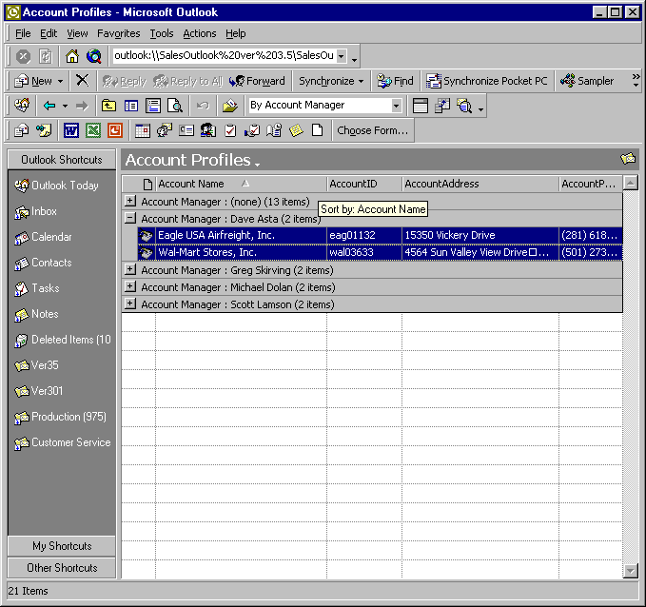

- Restore the SalesOutlook Delete form by clicking its icon on the Windows taskbar at the bottom of your screen, and then click the Delete Selected Item(s) button.

Note: The “Delete Sub Folder Items” checkbox is automatically checked. SalesOutlook recommends this box to remain checked to also delete any sub items associated with the selected Account(s). Sub items include, but are not limited to, such items as Account Contacts, Opportunities and Notes.
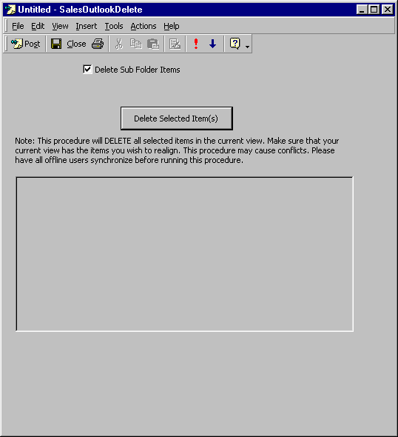

- You will receive a message indicating the number of records to be deleted and the folder they are in. Verify this information and click Yes to proceed with the Delete operation.

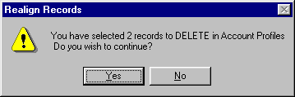

- Wait for the “All Done” message.

- You can now close this form or delete other records.
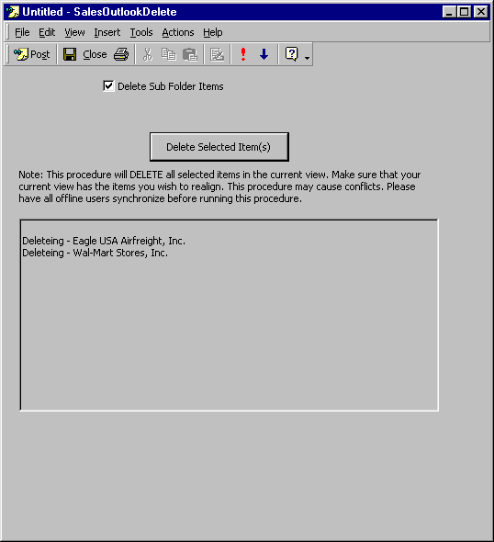

Note: Deleting an Account Parent will NOT delete the Account Locations associated with that Parent Account. To delete the Locations related to an Account, use the SalesOutlook Delete form to delete the Locations and their sub-items or select the Location records at the same time that you select the related Account Parent record.

Move Account Profiles Records

Purpose: The SalesOutlook Move/Copy utility allows Account Profile records to either be moved or copied from one Account Profiles folder to another Account Profiles folder. This tool is extremely handy when wanting to move accounts from a PST to your main SalesOutlook folder.

How To Move Account Profiles

- Open the SalesOutlook Move/Copy Account Profiles form from the SalesOutlook folder. (IE Navigate to the SalesOutlook folder from within the folder list and choose Action | New SalesOutlook Move/Copy Account Profiles.)
- Minimize this form and go back to Outlook.

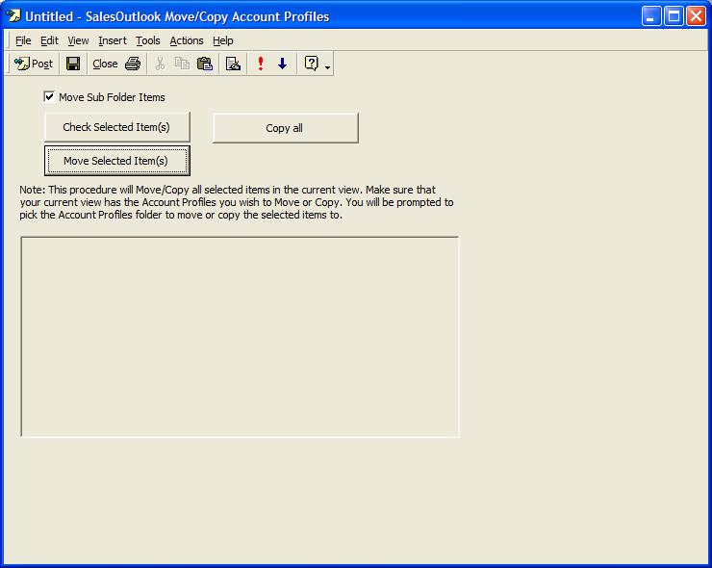

- Navigate to the Account Profiles folder for which you want to move or copy the Account Profiles from and select the accounts you want to move or copy. You can select all accounts or a group of accounts by holding down the Shift key or you can select accounts individually by pressing the Ctrl key on your keyboard while clicking an item within Outlook.

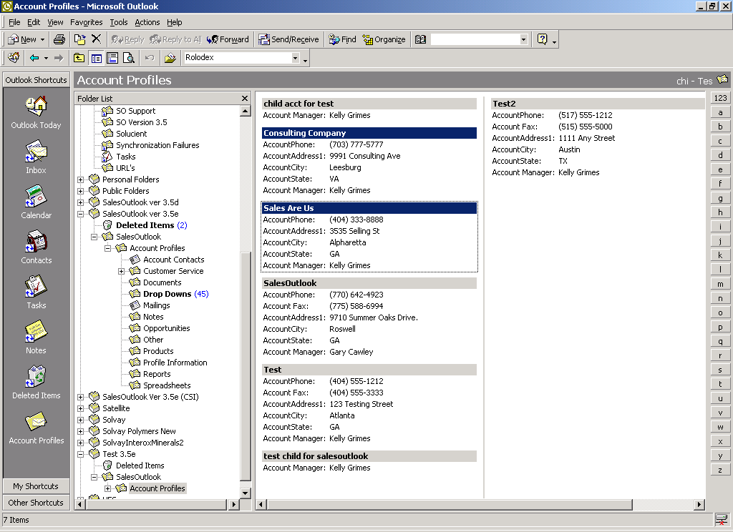

In this example we’ve selected 2 accounts. The Consulting Company and Sales Are Us.

- Restore the SalesOutlook Move/Copy Account Profiles form by clicking on its icon in the Windows taskbar at the bottom of your screen, and then click the Move or Copy button depending on whether you want to move or copy the Account Profile records. Selecting “Move” will completely remove the items from the current Account Profiles folder and move them to the other folder you select.

Note: The “Move Sub Folder Items” checkbox is automatically checked. SalesOutlook recommends this box to remain checked to also move or copy any sub items associated with the Account(s) being moved or copied. Sub items include, but are not limited to, items such as Account Contacts, Opportunities and Notes.

- You will receive a message indicating the number of records you wish to Move. Verify this information and click Yes to proceed with the Copy/Move operation.

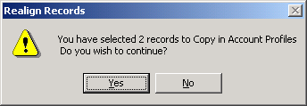

- Navigate to the Account Profiles folder for which you want to move the Account Profiles to and click OK.

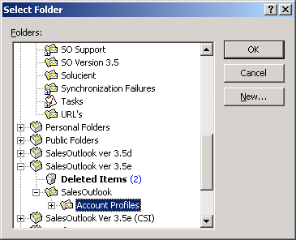

- Wait for the “All Done” message to appear. Information concerning the Accounts moved or copied is listed at the bottom of the Move/Copy form.

Copy Account Profiles Records

Purpose: The copy all button will copy all records from one folder to another. This is useful if you have item level security and you need to copy records between SalesOutlook databases.

- Click on copy all button.
- Select the source folder of the items you want to copy. Note: All items will be copied.
- Select the destination folder you want to copy the items to.

IMPORTANT NOTE: Make sure the destination folder has the correct default form for this folder set to the item type you want to be created in the destination folder.

Add The Same Note To Multiple Contacts and Accounts

Purpose: The SalesOutlook Create Note utility allows you to generate the same note for multiple contacts or accounts without having to manually enter each item through the Account or Contact forms.

How To Use The SalesOutlook Create Note Utility

- Open the SalesOutlook Create Note form from the SalesOutlook folder. (IE Navigate to the SalesOutlook folder from within the folder list and choose Action | New SalesOutlook Create Note.)

- Minimize this form and go back to Outlook.

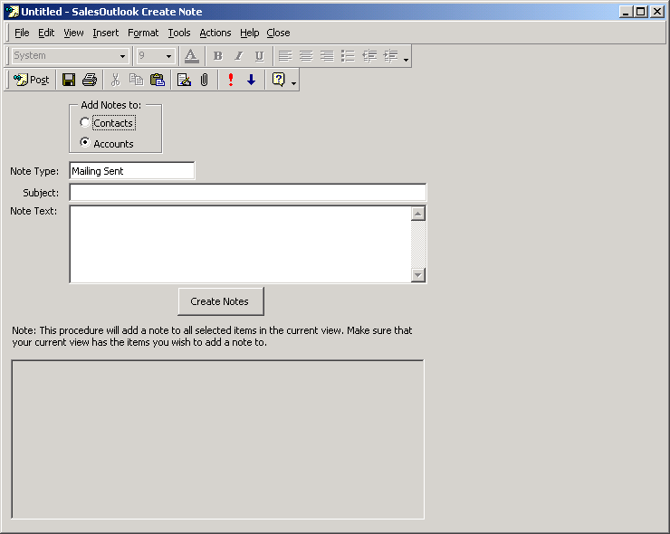

- If adding an Account note, navigate to the Account Profiles folder from within the folder list. If adding an Account Contact note, navigate to the Account Contacts folder from within the folder list.
- Select the items you want to create the Note for by either holding down the shift key or the control key and click on the Accounts (or Contacts) for which you want to create the Note.

In this example we’re adding notes to contacts. Therefore, we’ve selected the Account Contacts folder and selected only the contacts we want to create a note. (Jim Johnson & Jerry Jones)

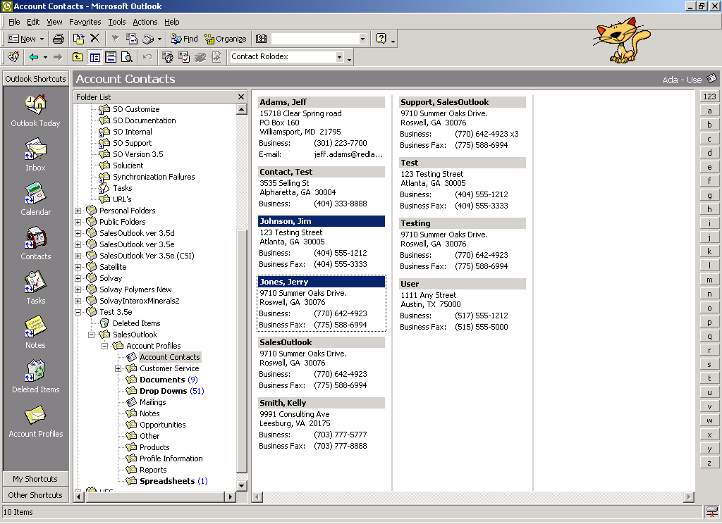

- Restore the SalesOutlook Create Note form by clicking its icon on the Windows taskbar located at the bottom of your screen.
- If creating a note for Accounts, select Accounts for the radio button group labeled “Add Notes to”.

In this example were using Contacts. Therefore, we’ve selected the Contacts radio button in the “Add Notes to” option group.

- Continue to complete the other information on the form including Note Type, Subject, and Note Text. After completing the form, simply click the “Create Notes” button to generate the Note for all Accounts or Contacts you selected.

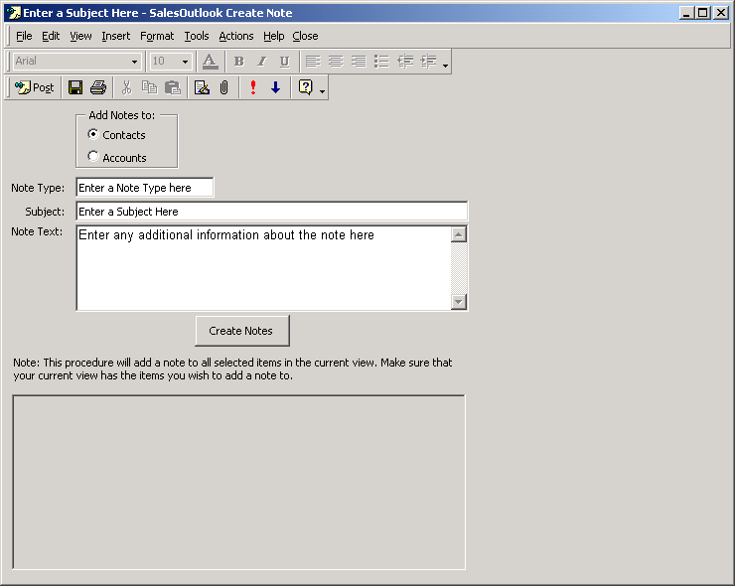

- You will receive a message indicating the number of records you wish to create the Note for. Verify this information and click Yes to proceed to create the Notes.

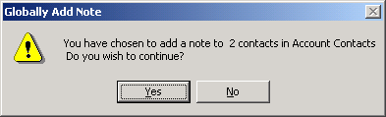

- Wait for the “All Done” message to appear. Information regarding the Notes that were created is listed at the bottom of the SalesOutlook Create Note form.

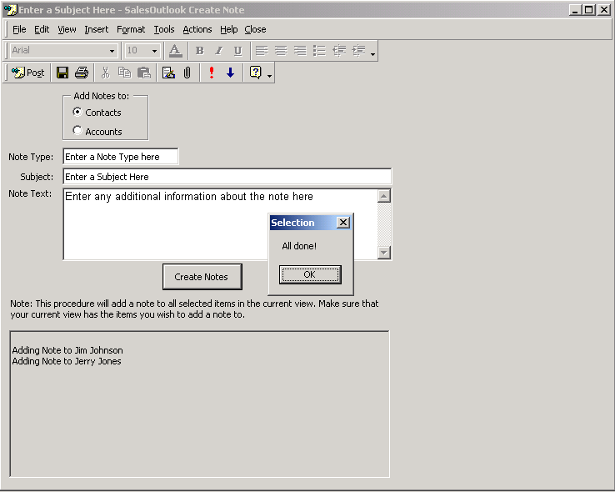

Importing Outlook Contacts Into SalesOutlook

Purpose: The SalesOutlook Import Outlook Contacts utility allows you to import multiple contacts from your personal Outlook Contacts into SalesOutlook. This utility will create a new Account Profile and new Account Contact(s) related to that Account Profile for each Outlook contact that appears in the active view for the selected Outlook Contacts folder. Directions for running this utility are located within the SalesOutlook Import Outlook Contacts form.

NOTE: Also See the Advanced Data Import at the end of this document.

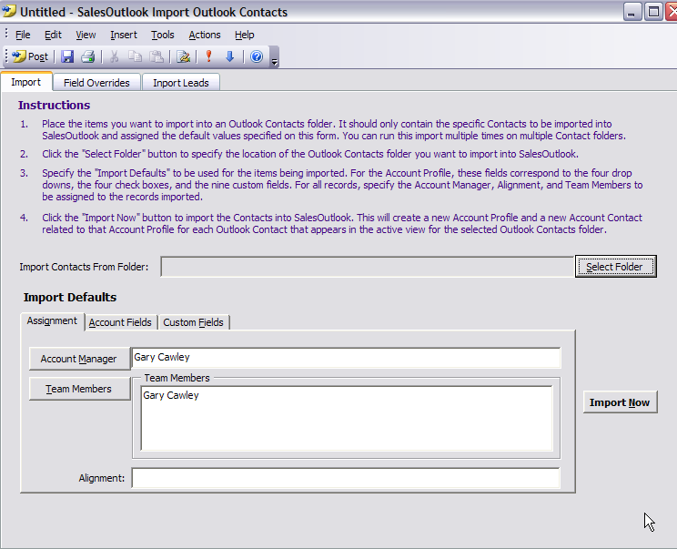

Please refer to the SO4X – Import Outlook Contacts Quick Reference Guide included in the SalesOutlook documentation set for detailed instructions for using this utility, including the steps you should take in preparing your Outlook Contacts for import and how to create a separate database to use as an import workspace.

Understanding User Alignment

Understanding the nature of the User Alignment field is important for Administrators of multi-user installations. The User Alignment value defines the hierarchical structure of the organization's people, and it also provides a method of securing and filtering records. As SalesOutlook users create records, their User Alignment value is stored as a permanent part of the record. Organizations who find the most benefit of the alignment feature are organizations with a hierarchy such as Divisions, Regions, and Territories.

How it Works
SalesOutlook uses sub-strings to develop the hierarchy. For example, assume that your organization is organized into Divisions, Regions, and Territories. Suppose that we develop a coding schema so that "D" means Division, "R" means Region, "T" means Territory, and "S" means Salesperson. Then, we develop a numbering system for our Divisions, Regions, Territories, and Salespeople. Suppose that a user is in Division 01, Region 05, Territory 58, and Salesperson 0194. The User Alignment value for that user would be "XD01R05T58S0194" given our schema. The "X" provides the means to give all users access, and its use will be described later within this document.

Defining the Organizations Structure
For example, suppose that the user in the example above collaborates with several other people on his/her accounts. The user has a Sales Manager that has responsibility for Territory 58, and that Sales Manager has a Regional Manager above him/her who is responsible for everything in Region 05. And let's not forget the VP in charge of Division 01. Of course, there's the various admin staff that "floats" between Regions and Territories, but they never cross Division lines.

Here's how to determine the appropriate User Alignment values for the various users and roles. First, remember that SalesOutlook uses a sub-string function to determine if User A's Alignment Value is shorter than User B's value. If the shortest value matches the left-most characters of the longer value, then access is granted.

In our example, we would encode the various users as described in the table located on the next page to create the business rules described in the previous paragraph.

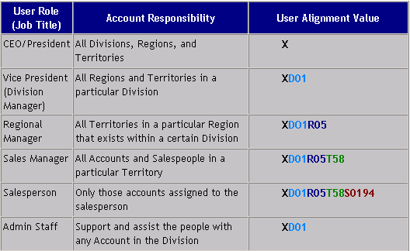

Notice that the Alignment values are the same at the left-most part of the string, but they become different as the value moves to the right. System Administrators and the CEO of the organization can see all accounts, just as the Customer Service staff. These individuals will all receive an Alignment value of "X" so that they can access all records. However, since the VP in charge of Division 01 has an Alignment value of "XD01", then he/she will only have access to those records having an Alignment that begins with "XD01". Similarly, the Regional Manager will have access to all records that have an alignment of "XD01R05", and so on.

Note: Administrators who choose to use the alignment feature will need to set the alignment value on each user’s pc. The alignment value is located on the SalesOutlook Folder Settings tab by selecting Tools / Options / SalesOutlook Folder Settings from the toolbar.

How To Use The SalesOutlook Email Blast or Html Blast Utilities.
- Navigate to the SalesOutlook Folder. Note: You must have create rights in this folder.
- Click on the Outlook menu item Actions and select New SalesOutlook Email.
- Enter you Email information. 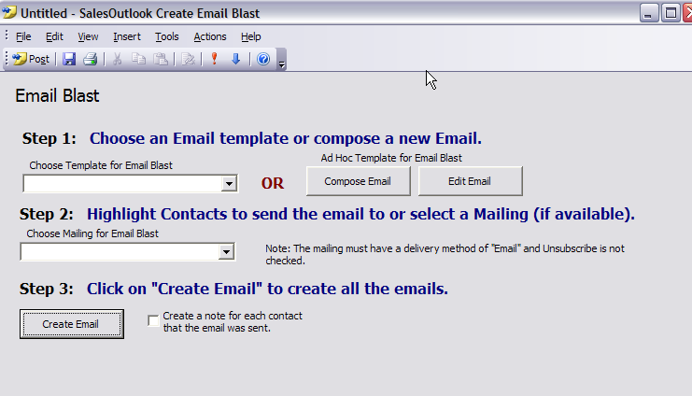
- Minimize the email form and navigate to your Account Contacts or mailings folder.
- Select the contacts that you want to send the email to.
- Click on the Create Email button.
- An email will be sent to each contact and a note will be created that the email was sent.
- You may need to have Outlook security setting set to allow for email addresses or you may receive a pop up to allow access to these contacts.

Appendix A: Advanced Data Import

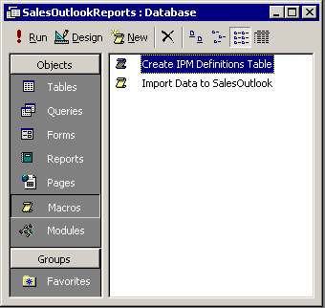
Launching The SalesOutlook Data Import Screen

To begin using the SalesOutlook Data Import Routines, open the SalesOutlookReports.mdb file from the \Documents and Settings\<<username>>\Application Data\SalesOutlook directory. As a prerequisite, the user of this facility must have Access 2000 or later installed on the machine.
2

- Simply click on the Macros icon.
- Then double-click the Import Data to SalesOutlook macro to begin.
1

This will launch the main screen for creating the staging tables for data import as well as the actual automation for importing the data which is placed in those staging tables. See graphic detailed below.

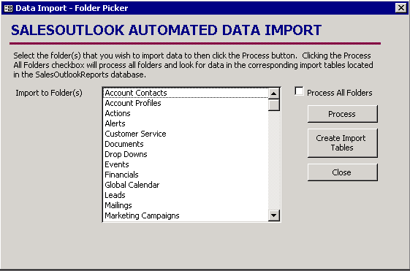
Creating The Import Staging Tables
When the data import screen first appears, you will see a list of public folder links. These entries signify the tables for which data can be imported to.
1

- The first step in the process is to click the Create Import Tables button. This will create the staging tables in the database for which you can begin populating with data to be imported to SalesOutlook.
NOTE: Do not click on Create Import tables or map salesoutlook data within Outlook if you have imported your data to the import tables or your imported data will be lost.

The end result will be a staging table for every public folder link listed on the data import screen. A sample is detailed in the following graphic.

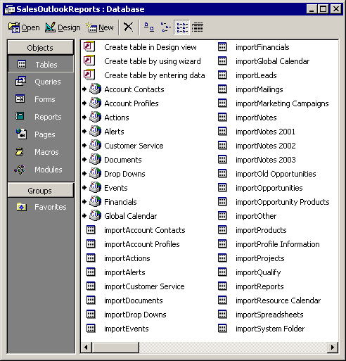
Identifying The Import Staging Tables

As you can see, the import staging tables are created. They are all prefixed by the word "import" so you can easily identify where to put the data to be imported. For example, to import Account Profile records, you would populate the importAccount Profiles table with data.

KEY RECORD FIELD IDENTIFIERS:

There are a few key field indentifiers that are located in each table in SalesOutlook that must be populated in order to facilitate referential integrity.

ACCOUNTID - 24 character unique record identifier for account profiles. ACCOUNTID is cascaded to all records relating to an account. It is the key identifier in SalesOutlook. It can be
Public Function GenerateID() As String
'////This function can NOT be called as an expression within an Access Query////
Dim sobj As Object
Set sobj = CreateObject("SalesOutlook.Connect")
GenerateID = sobj.GenerateID()
Set sobj = Nothing
End Function

generated using the SalesOutlook COM component method GENERATEID(). The above Access function will assist create these unique identifiers. NOTEL: You can use the phone number as the AccountID.

CONTACTID - 24 character unique record identifier for account contacts. CONTACTID is cascaded to all records relating to an account contact. It is the key identifier in SalesOutlook for contact record types.. It can be generated using the SalesOutlook COM component method GENERATEID().

(Please refer to the SalesOutlook 4.0 Entity Relationship Diagram shown on the next page to determine the primary key and foreign key identifiers used in the SalesOutlook data structure to link items contained in the various SalesOutlook folders.)

Processing A Data Import
2
Once the import staging tables have been populated, you are ready to perform the actual import process. The data that was originally placed in the staging tables will be imported into the corresponding SalesOutlook public folder. There are two ways this process can be performed.
1

- You can multi-select the desired folders in the folder list and click the process button. This will perform the data import process for only those folders selected. OR
- You can click the "Process All Folders" check box and the process will import data for all the folders in your public folder list.

Please note that the SalesOutlook Data Import program does NOT delete the import staging records once they are imported into the SalesOutlook public folders. Clicking the process button multiple times will result in duplicate data being imported!

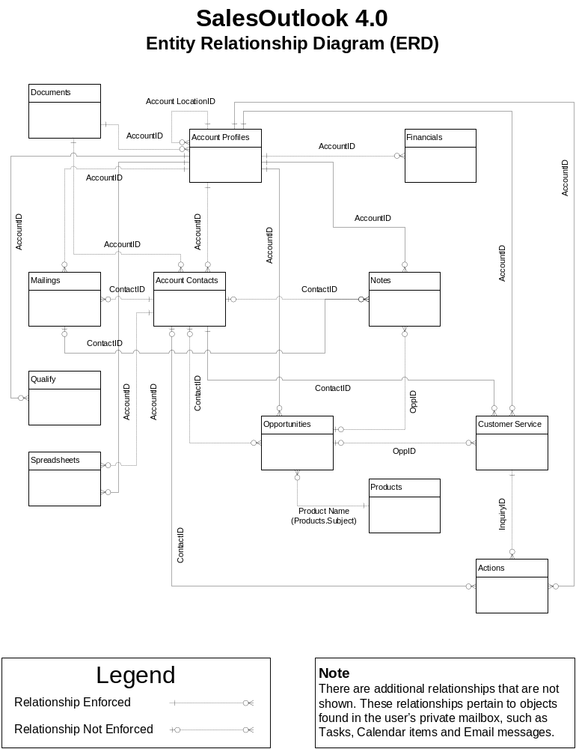

Appendix B: Setup Exchange 2000 Full Text Indexing for SalesOutlook

Configure a Full Text Index
- Start Registry Editor on the Exchange 2000 Full text indexing Server by typing regedit.exe at a command prompt on the Exchange server running the full text indexing services.
- Click the HKEY_LOCAL_MACHINE window.
- Locate the Software\Microsoft\Search\1.0 subkey.
- If it does not already exist, add a key under 1.0 called ExchangeParameters.
- Under Exchange Parameters, add a value with the name SchemaTextFilePathName, a data type of REG_SZ, and a string value of the path to the text file of properties, such as
E:\Exchsrvr\myprops.txt
- Quit Registry Editor.
- Copy the following text file to the location you specified in the registry. The file contents of myprops.txt are listed below.
http://schemas.microsoft.com/mapi/string/{00020329-0000-0000-C000-000000000046}/AccountID
http://schemas.microsoft.com/mapi/string/{00020329-0000-0000-C000-000000000046}/ContactID
http://schemas.microsoft.com/mapi/string/{00020329-0000-0000-C000-000000000046}/Accoun%20tLocationID
http://schemas.microsoft.com/mapi/string/{00020329-0000-0000-C000-000000000046}/OppID

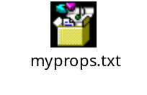

Install the latest Microsoft Service Pack: Must be Exchange SP3 Sept 2003 post fix or greater.

NOTE: Microsoft periodically updates service pack releases that may supersede this method of indexing Exchange content. In addition, when full-text indexing is enabled newly created records may not appear within the SalesOutlook forms and may not be found by SalesOutlook features such as Find Account and/or Find Contact for up to 15 minutes after the item is created. This is because the Full-Text Index is refreshed every 15 minutes (minimum) and although the item exists it does not have an entry in the index, and when searching for the item the search will not return an entry for it since it does not appear in the index.

Generate the Full Text Index

- Open the Exchange System Manager.
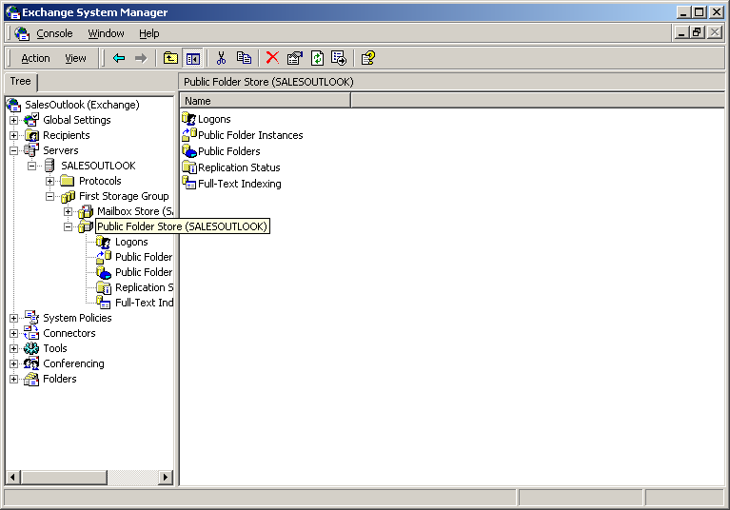

- Go to servers | <your server name> | <your storage group> | Public Folders. This is the storage group that houses your Public folders.

- Right click and select Create Full-Text Index.

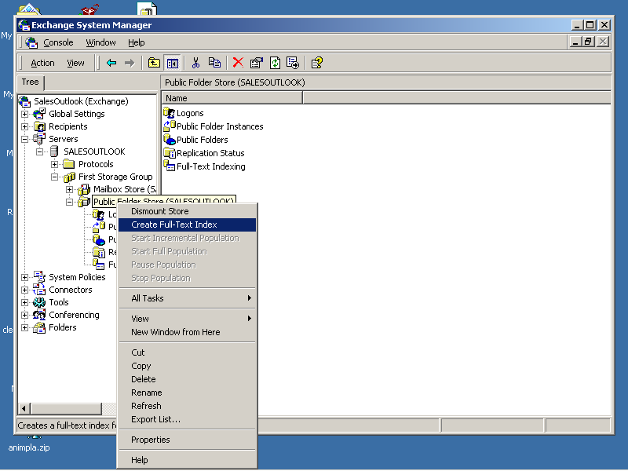

- Right click the public folder again and select Start full population.

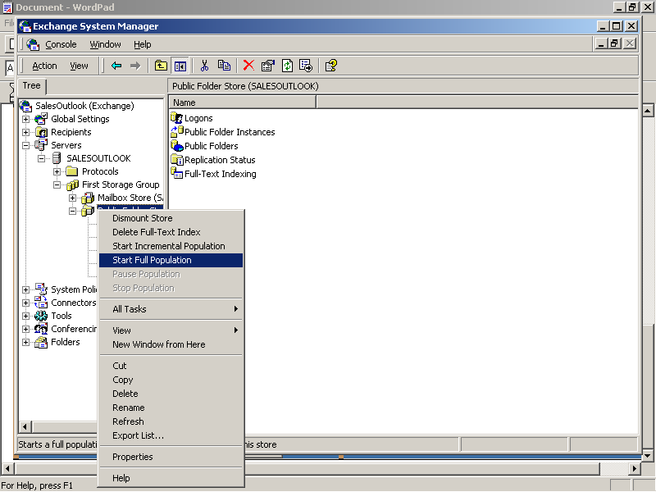

Note: This procedure will take considerable resources and should only be run off hours. This is a one-time procedure.
- Once the Full Text Index is built, right click on the Public Folders and choose Properties.

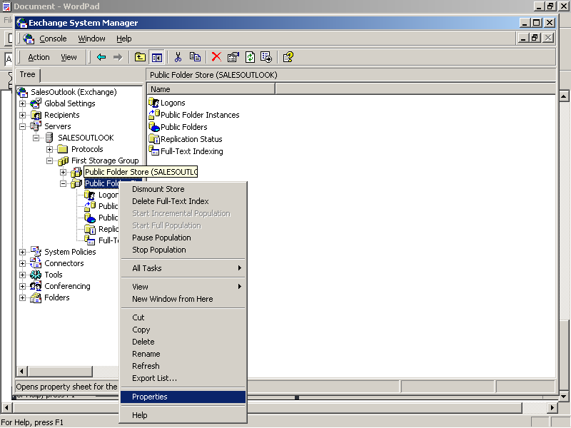

- Click on the Full-Text Indexing tab and select the checkbox “This index is currently available for searching by clients”.

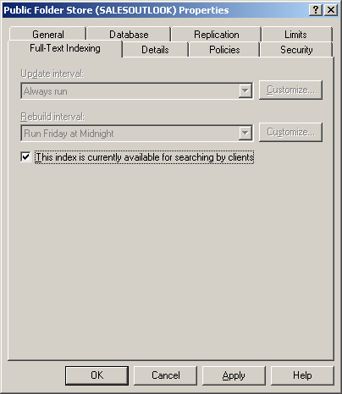

Full Text Indexing configuration is now complete and your full text index is operational.

srchadm.msc. You will need to register mssmmcsi.dll

Recommended Disk Configuration
Gather logs are the log files that contain log information for the indexing service. One set of logs exists for each index but there are even more File Types:

Catalogs are the main indexes. There is only one catalog for each mailbox store or public folder store in Exchange.
Property store is a database that contains various properties of items indexed in the catalog. There is only one property store per server.
Property store logs are the log files associated with the property store database.
Temporary files are the files that contain temporary information used by MSSearch.
Gather logs are the log files that contain log information for the indexing service. One set of logs exist for each index.
Microsoft recommends using a RAID-0+1 (RAID 1+0 = RAID 10) configuration.

A RAID-0+1 disk array provides the highest performance while ensuring redundancy by combining RAID-0 and RAID-1 technologies. . RAID-0 is a striped disk array in which each disk is logically partitioned in such a way that a “stripe” runs across all the disks in the array to create a single logical partition. RAID-1 is a disk array in which two disks are mirrored. In a RAID-0+1 disk array, data is mirrored to both sets of disks, and then striped across the drives. Each physical disk is duplicated in the array. RAID 10 requires many disks but is the best RAID solution for maximum performance and redundancy. Important: RAID-5 is not recommended for full-text indexing.

Memory Requirements
Microsoft doesn’t recommend running full-text indexing with less than 512 MB.

Add an additional 256 MB of RAM to the recommended configuration for a computer running Exchange 2003 Server.

Appendix C Exchange Mailbox can be used instead of Public Folders

The Exchange mailbox (Central Database Mailbox) can be used to store the database in lieu of Public Folders.

You will need to specify a mailbox as the central database location. SalesOutlook recommends a dedicated mailbox but you can use an existing mailbox if preferred. All other users use this database as a Delegate mailbox (See below)

- Log into Outlook as the Central Database mailbox and install SalesOutlook using all the defaults including the database.
- Right click on the upper most folder titled “Mailbox – {user name}” and choose properties and then permissions. Set Default permissions to “Owner”
- Right click on the “SalesOutlook” folder (not the SalesOutlook Version # folder) and choose copy to folder. Select the top level folder “Mailbox – {user name}”. See page 6. If you receive an error message then just ignore it.
- The database is now setup for others to share.
Note: If the database is stored in a users mailbox then select this database to be used by the user (Outlook 2007 Tools | Options | SalesOutlook Folder Settings. Outlook 2010 File | Options | Addins | Add in options | SalesOutlook Folder Settings).

Setting up additional clients to share the database.

Outlook 2007 clients only (not the Central database account) need a registry set to cache delegate mail folders. Office SP2 is required for this change.

1. Exit Outlook 2007.
2. Start Registry Editor:
o In Windows Vista, click Start

, type regedit in the Start Search box, and then press ENTER.

If you are prompted for an administrator password or confirmation, type your password or click Continue.
o In Windows XP, click Start, click Run, type regedit in the Open box, and then click OK.
3. Locate and then click to select the following registry key:
HKEY_CURRENT_USER\Software\Microsoft\Office\12.0\Outlook\Cached Mode
Note You can also use the following registry key:
HKEY_CURRENT_USER\Software\Policies\Microsoft\Office\12.0\Outlook\Cached Mode
Note You may have to manually create the registry key if it does not already exist on the system.
4. Right-click CacheOthersMail, and then click Modify.
5. Type 1 in the Value data box, and then click OK.
6. On the File menu, click Exit to exit Registry Editor.
7. Disable headers. To do this, follow these steps:
a. On the File menu, and then click Cached Exchange Mode.
b. Click to clear the following options:
Download Headers and then Full Items
Download Headers
On Slow Connections Download Only Headers
Note This step is required to enable this hotfix. If this step is not performed, Header mode may stop responding or may corrupt data.

Outlook 2007 and Outlook 2010
Configure SalesOutlook to use the Delegate (Central) database.

- Close Outlook.
- Open Control Panel | Mail and Add the Delegate Mailbox (Account Settings | Change | More Settings | Advanced Tab | Open these Additional Mailboxes | Add | Select the Central database Mailbox)
- Make sure Download Shared folders is selected.
- Restart Outlook and let the database build (it is best to click on all the folders to get Outlook to start Synchronizing)
- Once the database is synchronized then install SalesOutlook.
- If SalesOutlook is already installed then select the new database. (Outlook 2007 Tools | Options | SalesOutlook Folder Settings. Outlook 2010 File | Options | Addins | Add in options | SalesOutlook Folder Settings).

