Modifying the SalesOutlook Dashboard

The SalesOutlook dashboard can be modified per user or globally and includes the following customizations
- Chart Title
- Chart SQL statement

Modifying the Chart SQL per user
The title and data are customized using the registry. Open Regedit (Start | Run | regedit) Navigate to the Current Users\Software\SalesOutlook hive. Here you will see Chart Titles and Chart SQL. Chart1 and Chart 3 use the same SQL statement. You can modify the SQL statements

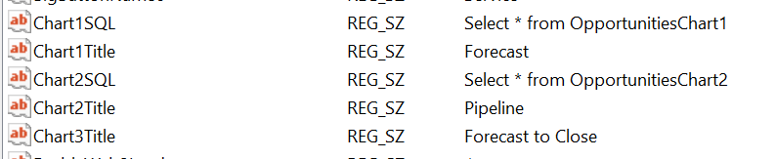

Breakdown of SQL statement to Chart values.
Funnel and Pie Charts.
The chart values need to be numeric, percent or currency. The grouping field is the funnel breakdown (top to bottom funnel value) and the sum field will total each breakdown or level. You can also add addition where clauses such as “where [Account Manager] =’Sales persons name’ ” or [forecast]=True. Make sure to include brackets around the field name.
Chart1SQL = "Select Probability,SUM(TotalPurchase) from Opportunities group by Probability"
Chart1SQL = "Select Probability,SUM(TotalPurchase) from Opportunities group by Probability where [Account Manager] = ‘Joe Friday’ and [Forecast] = True"

Bar Chart
The Bar chart is a date driven chart that will give a timeline and the amount for the time line. The first field must be a date and the second filed next to be a numeric, percent or currency field. You can add additional where or having clauses such as a date range.
Chart2SQL = "Select [Expected Close Date],SUM(TotalPurchase) as Expr1 from Opportunities group by [Expected Close Date] order by [Expected Close Date]"
Chart2SQL = "Select [Expected Close Date],SUM(TotalPurchase) as Expr1 from Opportunities group by [Expected Close Date] order by [Expected Close Date] where [Expected Close Date] HAVING (Expected Close Date])>Now()"

Modyfying the Chart SQL globally.

You will need Microsoft Access Installed to modify the Charts globally (Note: Only the administrator needs Microsoft Access Installed to modify the SQL Commands.

Click on the Access button from the SalesOutlook toolbar

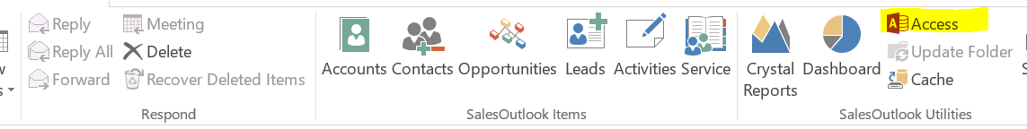
Select Queries if the Queries section is not already the default. You should see two queries setup for the chart Opp. Make sure the registry is set to Select * from OpportunitiesChart1 and Select * from OpportunitiesChart2 as seen below.ortunitiesCart1 and OpportunitiesChart2
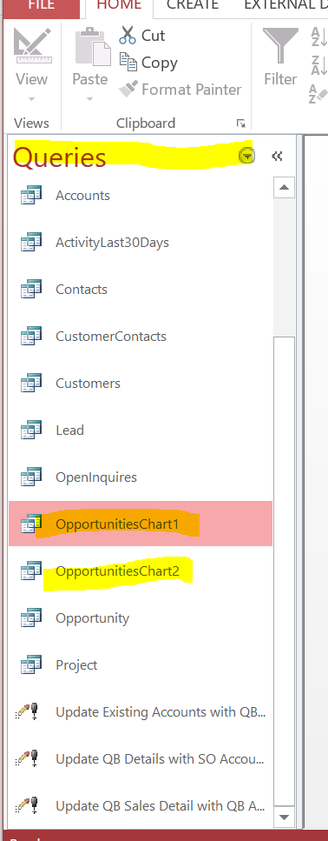
Right click on the OpportunitiesChart1SQL and choose Design View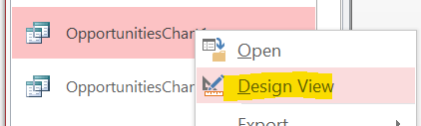
If your Query is not already in design view then click View | Design view.
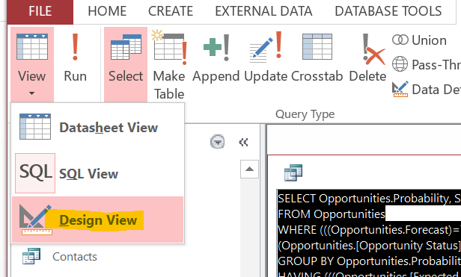

You can now customize the view the way you need it. Test the Query.
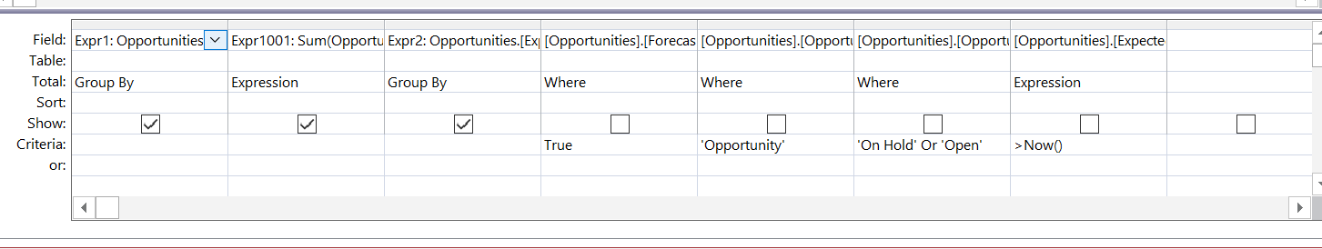
Copying the query for other users.
Once tested then you will need to replace the SalesOutlookReports.so in the SalesOutlook Folder and have the users map the SalesOutlook database.
Navigate to the \Users\{your username}\Appdata\Roaming\SalesOutlook folder. Rename SalesOutlookReports.mdb to SalesOutlookReports.so. This is case sensitive. Copy the SalesOutlookReports.so the Outlook SalesOutlook folder. In Outlook navigate to the SalesOutlook folder. Delete the SalesOutlookReports.so file and paste in the new one (Ctrl-V). Have each user click on Crystal Reports | Map SalesOutlook Data.
