How to add a drop down to a current SalesOutlook form. Outlook 2010 or greater.
- Open the form in design mode. Please see the SalesOutlook Administrator manual on how to open a form in design mode.
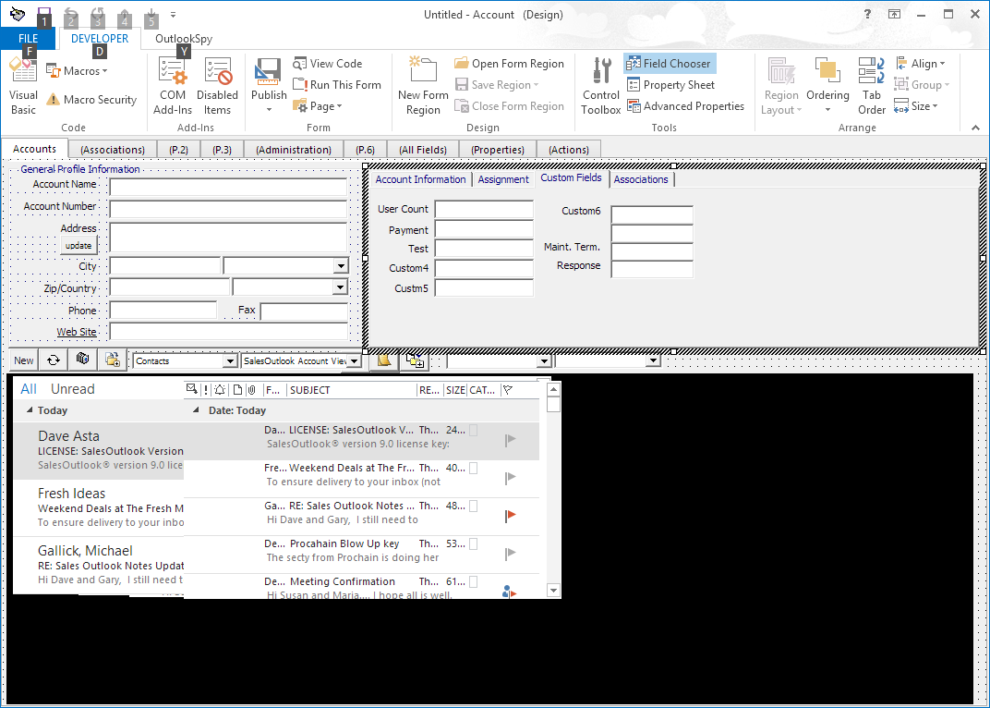

- Open the toolbox by clicking on the 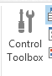 Control toolbox from the ribbon.

- Drag the combo box (or copy and paste an existing combo box) onto the form. Do the same for a label.
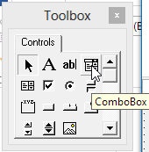 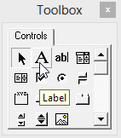 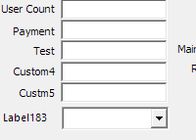

- Change the name of the label by right clicking the label and choose properties. 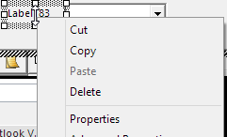

- Edit the caption then click ok.
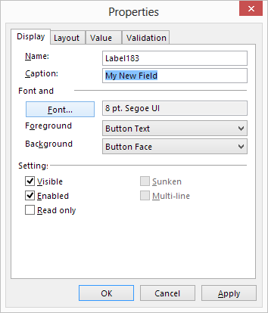

- Change the name of the combo box and bind a field to it. Right click the combo box and choose properties
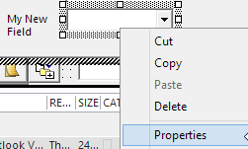

- Give the combo box a name. Note: keep track of the name as you will need it later.
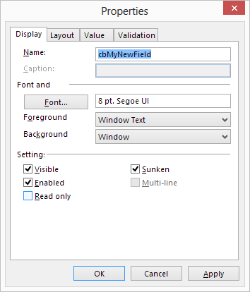

- Click on the value tab and bind a field to the control. Click new to create a new field or ‘Choose Field’ to choose an existing field. Click Ok.
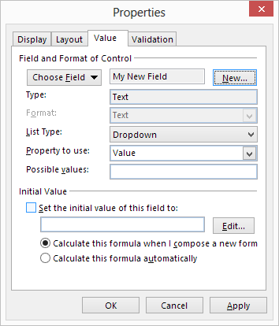

- Edit the code to recognize a new drop down. Click on the 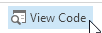 View Code button on the developer ribbon. Click Edit find from the menu bar
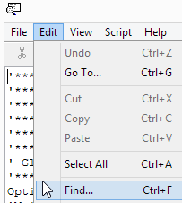

- Type in ‘Sub LoadPulldown” without the quotes.
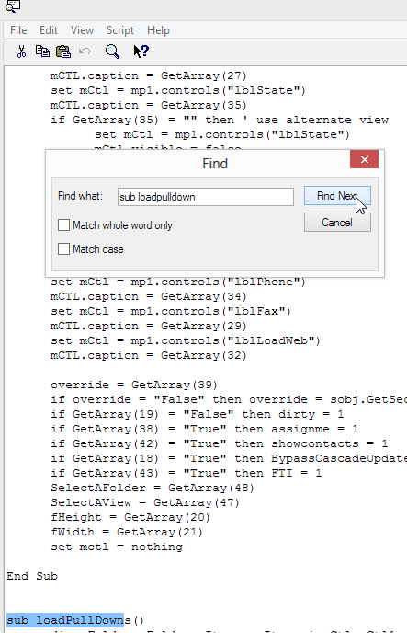

- Scroll down until you see three lines that make up the first drop down. Copy and paste these lines and change the first line to be the combo control name in step 7. Change the second line to be the new drop down value from the drop downs folder. Note: Make a note of this drop down name as you will need it later.
- Note: If you remove an existing drop down then remove the code for that drop down as well.
Close the editor.
- Move or replace a field on a form. If you want to replace a text box then delete the text box and move the combo box in its place. You can drag and drop the item to its new location.
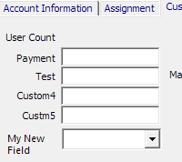 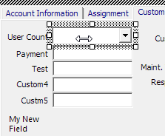
- Clean up the form and bring the form back to its default position. Note: If the form has a tab control then the current tab you are on will be the default tab shown.
Additional properties can be added at this time such as match required or make it a required field
  - Match entry only allows the user to select what is in the drop down. Right click the combo box and choose advanced properties. Look for Match Required and change it to True
  - Make required field can be set by right clicking the combo box and choose properties | Validation tab.
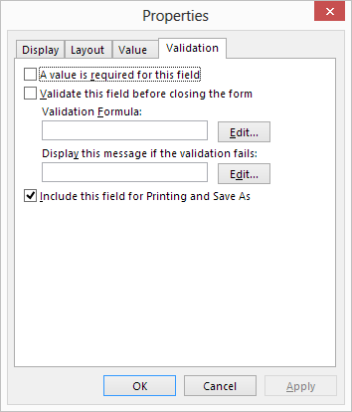
Click on Validate this field before closing the form and click edit. Select your field name and condition as follows. [My New Filed] <> “”
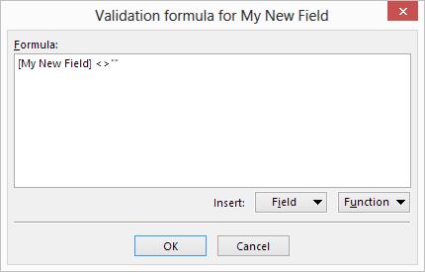
Enter the text you want displayed if the condition is not true.
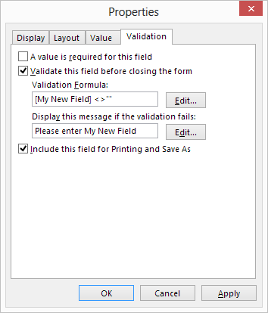
Click ok.

- Publish the form. Click on publish form | Publish form as | Click on Browse | Choose Public Folder All Public Folder and the original folder name (i.e. Account Profiles)
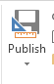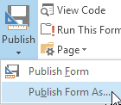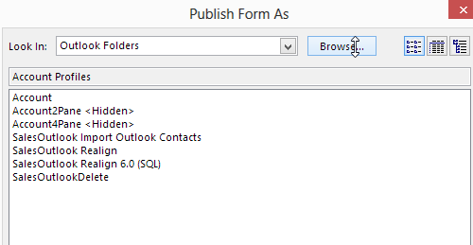
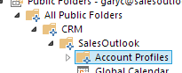
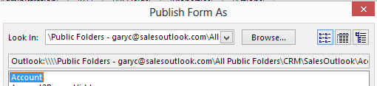
- Click Publish
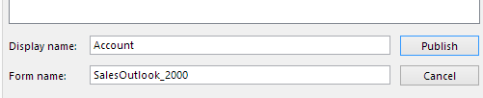
- Add the drop down values. Navigate to the Drop Downs Folder and click the new button.
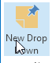
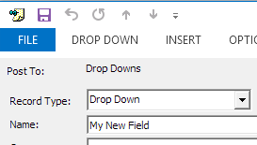
- Enter Drop Down as the record type and the name as defined in step 12. Close and save.
- Click New Drop Down and select your new drop down name “My New Field” and start entering your drop down names.
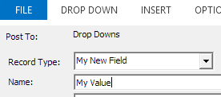
- After all the values are entered then click on the SalesOutlook cache button on the SalesOutlook Ribbon.
- Test the form to make sure everything worked ok.
