SalesOutlook®
Client Setup for Outlook Users

Revised: July 16, 2021

SalesOutlook, Inc.
9710 Summer Oaks Drive
Roswell, GA 30076
(770) 642-4923

Table of Contents

Purpose of this Document 3
Preparing To Install 3
IMPORTANT NOTES: 3
SalesOutlook Client Installation 4
Recommended -
Table of Contents
Purpose of this Document 3
Preparing To Install 3
IMPORTANT NOTES: 3
SalesOutlook Client Installation 4
Recommended - Adding cache mode to public folder favorites 4
Define the SalesOutlook folders as public folder favorites 6
Install the SalesOutlook Client Software 8
Manually installing the SalesOutlook Client software and setting the database - Troubleshooting. 10
Optional - Filtering Offline Data (offline / cached mode users) 13
Required Updates / Patches 19

Adding cache mode to public folder favorites 4
Define the SalesOutlook folders as public folder favorites 6
Install the SalesOutlook Client Software 8
Setting up Windows Desktop Search(Optional) 9
Manually installing the SalesOutlook Client software and setting the database - Troubleshooting. 10
Optional - Filtering Offline Data (offline / cached mode users) 15
Required Updates / Patches 20

Purpose of this Document

The purpose of this document is to setup a SalesOutlook client after the administrator has already installed the SalesOutlook database in multi-user environments. If your SalesOutlook database has not been setup then please reference the SalesOutlook Administration Guide (SO – Administration Guide) before installing. Single user and demo software installations can also use this guide to install SalesOutlook.

Preparing To Install
Please ensure that all system requirements are met, including Windows system-level updates, and that the most recent service packs and updates for Windows and Office applications are applied before installing any SalesOutlook program. Users will need rights to update the registry when installing client.

IMPORTANT NOTES:

- This document covers only the steps used to install and configure Outlook for use with SalesOutlook.
- If you are the system administrator and need to configure a shared SalesOutlook database on your Exchange Server Public Folders, please refer to the SO – Administrator Guide for instructions.

The Basic Installation Steps for cache mode outlined in this manual are as follows:
- Setup cache mode for public folders.
- Add the SalesOutlook database to the Favorites folder.
- Configure Windows desktop search.
- Install SalesOutlook client.

SalesOutlook Client Installation
The following procedures will be performed for each client user. SalesOutlook recommends the Outlook Cached Exchange Mode for each client .

BEST PRACTICE: Multi-user environments should first have the Administrator set up and configure security permissions for the shared SalesOutlook database in the Public Folders on your Microsoft Exchange Server (See SalesOutlook Installation and Administrator Guide).

Recommended - Adding cache mode to public folder favorites
While this feature is not required for LAN users but is strongly recommended because of the junk mail filter and performance increases with a slower Exchange server or network. It also allows a user to continue to work if the Exchange server is down, and when the server is up the new Cached Exchange Mode reduces network “chatter” and improve the performance of your network. Cached Exchange Mode is a hybrid between working connected and working with a local, offline database. The Cached Exchange Mode employs both simultaneously to optimize the performance for the user and to minimize network traffic and load on the Exchange Server. Note: Non-Cached Mode LAN users can skip to the topic Installing SaleOutlook Software on page 9.

- Click on File from the Outlook Ribbon.
- Click on Info | Account Settings | Account Settings. 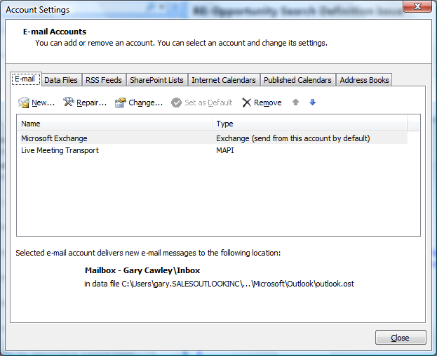
- Highlight Microsoft Exchange and click on Change.
- Click on the More Settings button.
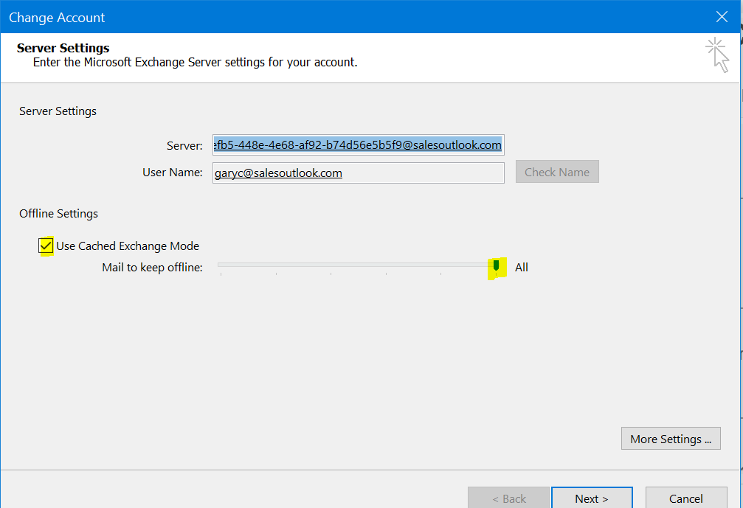
Check this box and then click the More Settings button for additional configuration options. Outlook 2016 + users need to set. The slider to all

- Click on the Advanced tab and make sure Download Public Folder Favorites is checked. 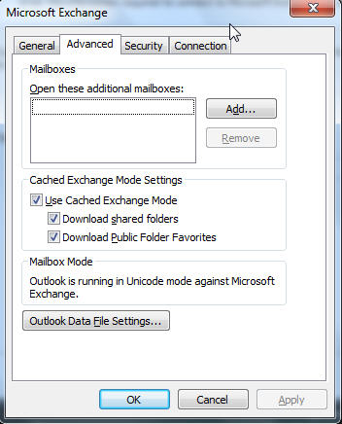
Make sure Use Cached Exchange Mode and Download Public folder favorites are checked. Click Share Folders if you share calendars.
Make sure database is set to Unicode. If not, then delete the *.ost database and *.oab offline address book files. Outlook will recreate them in Unicode format when Outlook is restarted.

Define the SalesOutlook folders as public folder favorites

- Display the Folder List by pressing the Ctrl-6 if the folder list is not already visible. Note that clicking the Mail group button displays a filtered list of folders. The only way to view the entire folder tree is to click the Folder List button at the bottom left-hand corner of your Outlook window or press Ctrl-6. You may have to click on the elipses
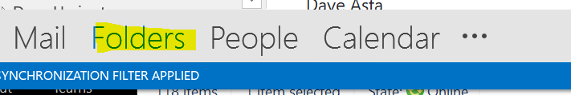.

- Navigate to the SalesOutlook folder in the Public Folders structure and highlight the SalesOutlook folder.

TIP: Please contact your Exchange administrator to find out where the SalesOutlook folder structure was installed. Normally, SalesOutlook is installed under Public Folders / All Public Folders /SalesOutlook.

- Right click on the SalesOutlook folder and choose Add to Favorites.

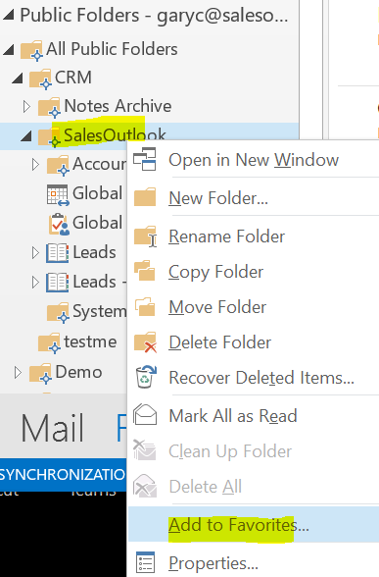

- Click on the Options>>> button and select the following options:
  - Add subfolders of this folder
    - Add all subfolders
  - Automatically add new subfolders
    - Add all subfolders.
  - Click Add.

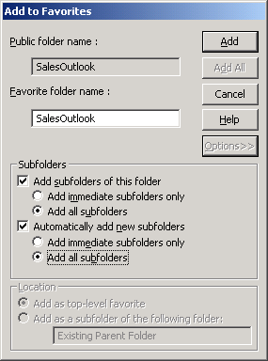

Note: Make sure the Database is replicated before continuing.
Check the SalesOutlook folder, the drop downs folder and the system folder to make sure they have items and are not replicating before installing the software. Do not continue to the next step until Outlook displays “All folders are up to date” in the lower right-hand corner of the Outlook status bar.

Set Outlook to work offline before installing the SalesOutlook client.

Install the SalesOutlook Client Software
- With Outlook closed, run the Setup.msi file provided by SalesOutlook.
- When Outlook is opened choose Next and finish through the splash screens. Cached users choose Work Offline .
- When the message pops up to select the database choose Yes. 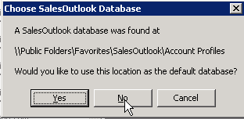
SalesOutlook setup is now complete and the user can work with SalesOutlook. The following text are additional recommended settings.

Setup is now complete. Restart Outlook. If you have problems or if you installed the software before installing the databse then follow the manually setting up the database below.

Manually installing the SalesOutlook Client software and setting the database - Troubleshooting.

If the Automatic configuration of the database did not work or if you have problems you can manually select the SalesOutlook database
- Select File | SalesOutlook | SalesOutlook Setup from the Outlook menu bar and Select the SalesOutlook Folder Settings screen.
- 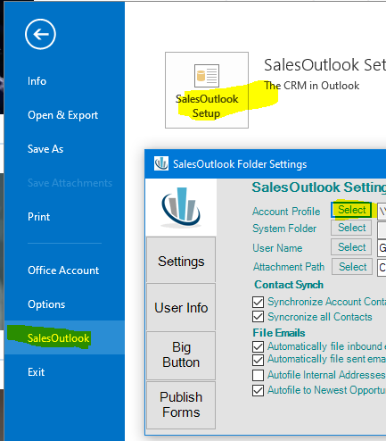
Click on the Select button to the ledt of the Account Profiles field. 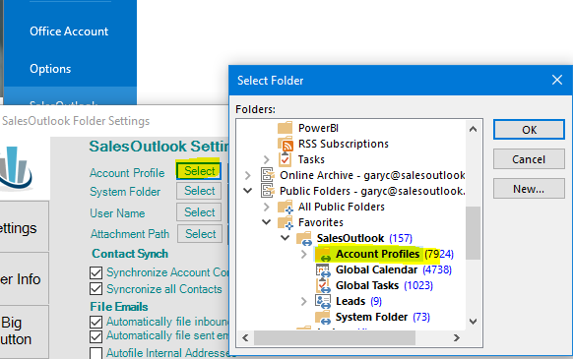
- Navigate to Public Folders\Favorites\SalesOutlook\Account Profiles. Click OK.

TIP: To navigate down to this folder you’ll need to click on the plus sign to expand these folders. Repeat this for all folders that you want your users to see on the shortcut bar.

- Click on the Select Button next to User Name.
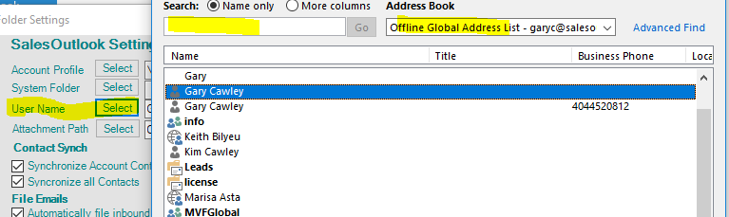

- Navigate to your name and click to highlight. Copy your name to the right column by clicking the User button and then click OK.
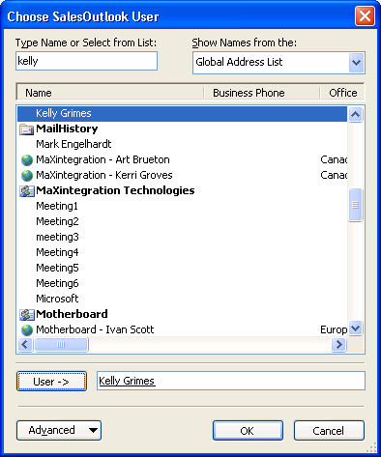

- Select the path to store the saved emails to such as Onedrive, Drop Box, Google Drive etc…. Please consult your shared drive instructions for sharing a folder. A Note will be created and the original email with attachments will be stored in your shared foldera
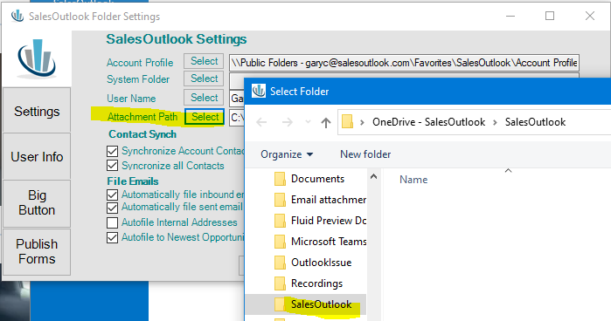

- Click Save. . SalesOutlook will map the database settings..

- If using the alignment feature, type in the User Alignment. Your administrator should have setup each SalesOutlook user with an alignment number.

Note: User alignment is only used for organizations that have a hierarchal sales structure (Region, Division, and Territory). This field can be left blank if you do have this type of organizational hierarchy or if you have decided not to use Alignment number.

- The SalesOutlook Client configuration for Outlook is now complete.

Optional - Filtering Offline Data (offline / cached mode users)
NOTE: You will need the February 2011 Hotfix or service pack for this feature to work
- To filter users, right click on the Public Folder Favorites and choose Properties.
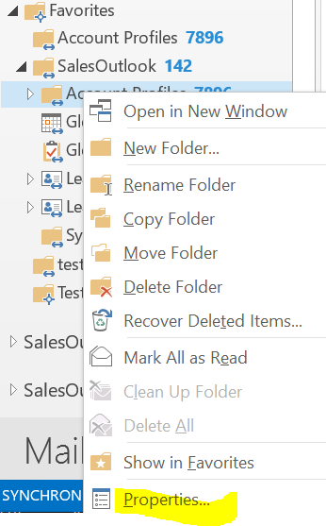
- Click on the Synchronization Tab. 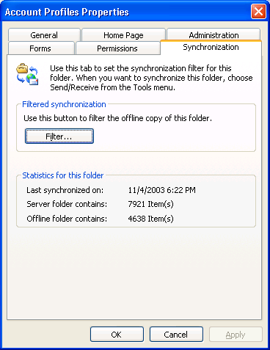

- Click on the filter button.

- Click on the Advanced tab.

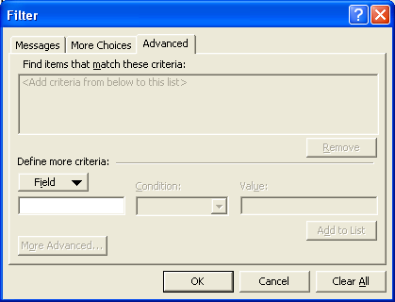

- Select Field | User Defined Fields in folder | and select Account Manager, Team or Alignment depending on how you want to filter your records.

NOTE: Account Manager or Team are the most common filters.

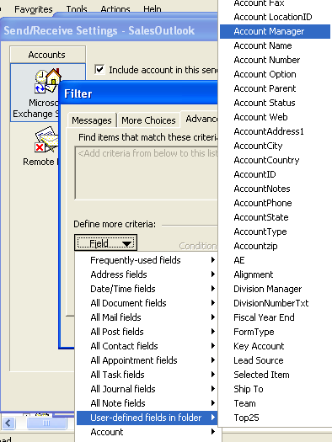

- Enter the user’s name if using the Account Manager field to filter the data or if using alignment number, select alignment number as the field and fill in the user’s designated alignment number. Click on “Add to List”. Click OK. Repeat for all folders that need filtering.

NOTE: SalesOutlook, Dropdowns, Products, System Folder and the Reports folders should not be filtered. Synchronization Filters should only be created or modified while working Connected to the Exchange Server.

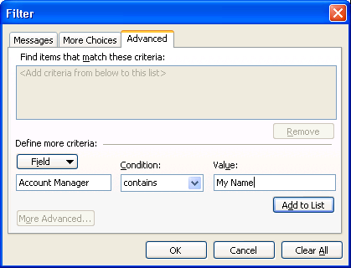

System Requirements
Please see the SO – System Requirements document for detailed minimum and recommended system requirements.

Required Updates / Patches
SalesOutlook requires the latest Microsoft patches and updates for Office.

CONFIGURATION NOTICE: The user must have local machine admin rights in order to perform the installation. The setup program will write information to the registry and create a SalesOutlook directory under Program Files and {username}\Application Data\SalesOutlook. The later directory needs to be read/write for the user after installation.

Users logged into a domain can be added to the Domain Admins group to perform the installation then removed after the installation.

Copyright Notice

© 2018 SalesOutlook, Inc. All rights reserved.

This document contains highly confidential information considered by SalesOutlook, Inc. to be a proprietary trade secret and is intellectual property that is owned solely by SalesOutlook, Inc.

This document and the information it contains is protected by international copyright laws and treaties and additional intellectual property laws and treaties as they apply to confidential information and trade secrets. Unauthorized distribution, transmission, disclosure or other use is expressly prohibited.

Individuals, and the individuals and/or organizations they represent whether through a formal or informal relationship, may face criminal and/or civil litigation that may result in severe fines, monetary damages and/or even imprisonment for disclosing the information contained in this document to any unauthorized person or entity.

No portion of the information contained in this document may be disclosed or distributed to any person or entity that is not a lawfully licensed user of the software product described by the technical characteristics and specifications contained in this document without first obtaining the express written permission of SalesOutlook, Inc. A SalesOutlook, Inc. representative may be contacted by visiting www.salesoutlook.net in your web browser.

Trademark Notice

SALESOUTLOOK®, SalesOutlook CRM, SalesOutlook Web Access, SalesOutlook Reports, Common Sense CRM and other SalesOutlook, Inc. brand names, product names and marketing slogans are either trademarks, service marks or registered trademarks of SalesOutlook, Inc. in the United States and/or other countries.

All other company, product and brand names are owned by other companies and/or individuals.

Legal Disclaimer

Information in the document is subject to change without notice and is offered “As Is” and without any warranty whatsoever, including warranties relating to merchantability or fitness for a particular purpose or use.

The software described in this document is furnished under a license agreement. The software may be used only in accordance with the terms of the license agreement. It is against the law to copy the software on any medium except as specifically allowed in the license agreement.

No part of this document may be reproduced or transmitted in any form or by any means – electronic or mechanical – including photocopying, recording, or information recording and retrieval systems, for any purpose without the express written permission of SalesOutlook, Inc.

Those who violate the intellectual property rights of SalesOutlook, Inc. will be prosecuted to the fullest extent allowed by applicable law.

